

**Name ………………………………… Class ………………………………**

_______________________________________________________________________________________________________________________

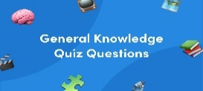

General Questions

|  |
| --- |
| Funny Seal Cartoon Royalty Free SVG, Cliparts, Vectors, And Stock  Illustration. Image 13281545.**1 – What is that?**  **A** . **It's a seahorse.** **B** . **It's a seal.** |
| **2 – What do you think about sharks?**  **A**. **I like dolphins.** **B**. **I think they are scary .** |
| **3 – Which of the following is a sea animal ?**  **A** . **seahorse**  . **B**. **horse** . |

________________________________________________________________________________________________________________________________________________________________________________________________

Reading short sentences

|  |  |  |
| --- | --- | --- |
| **1. The whale is small.** | 🗸 | 🗴 |
| **2. The dolphin is cute.** | 🗸 | 🗴 |



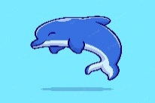



Controlled writing

|  |  |  |  |
| --- | --- | --- | --- |
| **______________________** | | | **1– think - I – whales – big - are. ( rearrange )** |
| **slow** | **scary** | **fast** | **2. Seahorse is ___________ . ( choose)** |

|  |  |  |  |
| --- | --- | --- | --- |
| **biggest** | **big** | **bigger** | **1 – The whale is ______ .** |
| **cutest** | **cuter** | **cute** | **2- The baby seal is the _______.** |
| **as** | **has** | **is** | **3. As fast ___ a dolphin .** |
| **am** | **is** | **are** | **4- What ___ those ?** |

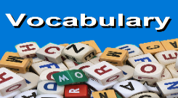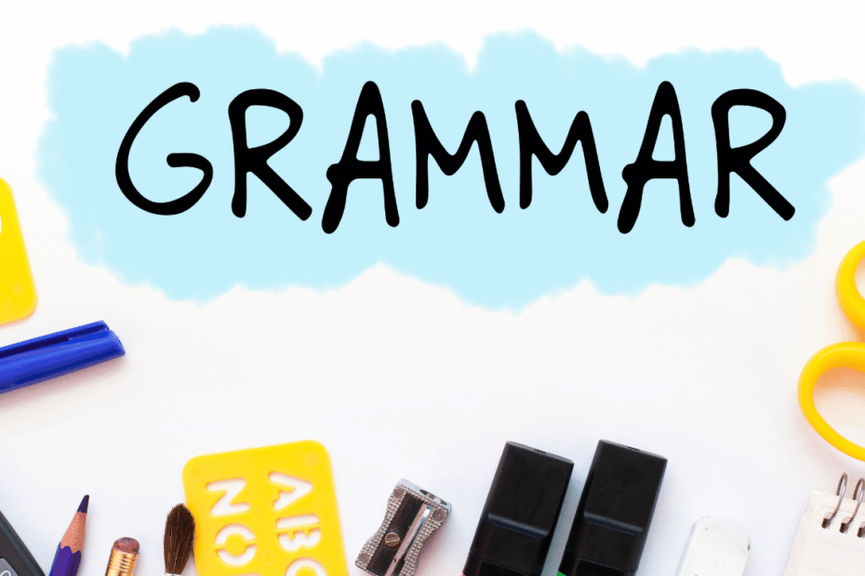_______________________________________________________________________________________________________________________________________________________________________________________________

Grammar

Vocabulary

**seal - seahorse – crab -starfish**

|  |  |  |  |
| --- | --- | --- | --- |
| Seahorse Cartoon Images | Free Vectors, Stock Photos & PSD | Cartoon Crab Stock Illustrations – 19,883 Cartoon Crab Stock Illustrations,  Vectors & Clipart - Dreamstime | Starfish cartoon hi-res stock photography and images - Alamy | Funny Seal Cartoon Royalty Free SVG, Cliparts, Vectors, And Stock  Illustration. Image 13281545. |
| ---------- | ---------- | --------- | --------- |

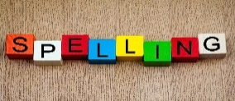

Orthography (spelling)

Choose the correct letter: **( ou - ow - oa )**

|  |  |  |  |  |
| --- | --- | --- | --- | --- |
| House vector illustration isolated on white background. House cartoon, house  clip art Stock Vector | Adobe Stock | cartoon illustration cool cow 6655953 Vector Art at Vecteezy | Cartoon Mouse Vector Art, Icons, and Graphics for Free Download | Cartoon Goat Images | Free Vectors, Stock Photos & PSD | Open Window Cartoon Vector Illustration Isolated Stock Vector (Royalty  Free) 158234942 | Shutterstock |
| **h_ _se** | **c_ _** | **m_ _se** | **g _ _ t** | **wind_ _** |

Controlled writing

------------------------------------------------------------------------------------------------------------------------------------------------------------

**Good luck**

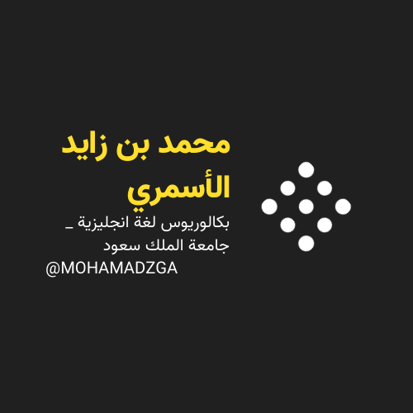

**لا تنسوني من صالح دعائكم**





**M_zaid0**