**Super Goal 2** - **Test** unit 1 & 2

Name :…………………………………………………………………… Class:…….……….

# Reading

## Read the text and answer the questions. Write T or F at the end question/statement.

2 Marks

**of each**

I like to go to the sports center. I go there every weekend. At the sports center, you can do many things. For example, you can play golf or tennis. There is a pool, so you can also swim or relax by the pool. There is a beach next to the sports center. You can swim, water-ski, or windsurf in the ocean. You can also sail on windy days.

There aren’t any fish near the beach, so you can’t snorkel. When I go to the sports center, I like to play volleyball on the beach. I also like to jog on the beach. I can’t swim well, so I don’t like to water-ski or windsurf.

|  |  |  |
| --- | --- | --- |
| 1. At the sports center, you can do many things. | ( | ) |
| 2. You can swim in the pool or in the ocean. | ( | ) |
| 3. People can windsurf in the pool. | ( | ) |
| 4. You can sail on windy days in the ocean. | ( | ) |

# Grammar

## Choose the best answer to fill in the blank in each question.

1. Who that girl?
   1. am **b**. is **c**. are **d.** i
2. **John:** your friend? - **Adnan:** He is in the restaurant.
   1. How’s **b**. What’s **c**. When’s **d.** Where’s
3. It a beautiful day today**.**
   1. is **b**. are **c**. not **d.** am
4. in that new TV film?
   1. He acting **b**. He are acting **c**. Is acting **d.** Is he acting
5. What is he eating ? - he's an apple .

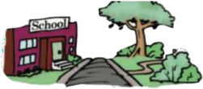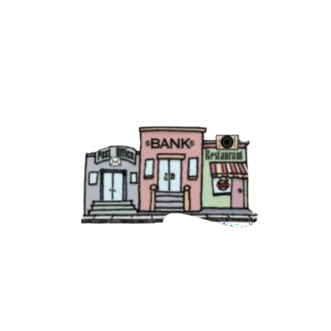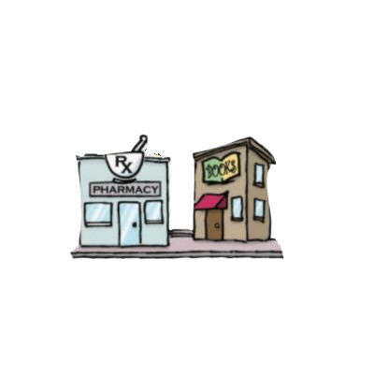

* 1. eat **b**. is eat **c**. eating **d.** ate

## Use ( across from – next to – between )

1. The park is the school .

5 Marks

* 1. Marks

1. The bank is the post office and the restaurant .
2. The pharmacy is the bookstore .

## Write the imperative sentence.

1.5 Marks

1. Will you clean up this mess?
2. Why aren’t you eating your vegetables?
3. You can’t take photographs.

# Vocabulary

## Choose the best answer to fill in the blank in each question.

5 Marks

* + 1. Thank you !
       1. You’re welcome. **b**. He’s from Muscat. **c**. That’s all right. **d.** Hi
    2. What is your country ?
       1. Fine thank you **b**. I'm 13 years old **c**. Nice to meet you **d.** I'm from Saudi Arabia
    3. Many young people traveling around the world are .
       1. old people **b**. backpackers **c**. teachers **d.** business men
    4. What is Ali doing ? - He’s soup .
       1. making **b**. breaking **c**. writing **d.** talking
    5. sometimes use webcams in the classroom.
       1. Students **b**. Teachers **c**. Farmers **d.** business men

## Write the correct word under the picture.



coffee shop – Webcam – Turn Right

3 Marks



…………………………………………. .…………….…………………………… ……….…….…….……………….

## Choose the correct letter.

2 Marks

* See you tomorr…..w. ( o – y – r )
* I don't he….r anything. ( t – a – r )