

English Language

elementary Grade …..

1st period Exam

…………….\20

Kingdom of Saudi Arabia

Ministry of Education

………………… School

Student's Name : class:

|  |
| --- |
|  |
| 5 |

**A-Choose the correct answer.**

|  |  |  |  |  |
| --- | --- | --- | --- | --- |
| her | my | his | This is our little brother. ……..name is Ahmad. | 1 |
| she | I | mine | Whose shoes are these? - They're ………….. | 2 |
| has | are | have | He …………. a new bag. | 3 |
| cutest | cuter | cute | A dolphin is ………………………... | 4 |
| slowest | slower | slow | A snail is the …………………… | 5 |

|  |
| --- |
|  |
| 2 |

**B- reorder.**

1- cook \ you \ Can \ ?

………………………………………………………………………………………….………

2- have \ Thay \ a car.

……………………………………………….………………………………………………….

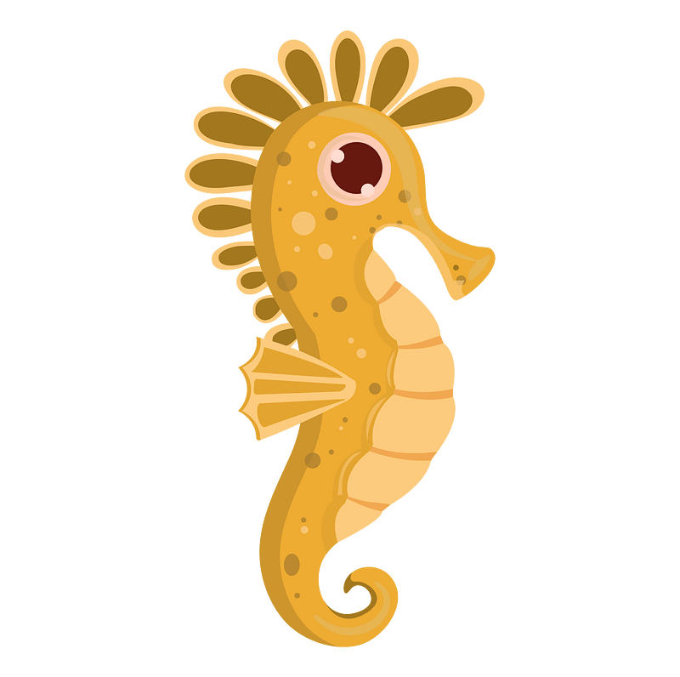**C-Answer the question.**

1-what's that ?

|  |
| --- |
|  |
| 3 |

It's a ( seahorse - fish - sharks ).

2-What are those?

Those are ( crocodile – seagull - baby seals).

3-What‘s that?

it's a ( squid – crab – squid ).

|  |
| --- |
|  |
| 3 |

**D.Match**

|  |  |  |  |
| --- | --- | --- | --- |
| Nice to meet you, too . |  | What's your name? | 1 |
| I live in Jeddah. |  | Nice to meet you . | 2 |
| My name is Ali. |  | Where do you live? | 3 |

|  |
| --- |
|  |
| 4 |

**E. Write the correct words under each picture**

Sleep goat rice turtle



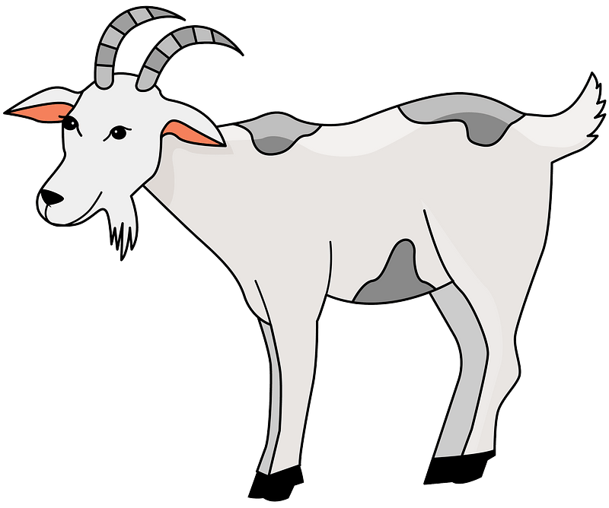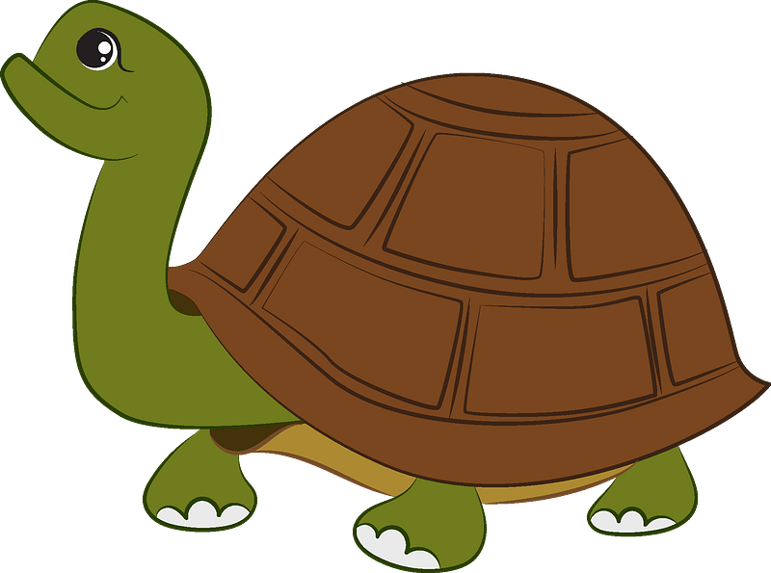

……………………….ر

……………………….ر

……………………….ر

……………………….ر

**F.Complete the missing letters.**

ee ay ou oa

|  |
| --- |
|  |
| 4 |



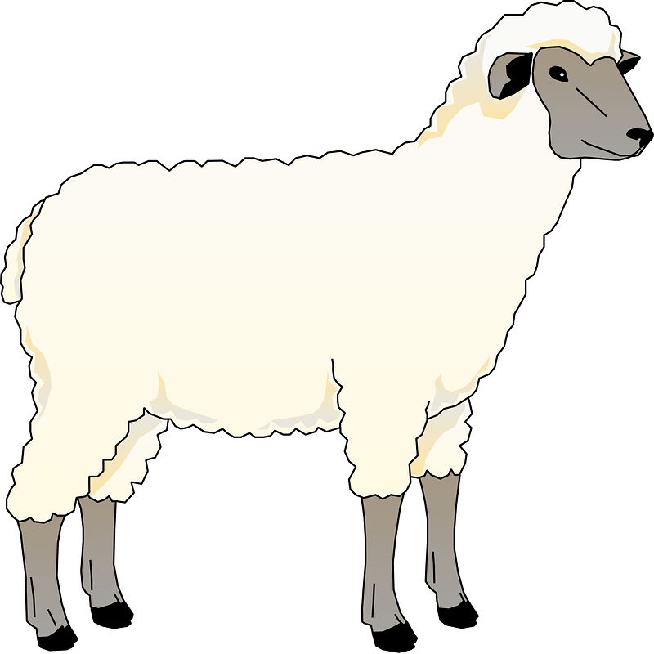



H…….se

Pl………

Sh……..p

C…….t



Your teacher: