Unit 2 [ Life Stories ]

I. Vocabulary

***A) Match the word and picture correctly:***

1. infant 2. donate 3. gather

C:\Program Files\Microsoft Office\MEDIA\CAGCAT10\j0233018.wmf

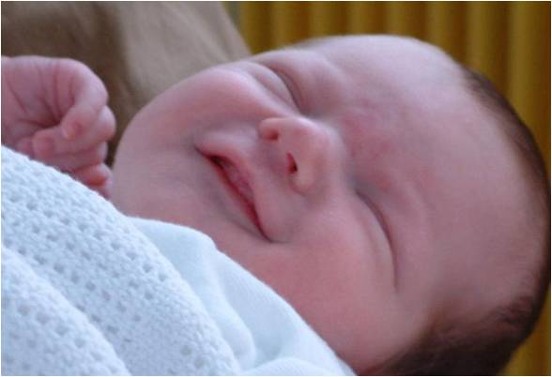

***B) match each word to its meaning:***

( A ) ( B )

1. infant ( ) support someone to succeed
2. donate ( ) take away stress and pain
3. outstanding ( ) throwing waste material around
4. twin ( ) give to charity
5. encourage ( ) important opportunity
6. effort ( ) get together / meet
7. big break ( ) newborn / baby
8. litter ( ) two persons who looks exactly alike
9. gather ( ) excellent
10. relief

***C) Choose the correct word to complete each sentence:***

[ used to - operation - not into - big break - donations - employee - a cripple ]

What about – turn up - principal - abroad – twins – into]

1. I didn't see the match. I'm ……………………………… football.
2. When I was a kid I ……………………………………………… play with dolls.
3. Our ………………………… is very strict about students' attendance.
4. It is wrong to make fun of ………………….. .
5. That's Mr. Adnan today is his first day with us. He is a new ……………………………………… .
6. Our religion encourages us to give ……………………………………… to others.
7. After high school Nada plans to travel to study .............................. .
8. Adnan and his brother look exactly alike. They are ………………………… .
9. They could ………………………………any time, they love surprises.
10. Har ……………………………… came when she won the coding competition.
11. Nada is really …………………………… make up.
12. I know you plann to take a course but ……………………………… travelling to France instead.

* ***Past Simple***

They

We

You

I

He

She

It

***+***  V+ ed +

Did?

**Fatima** cooked **dinner. They** ate **fish.**

**Fatima** didn't cook **dinner. They** didn't eat **fish.**

Did **Fatima** cook **dinner?** Did **they** eat **fish?**

***What*** Did **Fatima** cook**? *What***Did **they** eat**?**

1. ***Choose the correct word:***
2. Nada [ visit – visits – visited ] her aunt last week.
3. They played football 2 days [ everyday – next - ago].
4. I [ sleep – sleeps – slept ] early yesterday.
5. We [ meet – meets – met ] Amal 5 years ago.
6. Ali [ watch – watches – watched ] a movie last night?
7. I didn't [ drink – drinks –drinking ] milk yesterday.
8. **Do as shown between brackets:**
9. Amal ( buy ) a book yesterday. [ Correct the verb ]

…………………………………………………………………………………………………………………………………………………………

1. Ali ( drive ) to Riyadh last month. [ Correct the verb ]

………………………………………………………………………………………………………………………………………………………………

1. I [ have ] lunch with my friends last week. [ Correct the verb ]

…………………………………………………………………………………………………………………………………………………………

1. They visited their grandmother ***last week***. [ Form a Wh- question ]

……………………………………………………………………………………………………..…………………………………………………

1. Sami went to Rome two years ago. [ Form a Yes/ No question ]

………………………………………………………………………………………………………………………………………………………

1. Noura attended a lecture 2 days ago. [ Form a Yes/ No question ]

………………………………………………………………………………………………………………………………………………………

1. I went to ***the mall*** yesterday. [ Form a Wh- question ]

……………………………………………………………………………………………………………………………………………………

* ***Used to***

He

She

It

I

We

You

They

***S + used to + V …………***

***I used to******play******with dolls*.**

***I didn't use to play with dolls*.**

***Did you use to play with dolls*?**

1. ***Choose the correct word:***
2. They [ use to –used to – used ] use cell phones.
3. Ahmad didn’t use to [ help – helps – helped ] poor people.
4. The boys used to [ buy – bought - buys] ice cream after school.
5. I used to [ sleep – sleeps – slept ] late.
6. I didn't [ use to –used to – used ] play football when I was 6 years old.

1. ***Do as shown between brackets:***
2. They used to ***play tennis*** on Tuesday. [ Form a question ]

…………………………………………………………………………………………………………………………………………

1. Ali used to go to the beach every week. [ Change into negative ]

…………………………………………………………………………………………………………………………………………

1. Mona used to chat on line. [ Form a Yes / No question]

…………………………………………………………………………………………………………………………………………

1. Amani used to like ***pasta***. [ Form a Wh- question ]

…………………………………………………………………………………………………………………………………………

1. We didn't use to go school ***on Thursday***. [ Form a Wh- question ]

…………………………………………………………………………………………………………………………………………

* Be + Born

Was Were

We

You

They

He

She

It

I

I was born in Jeddah. They were born in Abha.

I wasn't born in Jeddah. They weren't born in Abha.

Were you born in Jeddah? Were they born in Abha?

1. ***Choose the correct word:***
2. We [ are – was – were ] born in Saudi Arabia.
3. Nick [ is – was – were ] born in New York.
4. Those students [ are – was – were ] born in Tokyo.

1. ***Do as shown between brackets:***
2. They were born in Madrid. [ Form a Yes / No question ]

…………………………………………………………………………………………………………………………………………

1. Ali was born in Cairo. [ Change into negative ]

…………………………………………………………………………………………………………………………………………

1. She was born in Riyadh. [ Form a Wh question ]

…………………………………………………………………………………………………………………………………………

1. We [ be ] born in Jeddah. [ Correct the verb ]

…………………………………………………………………………………………………………………………………………

* Preposition of time

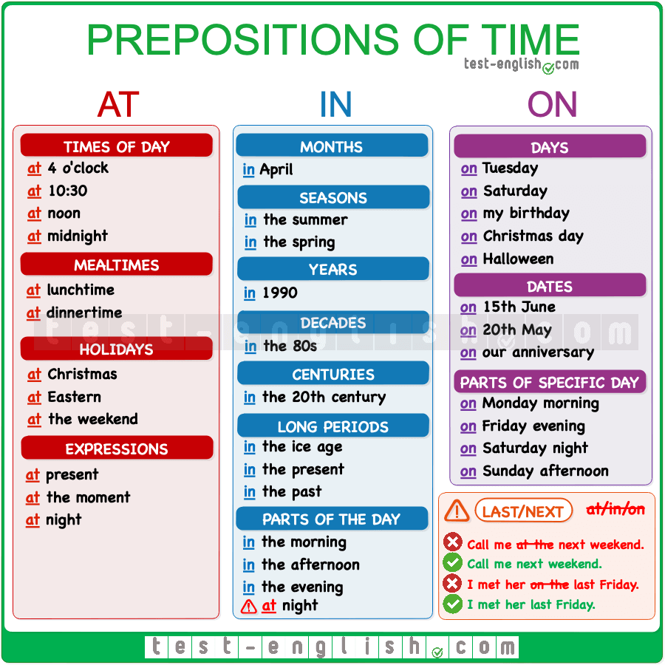

1. ***Choose the correct word:***
2. I saw Amal [ in – on – at ] the morning.
3. The twins were born [ in – on – at ] Tuesday.
4. The internet was invented [ in – on – at ] 20th century.
5. The arrived home [ in – on – at ] midnight.
6. My sister got married [ in – on – at ] 1442 H.
7. They are going to leave [ in – on – at ] Monday.

* Dictation

1. *relie***f 2.** a**b**road 3. cripp**l**e 4. tw**i**ns