

English Language

Intermediate Grade 2nd

1st period Exam

Kingdom of Saudi Arabia

Ministry of Education

………………… School

Student's Name : class:

|  |
| --- |
|  |
| 5  5 |

**1-Read the following e-mail then answer the questions below:**

Dear Salem,

I would like to tell you about my last winter vacation. I travelled to Morocco with my family. Morocco is a wonderful country in North Africa. It is famous for its high mountains. My family booked a hotel in a small village in Al-Atlas Mountains. We stayed there for a week. The views were wonderful. We watched the snow falling. After that, we went skiing in the mountains. On the next day, we went to the market to buy some presents for our friends. We bought some colorful wool rugs. The people were so **friendly** there. I advise you to visit Morocco soon.

Yours sincerely,

Rashid

|  |  |  |
| --- | --- | --- |
| 1- The best title for this email is: | | |
| c- The weather in Jordan | b- The weather in Oman | a- The weather in Morocco |
| 2- I travelled to Morocco with my ………………….. | | |
| c-cousins | b- family | a-friends |
| 3- Morocco is a wonderful country in …………. | | |
| c- North Africa | b- South Africa | a- East Africa |
| 4- We stayed in Morocco for …………. | | |
| c- a year | b- a month | a- a week |
| 5- The meaning of the word "friendly" in the last line is: | | |
| c- sad | b-hungry | a- welcoming |

**2-Choose the correct answer**

|  |
| --- |
|  |
| 5  5 |

1- I ( isn't – aren't – am n't ) doctor.

2- Sara is ( make – makes – making ) a cake.

3- Who ( is – are – am ) your teacher?

4-(open – opening – opened ) the book please.

5- Aisha and Fadwa ( is -are – am ) at the mall.

6-( How – what – where ) old are you?

7- The pizza ( smell – smells - smelling ) good.

8- Riyadh(is – are – am )in Saudi Arabia

9- I (liking – likes - like )martial arts films.

10- Don't ( eat – eats – eating ) junk food.

**3. Do as shown between brackets.**

|  |
| --- |
|  |
| 5  5 |

**A-( Correct )**

1**- when** is your name? …………………….……

2-I **wanting** a new cell phone. …………………

**B-(Give a short answer)**

a- is he a doctor ?

No,………………………………………………………...…..

**C-(make a Yes or No question)**

1-They are working now.

………………………………………………………………....…..?

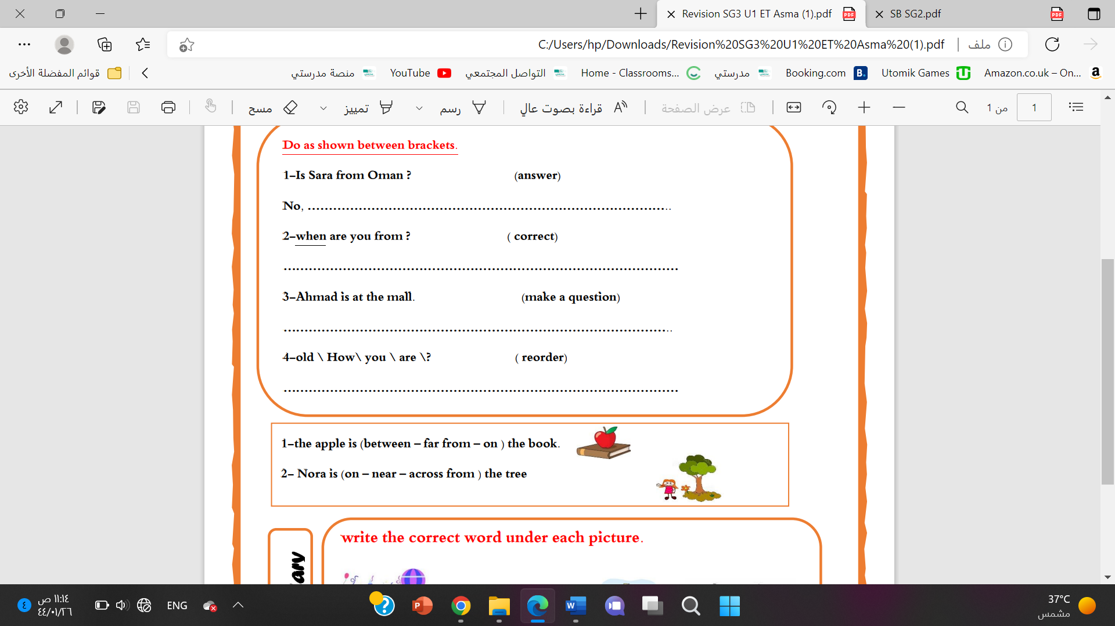a**-**Mahmoud isn’t in the kitchen.

…………………………………………………..………….………?

**D-(Choose)**

a- Nora is (on – near – across from ) the tree

b-The thieves are getting (in front of – away ) in a fast car.

**4-choose the missing letter**

1-During his summer ……acation, he visited Dubai. ( v - a - d )

|  |
| --- |
|  |
| 5 |

2-I had just returned from the Cannes Film Fe….tival. ( q - s - w )

**5- write the correct word under each picture.**

Webcam elevator volcano castle

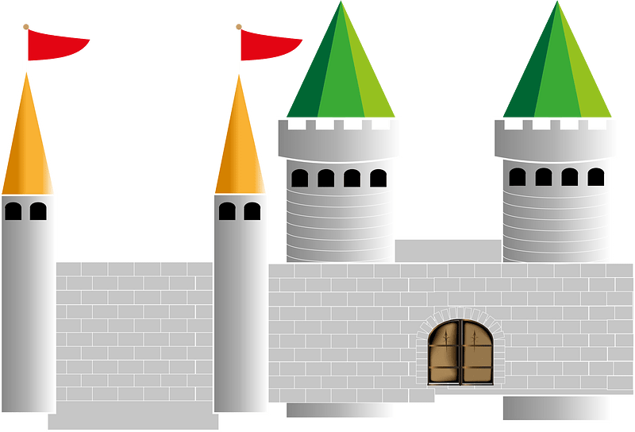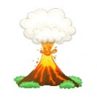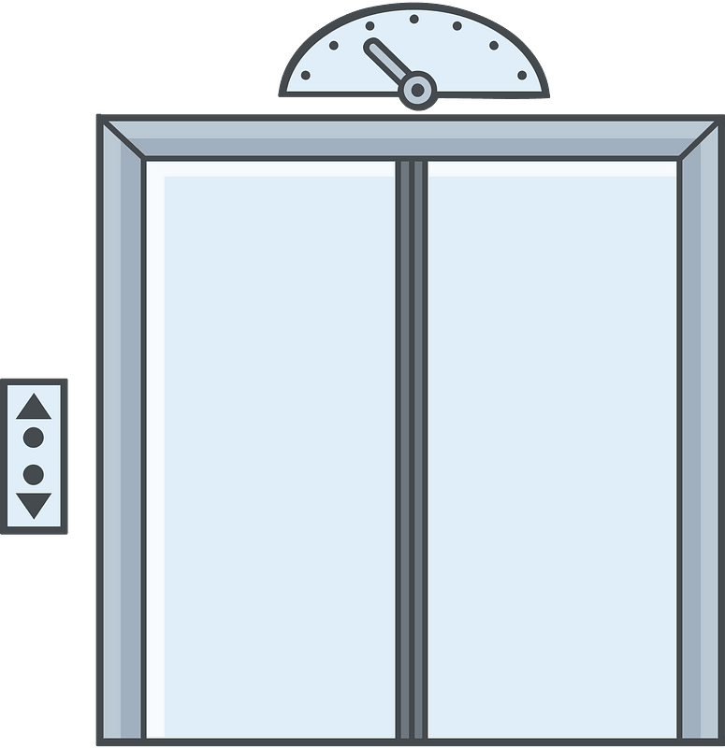

……………….

……………….

……………….

……………….

Best of luck

Your teacher:

Your teacher: