Kingdom of Saudi Arabia  Ministry of Education  Tabuk Education Directorate  21st Intermediate School  اختبار مادة اللغة الإنجليزية الصف الثالث متوسط الفصل الدراسي الأول (الدور الأول) 1442-1443 |  | English Language  …..3rd Intermediate Grade  1st Term Exam 1442 -1443  Time: 2 hours
Name/ ………………………………… | Class / …………… | Seat No./ ……………………………

Student’s Mark Written | Student’s Mark Number | Question |  | Number
 |  | Mark | Question
 |  | 6 | Composition | Q1
 |  | 6 | Reading Comprehension | Q2
 |  | 8 | Grammar | Q3
 |  | 6 | Vocabulary | Q4
 |  | 4 | Orthography | Q5
 |  | 30 | Total Written Tasks

Sign | Name | Corrected by
Sign | Name | Revised by
Sign | Name | Checked by

Page 1

اختبار الصف الثالث متوسط الفصل الدراسي الأول ( الدور الأول) 1442-1443

6

Q1 / Composition

A)-To maintain a healthy life style, you need a few steps. Read the diagram below,
then write a correct paragraph:
Avoid eating
Junk food
Drink
Too much water
Add fruits
And vegetables

Healthy
Lifestyle

Stay with
Positive people
Keep eating
Healthy

Go to
the gym

To maintain healthy life style ,………………………………………….

……………………………………………………………………………………

…………………………………………………………………………………..

…………………………………………………………………………………

…………………………………………………………………………………

…………………………………………………………………………………..

……………………………………………………………………………………

……………………………………………………………………………………..

Page 2

اختبار الصف الثالث متوسط الفصل الدراسي الأول ( الدور الأول) 1442-1443

6
Q2 - Reading Comprehension

Read the following passage and choose the correct answer below:
Forest , forest , what have they done to you?
They cut your trunks and cut your branches
They said they needed you for ranches
Look what they have done to you

But we can save the birds and the bees,
Mountains, rivers , flowers , and trees
It is a problem that we all must face
If we all just do our share .

Parrot, parrot , what have they done to you?
They put you in a cage and made you talk
They cut your wings and make you walk
Look what they have done to you

River, river , what have they done to you ?
Your crystal waters no longer flow
The fish and lilies no longer grow
Look what they have done to you.

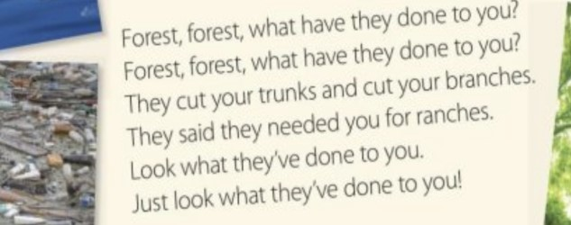
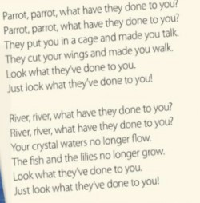

-1- What happened to the parrot?

They put it in ... [ a –cage b- car c- bed ]

2- Is the water in the river clean?..............

[ a - yes, he is. b- No, it is not c- yes, they are ]

3- Why did they cut the trees down? Because they need them for …..

[ a- read b- food c- ranches]

4- [They] refers to …………………

[ a- people b- children c- cars ]

5- bees are a kind of ………………….

[ a – insect b- flower c- farm ]

6- A kind of flower ………………..

[ a- sweet b- lilies c- meat]
Page 3

اختبار الصف الثالث متوسط الفصل الدراسي الأول ( الدور الأول) 1442-1443

8
Q3 – Grammar

Choose the correct answer

7- I eat a ………..carrots

[ a – little b- few c- am ]

8- I go to school ……..7 a.m

[ a – in b- on c- at ]

9- I rarely ……..coffee

[ a – drink b- drinks c- drinking ]

10- I used to …………. With toys.

[ a – play b- plays c- bought]

11- …………..milk do you drink?

[ a – How much b- How many c- Where]
12- I do not have ……..for lunch.

[ a- something b- some c- anything ]

13- He likes to look at ……in the mirror.

[ a – herself b- himself c- myself ]

14- Both of them …………science

[ a- teach b- teaches c- teaching ]

Page 4

اختبار الصف الثالث متوسط الفصل الدراسي الأول ( الدور الأول) 1442-1443

6
Q4- Vocabulary

Choose the correct answer
15- Some one who exercise a lot is ……

[ a- exercise freak b- old c- anyway ]

16-Prince Sultan flew abroad the space shuttle……..

[ a - infant b- Discovery c- donate ]
17- King Salman became the king on ……..23 , 2015

[ a- September b- October c- January ]
18-The opposite of the word [ poor] is …….

[ a- busy b- rich c – nice ]
19- My teachers are ………..helpful.

[ a- extremely b- Huge c- excuse me ]
20- The odd word is ……………..

[ a – beef b- yogurt c- meet ]
Page 5

اختبار الصف الثالث متوسط الفصل الدراسي الأول ( الدور الأول) 1442-1443

4
Q5- Orthography “Spelling”

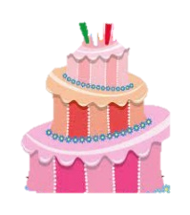
Choose the correct spelling
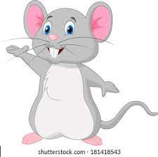
21- This is a ……….

[ a – cake b- ceeku c- kace ]
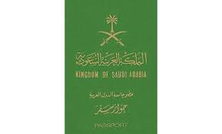

22- The Saudi ………is green

[ a – possrt b- passport c- pass ]

Choose the missing letters:

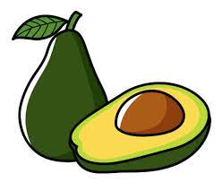
23-I like avoc….o

[ a- rd b- ad c- dd ]

24- This is my tic….t

[ a-ka b- ce c-ke ]

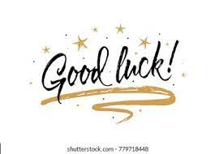

انتهت الاسئله

T.AFAF

Page 6

