Name / ………………………………………………………….. Midterm 3rd grade

***Q1 - Read the following paragraph then answer the questions below:***

Let me tell you about my best friend, Ali. Ali and I went to the same elementary school. He was born in Jeddah. He was grew up in Abha. He was educated in a privet school. He has three brothers. He used to play with football. We started going to the intermediate school in 1991. He likes reading so, He usually spends most of his free time reading short stories.

A-Choose the correct answer :

Where was Ali born ? a Jeddah - Makkah - Riyadh

-He was educated in : Dammam - privet school – Hail

b-( 🗸 ) or ( 🗴 )

-Ali likes swimming ( )

-He spent his free time in reading ( )

_______________________________________________________________________________________________

***Q2 -Grammar – Choose the correct answer***

?a- Does ............... usually drink coffee

She - you - they

b-The students ...................... study hard , can easily pass the exams

Which - who – where

of the 3 books are not mine.........................c-

Both - Neither - none

.d-I ................play video games

used to - use to

_____________________________________________________________________________________

***Q3-a-Vocabulary - choose the correct answer***

**exercise freak ) =**  a big city - exercise a lot - gave to charity **)**

***b- write the correct word under the picture :***

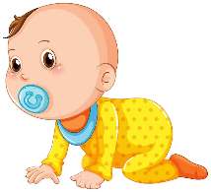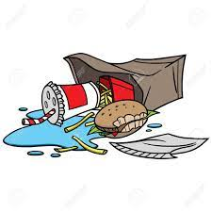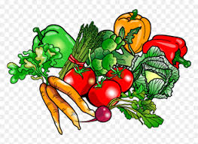Litter - infant - vegetarian - puzzle

---------------------------------- ---------- ------------------------- ----------------------------- -

***Q4- choose the correct spelling ;***

a-Rahaf is a health food fan...tic ( a - t - m ) b-He dona...ed blood ( a - t - n )