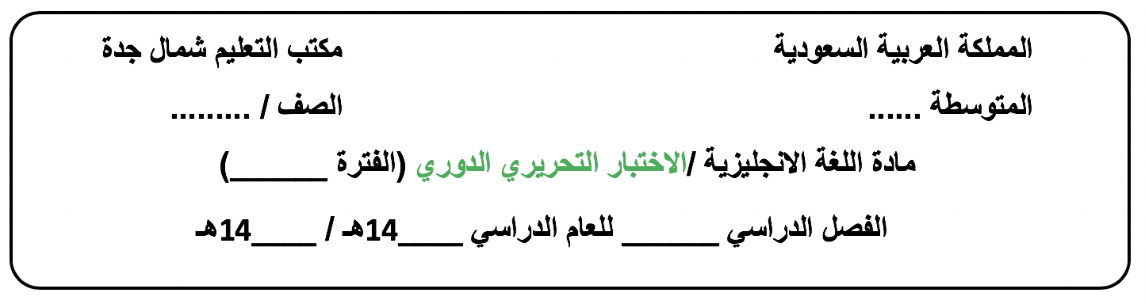

**الثالث متوسط**

**الأولى الوحدة 1**

B

**44**

**43**

**الأول**

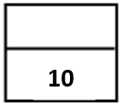**Day/ ………………………. Date/ …… / ….. / 1444H**

**Name /…………………………………………………………………..…………….Class/ 3 - …….**

**-------------------------------------------------------------------------------------------------------------------------------------------------------------------------------------------**

**Vocabulary: ½ for each**

|  |
| --- |
| **A. Choose the correct answer:** |
| 1.They’re doing exercises to improve their……………………………  a-herbal b- addict c-thumb d-fitness |
| 2. Work hard but don't…………………..it  a-overdo b-solve c- help d-grow up |
| 3.I'm trying to…………..this problem.  a- enjoy b- work out c-solve d-play |
| 4.Khaled never eats meats.He’s …………………………………..  a-popular b-vegetarian c-proud d-different |
| 5.Saeed always works on the weekend.He’s …………………..employee.  a-lazy b-kind c- devoted d-unfaithful |
| 6.Hadi works very hard .He …….takes work home from the office.  a-often b-never c-always d-sometimes |

|  |  |  |
| --- | --- | --- |
| **B. Match the word with its meaning (synonym), antonym( opposite ) or definition:** | | |
| 7.Andy is a health food fanatic.. |  | a.The meaning is the way in which a person lives. |
| 8.He works out at the gym regularly. |  | b.The meaning is to find answer. |
| 9.Omar is a bit of an exercise freak. |  | c.It means someone who exercises a lot. |
| 10.You must check your lifestyle. |  | d.The antonym is addict negatively. |
|  |  | e.It means to exercise. |

**Grammar + Orthography ½ for each**

|  |
| --- |
| **Choose the correct answer:** |
| 11. I’m downloa__ing the pictures now.  a- ( m ) b- ( d ) c- ( k ) d- ( s) |
| 1. Does he usu__lly play football on Sunday ?   a- ( o ) b- ( e ) c- ( i ) d- ( a ) |
| 13.Do you always sleep late ? **(Grammar )**  a-No, you do. b-No, I doesn’t. c-Yes,I don’t . d-No, I don’t. |
| 14.They don’t ……….the dishes.It’s not their job .  a-did b-do c-does d-doing |
| 15.Khaled and Ali speak English. of them speaks Chinese.  a-All b-Neither c-None d-Both |
| 16.My grandpa …………. watching documentaries.  a-loving b-is loving c-loves d-loved |
| 17……………you fight with your sister every day ?  a- Do b- Does c- Did d-Are |
| 18.   1. Seldom exercises he.   b- Exercises seldom he.  c- He seldom exercises.  d- He exercises be seldom. |
| 19. Wasan talks to ……..every day.  a-me b- I c- my d-mine |
| 20.   1. Are them none of teachers. 2. None of them are teachers. 3. Teachers are none of them.   d- None of teachers them are. |

[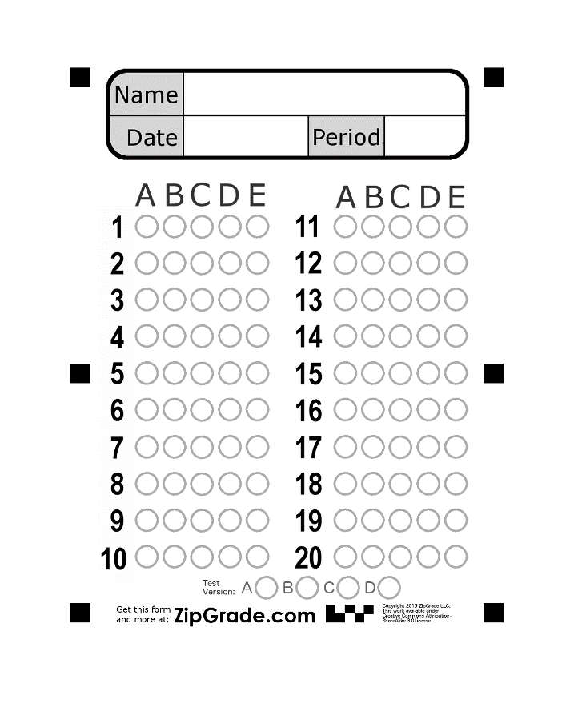](https://www.google.com.sa/url?sa=i%26rct=j%26q=%26esrc=s%26source=images%26cd=%26cad=rja%26uact=8%26ved=0ahUKEwi8veOT4vrWAhVKmBoKHaBlBy4QjRwIBw%26url=https://www.zipgrade.com/forms/%26psig=AOvVaw3T9JlY9f3gYoNV7bWnXoiP%26ust=1508436536107788)

**Good luck.**