

Kingdom of Saudi Arabia

Ministry of Education

………………… School

English Language

Intermediate Grade 1st

1st period Exam

Student's Name : class:

1-Read the following passage and answer the questions below:

Our Homeland is our own country. There are many things that make us love our homeland so much. It has the two Holy Mosques in Makkah and Madina and many historical places that remind us of the prophet Muhammad ( PBUH) . It is one of the largest and the most beautiful , enormous country. Saudi Arabia is the symbol of peace and safe because its first and main base is Islam and its great principles. We should have patriotism and be proud of this beloved homeland. Saudi Arabia is the best country in the world

Put (√ ) for the right statement or ( x ) for the wrong one:

1) Homeland is our own country. ( )

2- There are many things that make us love our country so much. ( )

3- The two Holy Mosques in Makkah and Madina are in Oman ( )

4) Saudi Arabia is one of the smallest country. ( )

5) Saudi Arabia is the symbol of peace and safe. ( )

**2-choose the correct answer**

1-I always (do - does – doing ) my homework in the afternoon.

2-Sarah (eat- eats – ate ) chocolate morning, noon, and night.

3- How ( many – old -much) time do you spend in the shower?

4- These books are all Mona’s. (All – None – both)of them belong to me.

5-( Do – Does – Are ) Saad usually watch T.V in the morning?

6-( last – ago – yesterday ) year I were in Canada.

7-Did you (live – lived – living) in Jeddah?

8-When Ali was little, I used to(played – playing- play )with toys.

9-I asked my teacher a question (last – ago – yesterday).

10-where did they ( work- worked- working) ?

**3. Do as shown between brackets.**

**A-Correct**

1-I didn’t use to **playing** video games………………………………..

2-The twins **was** born on June 21st………………………………..

3- Neither of them **like** pizza. ………………

4. How often does Ibrahim **talks** on the phone?

**B-(Reorder).**

1-you \ How often \ surf \ do \on the internet \ ?

……………………………………………………………………………………….………….

2- always \ plays tennis \ Sami

……………………………………………………………………………………………………

3-What \ do \ used to \ did \ Ahmad \?

…………………………………………………………………………………………

4- Omar \ stay \ at \ home \ didn't

………………………………….………………………………………………………

**4- Match**

|  |  |  |  |
| --- | --- | --- | --- |
| a big city |  | metropolis | 1 |
| a baby |  | relief | 2 |
| in other countries |  | encouraged | 3 |
| taking away stress and pain |  | abroad | 4 |
| supported someone to succeed |  | gathered | 5 |
| got together/met |  | infant | 6 |

**5- Write the correct word for each picture**

**Herbal twins vegetarian**

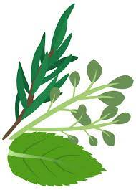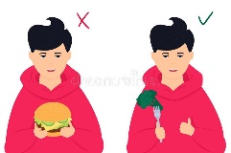

**6-choose the correct answer.**

**1-** Jake never eats meat. He’s ( an Internet addict- a vegetarian).

**2-** Ali is online all the time, even in the park!He is**(**an exercise freak-an Internet addict)

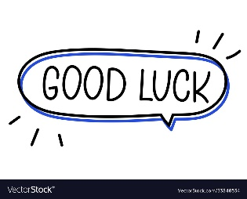

Your teacher: