**S.G.5 Unit 3 [ When Are You Leaving ]**

**1. Vocabulary**

***A) Match the word and picture correctly:***

1. Ticket 2. suitcase 3. vaccination 4. Passport 5- ID card 6- air plane

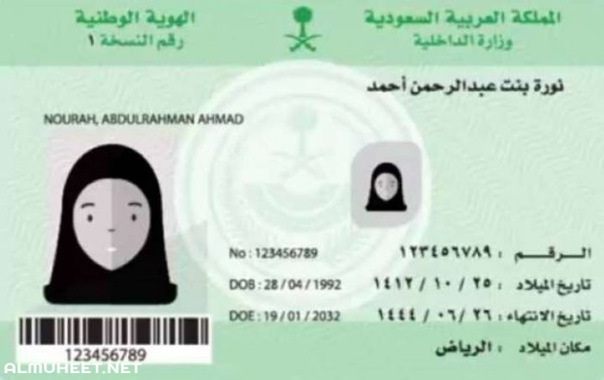



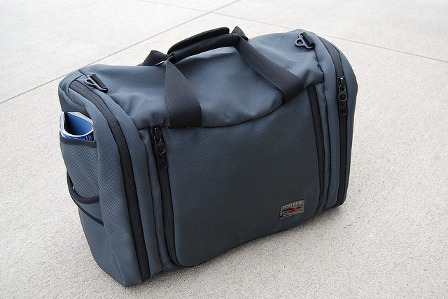

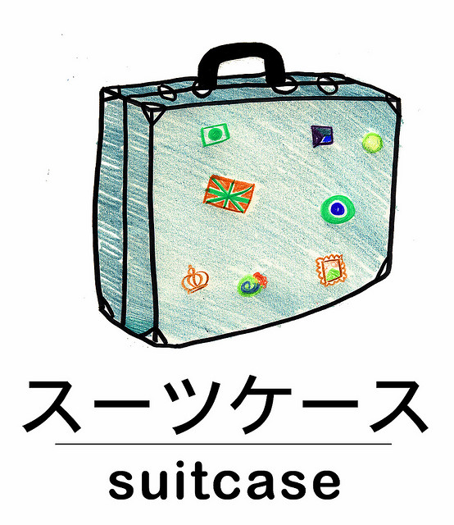

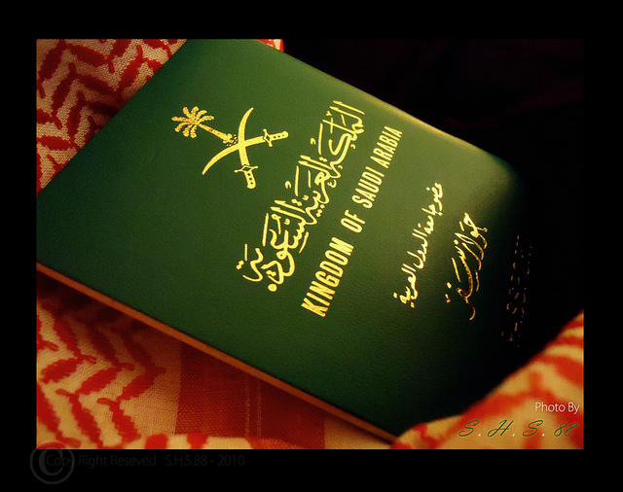

***B) match each word to its meaning:***

( A ) ( B )

1. Pretty ( 4 ) weather
2. pick up ( 2 ) learn easily
3. delayed ( 1 ) very / quiet
4. climate ( 3 ) be late

***C) Choose the correct word to complete each sentence:***

[ visa - boarding pass- tag - baggage ]

1. You need a ……………boarding pass……. to get on a plane.
2. You must have a ………………visa…………………… to enter European countries.
3. Put a name ………tag……… on your suitcase .

**2- Grammar**

***D ) Choose the correct word:***

1- They [ am leaving – is leaving – are leaving ] now.

2 –I am [ study – studies - studying] at the moment.

3- What are you doing [ yesterday – now – often ] ?

1. Samara will [ travel - travels - traveling ] to Abha next week.
2. Maybe the girls will [ cook –cooking – cooked ] dinner tonight.
3. They won't [ buy – bought – buys ] a new car next year .
4. Ali is going to [ play - plays - playing ] basketball tomorrow.
5. He went [ across – towards – out of ] the room to smoke.

**E )Do as shown between brackets:**

1. Amal is ( read ) a book now. [ Correct the verb ]

………………reading ………

1. I will travel to London next month . [ Change into negative ]

…I …wont travel ……………………..

They are waiting at ***the airport***. [ Form a Wh- question ]

…where are they waiting ?…………………

1. 4- I will go to the mall to buys a dress . [ Correct the verb ]

………………… buy ………………………………

F) Match the phrase with the correct time clause :

1-Take your ticket and passport with you ……3… while you are in college

2- They will probably visit musueum ……2… when they are in London

3- We are going to miss you …1…. before you leave for the airport .

Best wishes

T. Mayadh Fayhan