SG5 U.4 What do I need to buy ?

1. **Choose the correct answers :**

1- I drink **(little- few- many)** water.

2-How **(much- few -many)** milk do you drink a day ?

3- He eats **(few- little- much )** apples.

4-How **( much - -little- many)** books do you read ? 5-Ali can't buy **(nothing – something –anything )** ,because he doesn’t have money .

1. **Fill the blank with suitable words :**

**(finally – then – after that – first – so )**

……first.. , mix the flour and eggs . ….then …… add a little oil .

………after that ……………… , add a teaspoon baking powder and vanilla.

……finally ………….. , bake it in the oven .

**C) Write the correct answers (myself - her self – them selves – ourselves )**

1- I like to look at **(…myself ….)** at the mirror .

……………………………………………………………………………

2- Sara burned **( …herself….. )** when she cooked.

…………………………………………………………………………..

3- they bake the cake **(…themselves …..)** in the kitchen .

………………………………………………………………………….

1. Join the sentences by using ( So / Because )

1-Ahmad goes to a hospital . He is sick .

Ahmad goes to a hospital because He is sick . ………………………………………………………………………………………..

2-I am hungry . I ate sandwich .

I am hungry so I ate sandwich .……………………………………………………………………….

1. Match the correct picture with correct word :
2. Sea food 2-Grill 3 –diary 4- boil 5-bake 6-mix

4

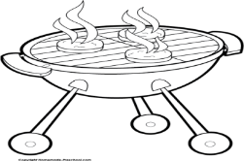 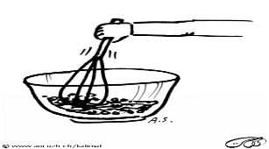 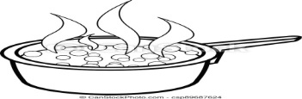 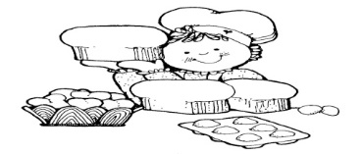 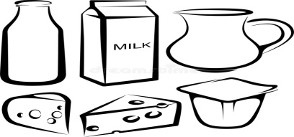 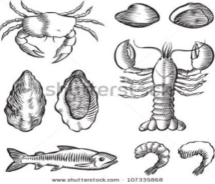

1

F)Match with the opposite :

1. Buy ( 4 ) finally
2. Healthy ( 3 )few
3. Many ( 2 ) unhealthy
4. First ( 1 ) sell

G ) Match expression with correct meaning

1-How should I cook ? ( 2 ) address 2 or more than 2

2-Hi guys ( 3 ) eager for something

3-I cant wait ( 1 ) asking for advice

**T.Mayadh Fayhan**