

اختبار فتري – الصف ..........
الاسم ثلاثي: |  | الفصل | / | الدرجة | / 20
Midterm Exam

I. CHOOSE
2
- What is your name ?
- I am 13 . | - My name is Ali .
- How old are you?
- I am fine . | - I am 10 years old .


- What is that?
- It's a seal. | - It's a whale.

222
II. CHOOSE  OR 
3

This is a computer. | The whale is small. | This is a dolphin.
 |  | 
  |   |  
2
III. DO AS SHOWN BETWEEN BRACKETS

where | whose | who | 1- ______ skirt is this? It's mine . ( Choose )
slow | scary | fast | 2. Seahorse is ___________ . ( choose)
your | my | his | 1 – I am a teacher , _____ name is Nora .
have | has | is | 2. I _____ a box
2

V. CHOOSE

6

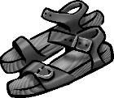 |  | 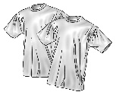 | 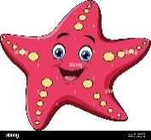 | 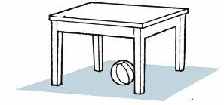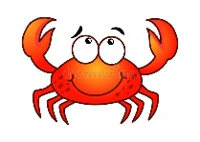 | 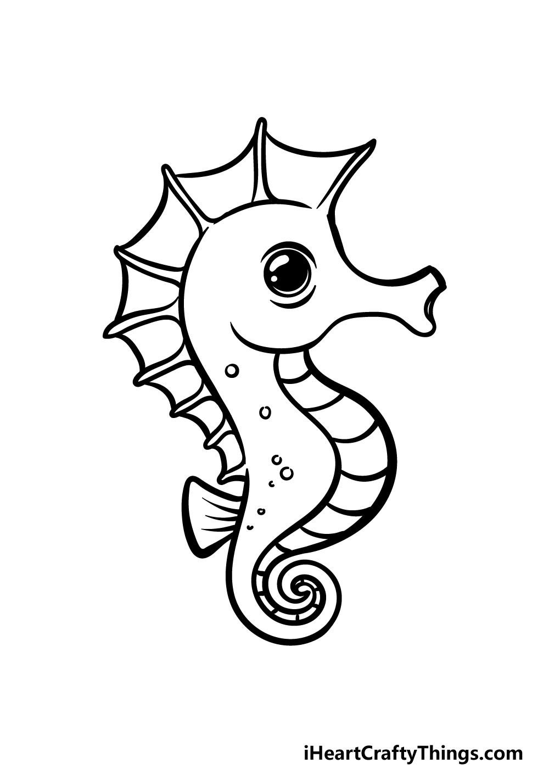
sandals | Thobe | T-shirts | starfish | fish | Seahorse
jacket | cap | Hat | cat | crab | whale
VI. CHOOSE THE CORRECT LTTER
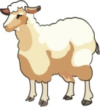  sh_ _ p | 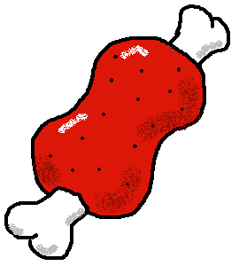  m_ _t | 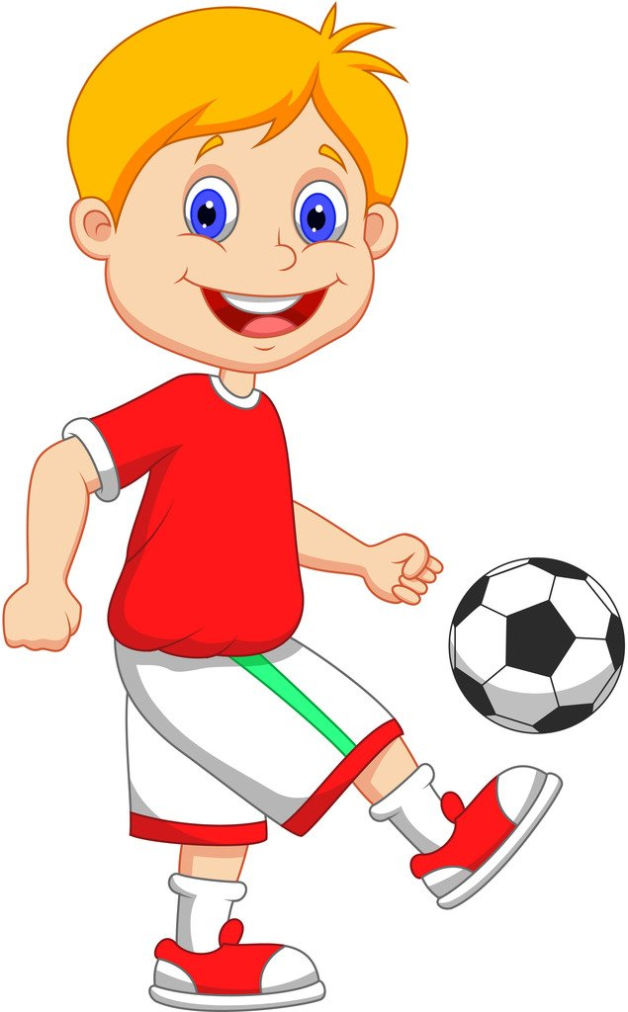  Pl_ _ | 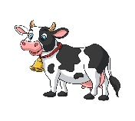  c_ _ | 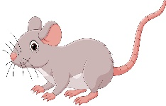  m_ _se
ea | ea | ay | ow | ow
ee | ee | ea | ou | ou
5

TEACHER :

