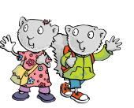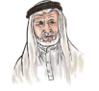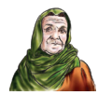

My family

The objective

**Unit : 3 Lesson : 3 page.24**

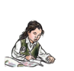

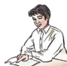

**I can match words to photos**

**Match**

|  |  |  |
| --- | --- | --- |
| **Dad** | **Grandma** | **Grandpa** |
| **sister** | **brother** | **Mom** |

|  |  |  |
| --- | --- | --- |
|  |  |  |
|  |  |  |
|  |  |  |
|  |  |  |

**Teacher \ Zuhra Hattan** 