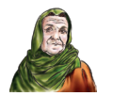

**Unit : 3 Lesson : 4** page**.26**

My family

**The objective:**

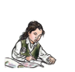



**I can recognize and supply missing letters and words.**

**Match**

|  |  |  |  |  |
| --- | --- | --- | --- | --- |
|  |  |  |  |  |

|  |
| --- |
|  |
|  |
|  |
|  |
|  |

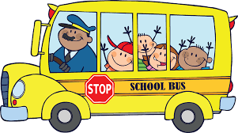 **Teacher \ Zuhra Hattan**

**Teacher \ Haleema Al-Mahmoudi**