

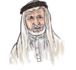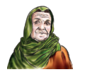

My family

**The objective:**

**Unit : 3 Lesson : 4** page**:26**

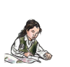

**I can recognize and use the articles**

**(A & An).**

**Choose**

|  |  |
| --- | --- |
| **A** | **An** |

|  |  |  |
| --- | --- | --- |
|  |  |  |
|  |  |  |
|  |  |  |
|  |  |  |
|  |  |  |

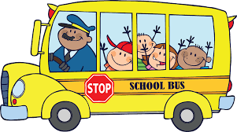 **Teacher \ Zuhra Hattan**

**Teacher \ Haleema Al-Mahmoudi**