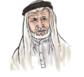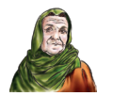

The objective:

My family

**Unit :3 Lesson : page.**

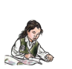



Ican ask and respond to basic questions**.**

**Complete the dialougue :**



**It's a C.**

**Nice to meet you .**





**What's this letter?**



**Who is this ?**



**This is my friend , Ted.**

**Nice to meet you , too.**

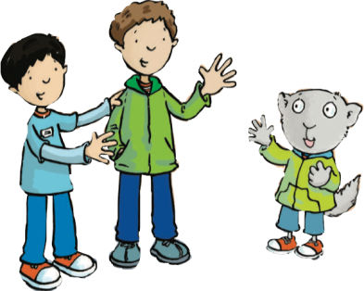

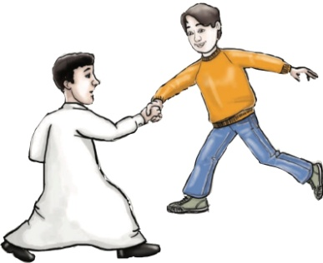

**c**

**Teacher : Reefa Al-Otaibi**