
Kingdom of Saudi Arabia Prince Abdulmajeed Intermed. School

Ministry of Education 1st term 1st Final Exam 1443 H
Aljouf Educational Directorate (Boys) Second Intermediate Grade
Domat Aljandal Educational office Time: 2 hours

أسئلة اختبار مادة اللغة الإنجليزية للصف الثاني المتوسط
اسـم الطالب : ....................................................... الصف: الثاني متوسط ( )
اليوم : الاثنين التاريخ : 17 / 4 / 1443 هـ رقم الجلوس : ................

رقم القاعة :............................ الدور : ( الأول ) عدد الأوراق : 3

Items | Marks in numbers | The deserved  mark | Teacher's Sign | Reviser's Sign
Guided Composition | 6
Reading Comprehension | 6
Grammar | 7
Vocabulary | 7
Orthography | 4
Total Mark | 30
Listening Comprehension | 10
Final marks | 40

6
Writing

Write a paragraph about yourself
………………………………………………………………………………………………………………………………………
………………………………………………………………………………………………………………………………………
………………………………………………………………………………………………………………………………………
………………………………………………………………………………………………………………………………………
………………………………………………………………………………………………………………………………………
………………………………………………………………………………………………………………………………………

6

Reading Comprehension

My name's Faisal. I'm nineteen years old. I come from Jeddah but I live in Tabuk. It is a big and a modern city. I'm a student and I go to Tabuk University. I have three brothers, Osamah, Ahmad and Yasser. They like playing basketball. I have a sister. Her name is Sara. She likes drawing. I love football! I play every weekend.

- Choose the right answer:
- Faisal is ( 11 – 15 – 19 ).
- Faisal lives in ( Tabuk – Amman – Aljouf ).
- Faisal is ( teacher – student – doctor )
- He has ( one – three – nine ) brothers.

- Put (T) for True or (F) for False:
- Faisal's sister likes swimming. ( )
- Faisal loves football. ( )

7
Grammar

Choose the correct words:
1- My brother ( am – is - are ) a good swimmer.
2- We are ( reading – speak – listen ) a book now.
3- I ( playing – played – play ) tennis every day.
4- I know how to (writing – write – wrote ) stories.
5- I can't pay. I haven't got ( any – an – the ) Money.
6- I can't stand ( go – went – going ) to the cinema.
7- Tom ( where – who – when ) is 76, has just retired.
8- ( What – Where - When ) is your name ?

7
Vocabulary

Vocabulary

A-Write the suitable word under the right picture:

( waiter – lettuce – cameraman - credit card )
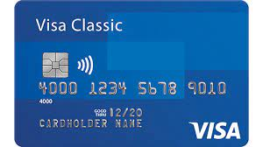


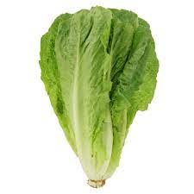

……………………… ……..……………….. …………………… ………………….…..

B-Choose the right word:
- I live in this ( hospital – house – school )
- King Fu is ( martial art – math – English )
- The ( teacher – engineer – pilot ) landed the plane safely.

Orthography

Vocabulary

4

Write the missing letters :

1- nat…onality ( i – n ) 3- colle…e ( g – p )
2- l…cation ( i - o ) 4- e…ercise ( s – x )

good luck
Muyidi Your teacher

