

12

**Kingdom of Saudi Arabia English Language Final Exam**

**Ministry of Education The Second Trimester,1st Session, 144**

**General Directorate of Education in Makkah The 2.1 Secondary Grade**

**South Education Office Time: 2 hours & 30 m**

**14th Secondary School No. of pages: 3 Questions: 4**

6

**I- Composition**:

**A- Guided Composition:**

**Write about [ Socializing Online & In Person]** .**Use the given words**

Different-emotion-understand-mental health-talk -advantages-dis advantages-comfortable -

**Socializing Online & In Person** …………………………………………………………………………………………………………………………………………………………………………………………………………………………………………………………………………………………………………………………………………………………………………………………………………………………………………………………………………………………………………………………………………………………………………………………………………………………………………………………………………………………………………………………………………………………………………

……………………………………………………………………………………………………………………………………………………………………………………………………………………………………………………………………………………………………………………………………………………………………………………………………………………………………………………………………………………………………………………………………………………………………………………………………………………………………………………………………………………………………………………………………………………………………………………………………………………………………………………………………………………………………………………………………………………………………………………………………………………………………………………………………………………………………………………………………………………………………………………………………………………………………………………………………………………………………………………………………………………………………………………………………………………………………………………………………………………………………………………………………………………………………………………………………………………………………………………………………………………………………………………………………………………………………………………..……………………………………………………………………………………………………………………………………………………………………….………………………………………………………………………………………………………………………………………………………………………………

**B- Free Composition:**

6

**Write an essay about 1-(Crime you have read ) Or**

**2-(Book Review That You Have Read )**

…………………………………………………………………………………………………………………………………………………………………………………………………………………………………………………………………………………………………………………………………………………………………………………………………………………………………………………………………………………………………………………………………………………………………………………………………………………………………………………………………………………………………………………………………………………………………………………………………………………………………………………………………………………………………………………………………………………………………………………………………………………………………………………………………………………………………………………………………………………………………………………………………………………………………………………………………………………………………………………………………………………………………………………………………………………………………………………………………………………………………………………………………………………………………………………………………………………………

**II -Grammar:**

6

**A-Choose the correct answers:**

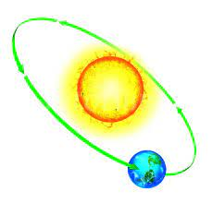1- Is your coffee [enough hot- hot enough-hot extremely]?

2-​ His parents booked [ him a new hotel- a new hotel him- a new him hotel ]

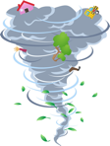3- [ A- An -The ] Earth orbits [ a- an -the ] Sun.

4- We will [encountering- encounters- encounter] a tornado next month.

5- I would [declined-decline-declines] my appointment.

6- The T.V needs to be [ fixes-fixin-fixed]

**B-Do as shown between brackets:**

[Write ***D.O.*** for the direct object and ***I.O.*** for the indirect ones ]

1--The judges give the winner SAR 100,0.

2- name / his / know / scarcely / I / . [Unscrambled the words]

…………………………………………………………………………………………………………………………………………………………………….

|  |  |
| --- | --- |
| Past Progressive | Past Perfect |
|  |  |

3 –

Was arresting - had assumed - installed

[ Classify the words]

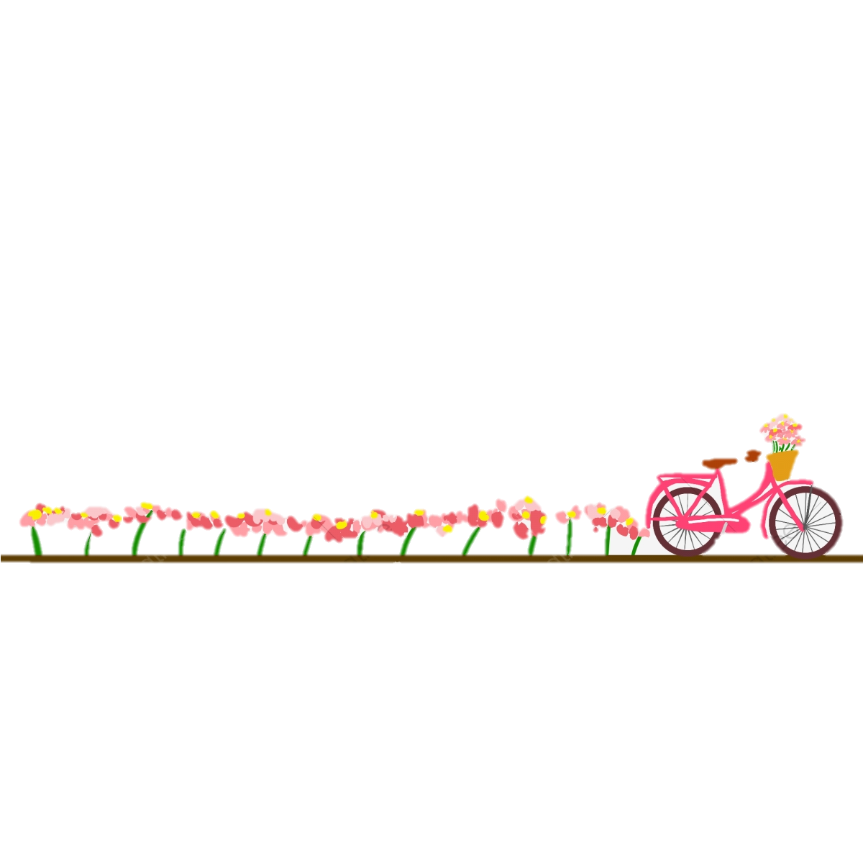

6

**III- Vocabulary:**

**A-Match between the words and their pictures:**

**1-**

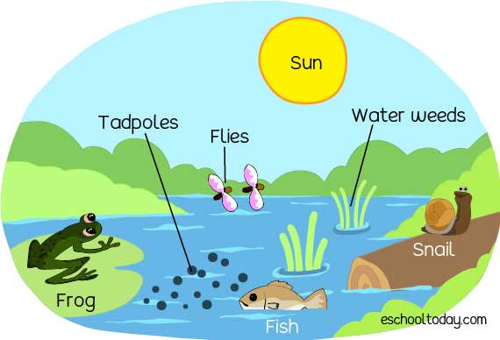

|  |  |
| --- | --- |
| Fraud | 1- |
| ecosystem | 2- |
| network | 3- |
| Contestants | 4- |
| hijack | 5- |

2- Match the words with the meanings:

|  |  |
| --- | --- |
| 1- weird | ( ) dig |
| 2- drill | ( ) very strange |
| 3- reschedule |  |

3- Circle the Odd words

a**-** WU-LOL-B4N- get it.

b- awesome , stunning , breathtaking , crummy

4-Give the antonyms for the words:

a- unauthorized #-------------------

b-disbelief #-----------------------

:

5- Fill in the blanks with correct words:

Conservation- To begin with- portion

a-……………………………………success needs more effort.

b- The government encourage people for …………………………………………..

6

**IV-Reading**

**Read the following passage and answer the questions below:**

Good evening and welcome to today’s World Weather report. Well, the weather’s been even busier and even more exciting than usual, especially in North America and Asia!

As we move into the early summer, temperatures have been rising more quickly than normal and this is producing dangerous weather conditions.

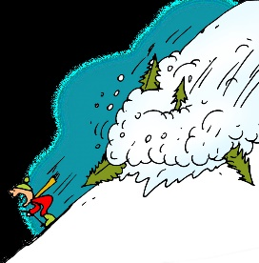 Let’s start in South Asia with the Himalayas. Here in the world’s highest, most dramatic mountains, snow and ice are melting earlier and faster than usual and this is causing more avalanches. And as melting continues, enormous quantities of water are entering the great rivers of India and Bangladesh. These are already rising and causing floods. Let’s move now to South-East Asia. There, a big storm with heavy rainfall of over 700 mm and wind speeds as high as 120 kph has smashed into the Philippines. **It** isn’t as violent as some other storms, but it’s bad enough to cause many problems. Mudslides on steep hills have destroyed many homes and worse is expected. Emergency workers are moving people away from more dangerous areas to places of safety

**A-Answer these questions:**

**1–**What is the text about?

………………………………………………………………………………………………………………………………………………………………………………**2-**What is happening to the snow and ice?

………………………………………………………………………………………………………………………………………………………………………………

**3-** Have mudslides on steep hills destroyed many homes and worse is expected?

………………………………………………………………………………………………………………………………………………………………………………

**B- Write [ T ] for True or [ F ] for False :**

|  |  |
| --- | --- |
| 1. Enormous quantities of water are entering the great rivers of India and Bangladesh |  |
| 1. Mudslides on steep hills have built many homes |  |

**C- Choose the right answer:**

1. The weather’s been even busier and even more exciting than usual,

**a-** North America **b-** North America and Asia **c-** Asia

2. Emergency workers are moving people away from more dangerous areas to places of

**a-** safety, **b-** danger**, c-** adventure

**D-Complete the following sentences:**

1. **Temperatures** ……………………………………………………………………………………………………………………………………….

****2. ………………………………………………………………………………………………………………………………………….**120 kph**