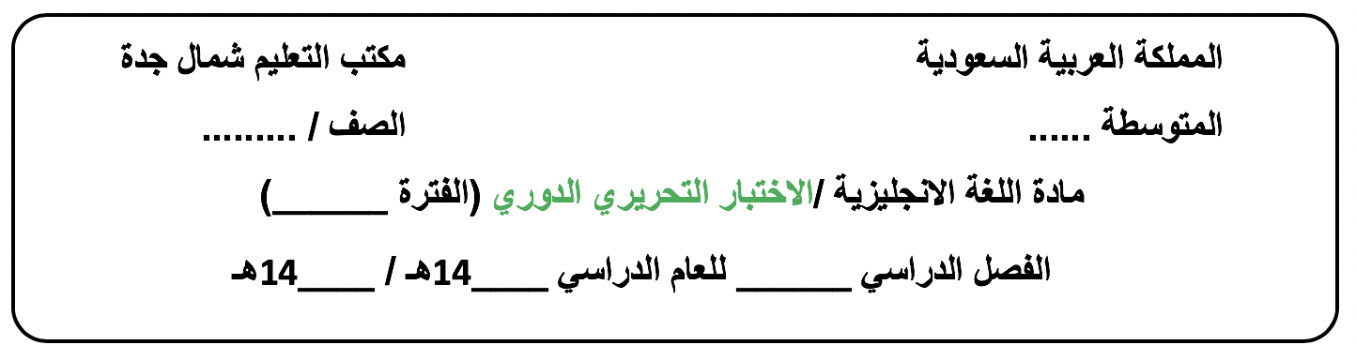

**الثالث متوسط**

**الأولى الوحدة 5**

**44**

**43**

**الثاني**

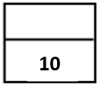**Day/ ………………………. Date/ …… / ….. / 1444H**

**Name /…………………………………………………………………..…………….Class/ 3 - …….**

**-------------------------------------------------------------------------------------------------------------------------------------------------------------------------------------------**

**Vocabulary: ½ for each**

|  |
| --- |
| **A. Choose the correct answer:** |
| 1.………………. have made our lives easier.  a-Films b- Addictions c-Inventions d-Witnesses |
| 2. I noticed that my mom never uses the ………to make the cookies.  a-computers b-camera c- micro wave oven d-printer |
| 3.You don’t need films for ……….. cameras.  a- digital b- old c-bad d-mass |
| 1. Nowadays, small and ……………….printers can be found in offices and homes everywhere.   a-traditional b-high-tech c-proud d-different |
| 5.Earlier cell phones models were called ……………..because they were so heavy.  a-Recharge b-device c- phone d-brick |
| 6.The buzzer ……………………. his thoughts.  a-interrupted b-went c-appeared d-offered |

|  |  |  |
| --- | --- | --- |
| **B. Match the word with its meaning (synonym), antonym( opposite ) or definition:** | | |
| 7.Children dressed as miniature adults. |  | a.The synonym is inelegant and solid. |
| 8.My father’s cell phone was big and clumsy. |  | b.The meaning is a way of doing something. |
| 9.Mass printing has been around since 1440 in Germany. |  | c.It means small models. |
| 10.The techniques of short films form the art of special effects. |  | d.The antonym is movable . |
|  |  | e.The antonym is small . |

**Grammar + Orthography ½ for each**

|  |
| --- |
| **Choose the correct answer:** |
| 11. Laptop computers have become smaller and faster and they contain a greater number of f_atures.  a- ( o ) b- ( e ) c- ( a ) d- ( i ) |
| 1. There was wi_espread support for the war .   a- ( b ) b- ( f ) c- ( d ) d- ( c ) |
| 13……………has she known her friend in London ? **(Grammar )**  a- Where b-How long c-How much d-What |
| 14.Saeed …….tried to learn French for three years.  a-have b-had c-has d-having |
| 15.He has played tennis …………2008.  a-for b-so far c-since d-already |
| 16.I have …………….the Great Wall.  a-see b-saw c-seeing d-seen |
| 1. The window ………………….. in my neighborhood.   a- has been broken b-have broken c- have been broken d-broken |
| 1. Ask Yes/ No question :   She has taken an English Course . …………………………………………………………… |
| 19. I’ve had ……….. car for about two years.  a-me b- I c- my d-mine |
| 20.Change into passive voice. :  Ali changed the flat tire 2 hours ago.  ….…………………………………………………………… |

[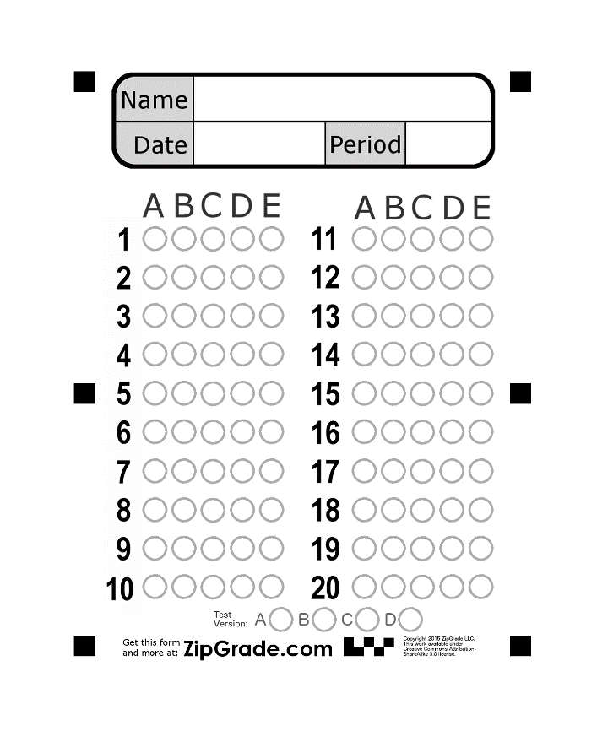](https://www.google.com.sa/url?sa=i%26rct=j%26q=%26esrc=s%26source=images%26cd=%26cad=rja%26uact=8%26ved=0ahUKEwi8veOT4vrWAhVKmBoKHaBlBy4QjRwIBw%26url=https://www.zipgrade.com/forms/%26psig=AOvVaw3T9JlY9f3gYoNV7bWnXoiP%26ust=1508436536107788)

**Good luck.**