S.G 3.2 Revision U.7 It is a good deal isn’t it ?

**A) Choose the correct answers :**

1- You were in Jeddah, ( wasn't- weren't- aren't ) you?

2- She studied in Dammam, ( didn't- don't - doesn't) she?

3-They aren't from Abha, ( are they - are not they – do they) ?

4- She hasn’t finished her job yet . ( has she – wasn’t he – hasn’t she ) ?

4- Majed is able to ( drive – drives – driving ) a car.

5-what should I ( do – does - doing ) tonight ?

6- -you could (make – makes –making ) pasta **) B)Correct :**

Spanish speak 1-They are able to

2-Lets going to the restaurant . go

3- He is a good reader , aren’t he ? isn’t he

**C) Do as shown between brackets :**

1- Go / lets / shopping. Let's go shopping . ( reorder )

2- We travel to Dubai . why don’t we travel to Dubai ( Use why don’t )

**Vocabulary:**

**D) Match the words with their meanings :**

|  |  |  |
| --- | --- | --- |
| Genes from generation to another | 4 | 1- Triplet |
| Child who has lost his parent . | 3 | 2- coincidence |
| 3 baby born at the same time | 1 | 3- Orphan |
| By chance | 2 | 4-heredity |

**E) Match the expression with correct meaning :**

1-That’s a good idea . …2.. refusing suggestion

2-Sorry, I cant …3.. introduction

3-How do you do ? …1….. accepting suggestion

**F) Match the word with opposite :**

**( cry - sell - - build )**

1-buy ………… 2- Laugh...

3-destroy ……………

**G) Write the correct word under each picture( plate- spoon –knife- saw- hose – hammer )**  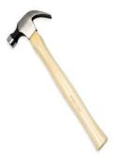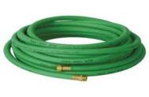 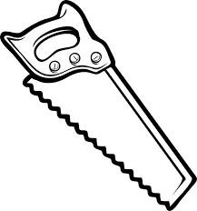 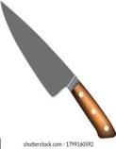  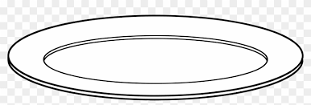

Hammer hose saw knife spoon plate

:

Best Wishes :T. Mayadh F. Abohamad