1st Grade English Exam ( Second Term ) for the first period ( Unit 6 )
Student’s name : ………………………………………………….. class : ……………………….
(1)Read the following passage and answer the questions below:
Jack has three new friends. Maria has short brown hair and she is nine years old. Maria’s school bag is purple and her shoes are pink. Jeremy is eight years old and has small eyes and a big head. Jeremy’s school bag is blue and his pants are blue too. Peter is nine years old and has curly black hair. Peter has got a basketball, green shorts and a gray shirt. Maria can swim, can dance and can sing but she can’t ride a bike. Jeremy can climb, can roller-skate, and can ride a bike but he can’t play the piano. Peter can run fast, can draw, can do karate but he can’t drive a car.
- How many friends does jack have ?
……………………………………………………………………
B. Choose :
1- Peter has curly ( brown - black – gray ) hair .
2- Maria’s ( bag – shoes – pants ) are pink .
3- Jeremy is ( 7 – 8 – 9 ) years old .
4- Peter can ( run - draw – drive ) fast .

Choose (True) or (False) |  | True √ | False x
1 | Jeremy can play the piano.
2 | Maria is nine years old.

(2) Grammar : ( choose the correct answer ) :
- There ( is – are - am ) a sound system in the living room.
- There ( is – are - am ) cabinets in the kitchen.
- ( Is – Are - Am ) there a window in the room ?
- Are there ( flower – flowers – a flower ) in the vase ?
- You can use a pencil ( and – but – or ) a pen to write the homework.
- I can speak English ( and – but – or ) I can’t speak French.
- We write ( and – but – or ) read in the class.
- There ( aren’t – not are – is not ) trees in the garden.
- There is ( a dryer – dryers – two dryers ) in the laundry room .
- Is There a balcony in your apartment ?
( Yes, is there – Yes, there is – There is yes )

(3) Vocabulary :
A - Choose the right answer

1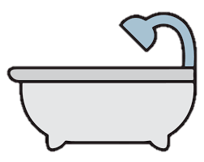 | 2 | 3 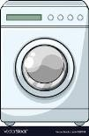 | 4  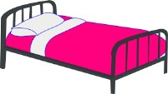 | 5 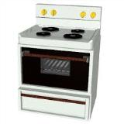 | 6 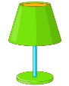
a. bathtub | a. dryer | a. window | a. bed | a. dish | a. desk
b. car | b. TV | b. shelf | b. curtains | b. stove | b. lamp
c. table | c. radio | c. washer | c. closet | c. chair | c. dryer

7  | 8 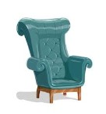 | 9 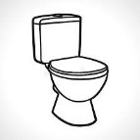 | 10  | 11 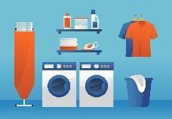 | 12  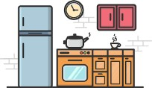
a. laptop | a. mirror | a. rug | a. garage | a. bedroom | a. bedroom
b. dish | b. armchair | b. sink | b. garden | b. laundry room | b. kitchen
c. chair | c. vase | c. toilet | c. upstairs | c. bathroom | c. living room

13 The dog is  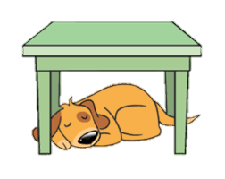  …………….. the table. | 14 The apple is ………….. the box  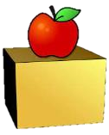 | 15 The mouse is ……….. the 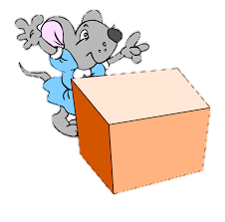box. | 16 The dog is  …………….. the box.   | 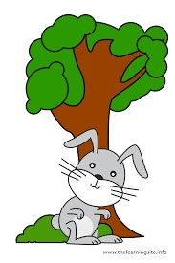  17 The rabbit is …………………... the tree.
a. under | a. on | a. behind | a. on | a. on
b. behind | b. in front of | b. on | b. under | b. in front of
c. on | c. in | c. in | c. in | c. in

Good luck Teacher : Moza ALzoabi
Good luck Teacher : Moza ALzoabi

