اختبار الفترة الأولى لمادة اللغة الانجليزية للصف الأول المتوسط الفصل الدراسي الثاني لعام 1443هـ

Super goal 1 . The 1st Mid Exam. 2nd Term. Name.......................................................

1. **Comprehension**

Read this passage and complete the sentences

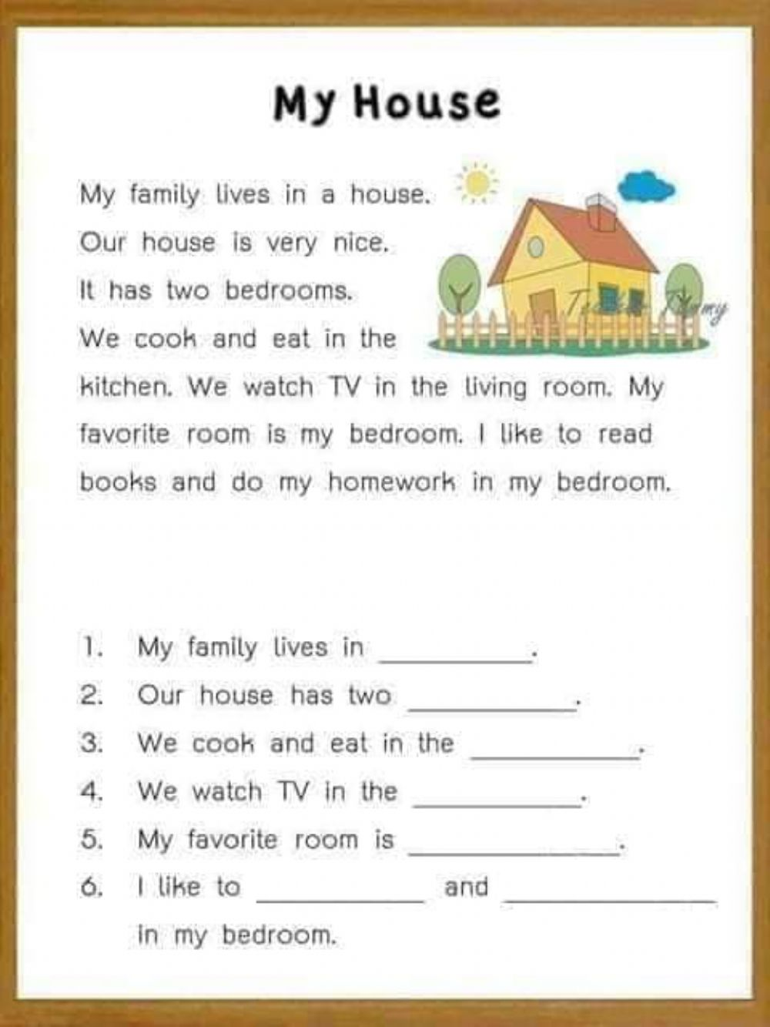

5

**II-Grammar**

6

**Choose:-**

1-There ( is - are – isn't ) six boys at the table.

2-We read ( and - but - for ) write in class.

3-I live ( in - on - at ) Jeddah.



4- The lamp is ( between – next to – far from ) the armchair.

5- Ali is ( tall- taller – tallest ) than Khalid..

6- Mona is the (most – more – many ) beautiful girl in the class.

**III-Vocabulary**

7

**A-Match A with B :**

|  |  |
| --- | --- |
| **B** | **A** |
| ( ) sink, stove and microwaves | 1- bedroom |
| ( ) sofa, TV and armchair. | 2- kitchen |
| ( ) bed, rug and desk | 3- bathroom |
| ( ) toliet, shower and bathtub. | 4- living room |

**B: Choose:-**

1-The ( restaurant - post office – pharmacy ) is a place to eat.

2-The ( health club - hotel - bookstore ) is a place to buy books.

3-There is a car in the ( garage – dining room - bathroom ).

2

**V-Orthography**

Rearrange the letters to form correct words:

**GOOD LUCK ☺ Tr. Nora**

1- k.a.r.p ____________

2- k.b.n.a ____________