Super Goal 2 Unit 1 What do you do?

Vocabulary;
1) Choose the right answer

1  | 2  | 3  | 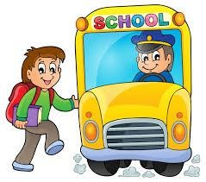  4 | 5  | 6 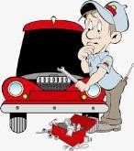
a. doctor | a. student | a. taxi driver | a. bus driver | a. doctor | a. student
b. waiter | b. nurse | b. chef | b. waiter | b. nurse | b. mechanic
c. teacher | c. secretary | c. doctor | c. nurse | c. waiter | c. secretary

7  | 8  | 9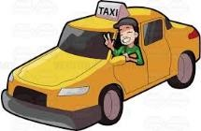 | 10  | 11 
a. teacher | a. waiter | a. taxi driver | a. chef | a. student
b. waiter | b. chef | b. chef | b. police officer | b. nurse
c. nurse | c. camera man | c. doctor | c. doctor | c. carpenter

Grammar
2) Choose the correct word:

1) She ………………… to school by bus.
 | a) go | b) goes | c) going
2) They ……………………… everyday.
 | a) work | b) works | c) working
3) He ……………… some cookies.
 | a) make | b) makes | c) making
4) What ……………….. she do?
 | a) do | b) does | c) doing
5) What …………………. They do?
 | a) do | b) does | c) doing
6) I am studying now…………………. I have a test tomorrow.
 | a) and | b) because | c) so
7) He is tired, …………… he is taking a nap.
a) and b) because c) so
8) ………………….. are driving fast? Because I’m late.
 | a) What | b) Where | c) Why
9) I like maths ………………. I don’t like history.
 | a) and | b) so | c) but
10) The house is big ……………….. modern.
 | a) and | b) so | c) but

