## Write the activities under the right pictures :

(reading magazine – drinking coffee – surfing the internet – chatting )

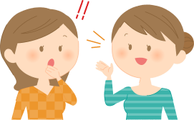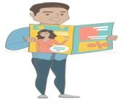

Match the words with their meanings :

1-What's up ? ( ) a)Looking for information 2-Checking out ( ) b) player.

3-Plays tennis ( ) c)What's happening?

4- teaches at school ( ) d) teacher.

# Correct the underlined mistake:

* 1. He **cook** at night . ……..……………
  2. They **is** playing games …………………….
  3. We **works** in an airline . ………………………

4- She is **read** now . …………………….

# Make a (yes/no) question then answer :

They are studying .

………………………………………………………….? Yes, they are

She is driving .

…………………………………………………………? No, she isn't .

What do you want to be ? ………… …………. ……….. ………… a doctor .

**Fill the blanks with suitable personal pronouns :**

**( because – he – they – so - Why )**

1-My father is a doctor . ………………………….. works in a hospital.

2-My sister is studying ……………………………. She has a test .

3-Ahmad and Mona are at the mall…………………………..are shopping.

4- Today is weekend , ……………………. i am happy .

5 - …………………. is he taking a nap ? Because he is tired