**اختبار الفترة الأولى لصف الثاني متوسط**

**Name …………………………………. Class ………………..**

**Comprehension**

My favourite colour is pink . I am going to my aunt's house for a party . I'm wearing a pink skirt and blouse . I'm looking for my pink shoes and a bag but I can't find them . I think I'll have to wear my white sandals instead .

*A-Questions :*

------

**3**

1. What is your favourite colour ?

……………………………………………………………………..

*B-Choose:*

I'm wearing a …………..……. Skirt and blouse .

🞎 Pink 🞎 yellow 🞎 green

*C-Put ( 🗸 ) or ( 🗴 ) :-*

1- My favourite colour is pink ( )

2- I can find my pink shoes and bag ( )

**…………………………………………………………………………..**

**Grammer ;**

------

**8**

1. I ( was - were ) at home last night .
2. They ( go - went ) to school yesterday .
3. I didn’t hear ( anything – nothing ) I was sleep .
4. I am happy ( so am I – so do I )
5. I didn’t watch the news ( so did I – neither did I )
6. The driver was sleepy ( so – because ) he didn’t see the stop sign .

--------------------------------------------------------------------------------------

**Write the past**

1. do ……………… 2- eat ……………… 3 – meet………………….

-------

**9**

**make negative**

**There was an accident .**

**………………………………………..**

**Vocabulary**

**Write a word under the picture**

------

**10**

**( stomachache --- headache --- toothache --- scared )**

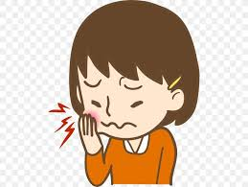  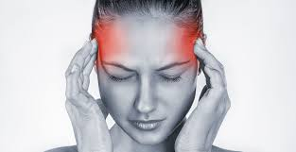 

**………………….. …………… ….………. …………..**

**Match :**

1. **What's up ( ) a- it's going to be quick .**
2. **The thing is ( ) b- The problem is .**
3. **it'll only take a minute ( ) c- what happing .**

**________________________________________________________**

**write the missimg letter :-**

|  |  |  |
| --- | --- | --- |
|  | الوصف: http://images.clipartpanda.com/tent-clip-art-green-tent-clip-art-vector-clip-art-online-royalty-free-public-600x284.jpg |  |
| **An--ry** | **Slee--y** | **Happ---** |

**Best wishes ..**

**T / Areej Alhausoni**