# MG 2.2 Unit (1) Working 9 to 5 Revision

***(subjunctive ) we use it to stress the importance or urgency of an action (use the base verb ( V inf )***

subjunctive

verbs

expressions

ask /demand / insist / recommend

request / require / suggest /urge

It is essential / It is imperative

It is important / It is necessary

S + V + that + s + **V** base form ...

Expression + that + s + **V** base form ...

The doctor insisted that he **eat** healthy food.

it is essential that he **eat** healthy food.

it is essential that he not **eat** fast food.

The doctor insisted that he not **eat** fast food.

***(I'd like you to / I want you to + V inf ) express a desire that someone do something***

**I’d like you to read** this **story. (I'd ) I would**

**I'd like you to not read this novel.**

**I want you to finish the report today.**

# Haapy Cute Kids Boy and Girl Study Stock Illustration - Illustration of homework, friends: 164179922



|  |  |  |  |  |  |  |  |
| --- | --- | --- | --- | --- | --- | --- | --- |
| **1** | **I would like you to ……………….my friend Maha next week.** | | | | | | |
| **A** | **meet** | **B** | **meets** | **C** | **met** | **D** | **meeting** |
| **2** | **I want you ……….. read this book.** | | | | | | |
| **A** | **for** | **B** | **to** | **C** | **at** | **D** | **that** |
| **3** | **It is imperative ………….the doctor wash his hands before entering the operating room** | | | | | | |
| **A** | **for** | **B** | **to** | **C** | **at** | **D** | **that** |
| **4** | **It is essential that you ……………. quit your job before you find a new one.** | | | | | | |
| **A** | **not** | **B** | **doesn’t** | **C** | **didn’t** | **D** | **don’t** |
| **5** | **I want you to ……………… the report tomorrow.** | | | | | | |
| **A** | **finishes** | **B** | **finish** | **C** | **finishing** | **D** | **finished** |
| **6** | **The teacher urged that we ………………hard for the exam.** | | | | | | |
| **A** | **study** | **B** | **studies** | **C** | **studied** | **D** | **studying** |
| **7** | **I would like you to not …………….too fast.** | | | | | | |
| **A** | **drives** | **B** | **drive** | **C** | **driving** | **D** | **drove** |
| **8** | **It is important that we not …………….late for the meeting.** | | | | | | |
| **A** | **is** | **B** | **were** | **C** | **be** | **D** | **are** |
| **9** | **I asked her to …………….. here on time.** | | | | | | |
| **A** | **be** | **B** | **is** | **C** | **was** | **D** | **were** |
| **10** | **We recommend ………………put your educational background on it.** | | | | | | |
| **A** | **you that** | **B** | **that you** | **C** | **are you** | **D** | **you that not** |
| **11** | **I want ………………call me if you have any problem.** | | | | | | |
| **A** | **to you** | **B** | **it you** | **C** | **you to** | **D** | **that you** |
| **12** | **I …………….like you to help with this project.** | | | | | | |
| **A** | **will** | **B** | **would** | **C** | **could** | **D** | **should** |
| **13** | **The boss demanded that he …………. late again.** | | | | | | |
| **A** | **is not** | **B** | **be not** | **C** | **not be** | **D** | **not is** |

# 

# MG 2.2 Unit (1) Working 9 to 5 Revision

***(Tag questions ) we use it to check information if it's correct or not and start a conversation***

|  |
| --- |
| **Auxiliary verbs ( helping verbs )** |
| **am / is /are have /has can /could will /would**  **was /were had must /should** |

**If the statement is positive , the question tag is** **negative**

**If the statement is negative , the question tag is positive**

**No, it wasn't.**

**wasn’t it**

**It was good, ……………..…………?**

**was it**

**Yes, it was**

**It wasn’t good, ………..…. ?**

**Yes, I am.**

**No, she didn't.**

**She didn’t study hard, did she?**

**You are from Riyadh , aren't you ?**

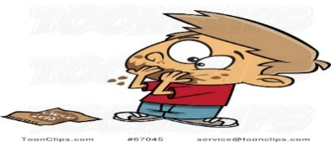

**Yes, he did**

**didn’t he**

**He finished it, ……………..……..………?**

|  |  |  |  |  |  |
| --- | --- | --- | --- | --- | --- |
| **Present simple** | | | | **Past simple** | |
| **do** | **I /you / they /we** | **does** | **She / he /it** | **did** | **I / you / they /we/ she/ he/ it** |

|  |  |  |  |  |  |  |  |
| --- | --- | --- | --- | --- | --- | --- | --- |
| **1** | **The book wasn’t very good, ……………?** | | | | | | |
| **A** | **was it** | **B** | **was the book** | **C** | **were it** | **D** | **wasn’t it** |
| **2** | **It's too hot today, …………….?** | | | | | | |
| **A** | **is it** | **B** | **isn’t it** | **C** | **wasn’t it** | **D** | **isn’t she** |
| **3** | **You are the new teacher, ……………….?** | | | | | | |
| **A** | **were you** | **B** | **are you not** | **C** | **are you** | **D** | **aren’t you** |
| **4** | **You didn’t break her vase, ……………?** | | | | | | |
| **A** | **did you** | **B** | **does you** | **C** | **didn’t you** | **D** | **wasn’t you** |
| **5** | **Alex is working in a bank now, …………………...?** | | | | | | |
| **A** | **is he** | **B** | **isn’t he** | **C** | **is Alex** | **D** | **aren’t he** |
| **6** | **Mary made this cake, ……………?** | | | | | | |
| **A** | **did she** | **B** | **doesn’t she** | **C** | **didn’t she** | **D** | **don’t she** |
| **7** | **You miss your father, ………………...?** | | | | | | |
| **A** | **don’t you** | **B** | **do you** | **C** | **did you** | **D** | **didn’t you** |
| **8** | **She works out every day, ……………………?** | | | | | | |
| **A** | **does she** | **B** | **doesn’t she** | **C** | **don’t she** | **D** | **didn’t she** |
| **9** | **you hadn’t cook dinner, ………………?** | | | | | | |
| **A** | **haven't you** | **B** | **hasn’t you** | **C** | **had you** | **D** | **hadn’t you** |
| **10** | **Eat your food,……………..? ( start with a verb as a demand )** | | | | | | |
| **A** | **doesn't you** | **B** | **will you** | **C** | **won't you** | **D** | **did you** |
| **11** | **Give me that pen,…………….? ( start with a verb as a request )** | | | | | | |
| **A** | **doesn't you** | **B** | **will you** | **C** | **won't you** | **D** | **did you** |
| **12** | **Let's play a game, …………………? ( start with a suggestion )** | | | | | | |
| **A** | **will we** | **B** | **shall we** | **C** | **won't we** | **D** | **don’t we** |
| **13** | **I am late, …………….?** | | | | | | |
| **A** | **I am not** | **B** | **aren’t I** | **C** | **am I** | **D** | **aren’t me** |
| **14** | **I am not late, ………...?** | | | | | | |
| **A** | **I am not** | **B** | **aren’t I** | **C** | **am I** | **D** | **Aren’t me** |

# MG 2.2 Unit (1) Working 9 to 5 Revision

***1-polite ways to ask for information with*** *Can, Could, Would****,*** *Would you mind*

When you ask people you don’t know

When you ask Family and friends

( people you know)

**Can you tell me where the mall is?**

**Where is the mall?**

# 

# الكرتون المدرسة الابتدائية المدرسة المدرسة, المراهق, أطفال الرسوم المتحركة, يذهب PNG وملف PSD للتحميل مجانا

***Can / Could / Would***

***Can you tell me where the bank is?***

***Would you mind telling me where the bank is?***

***Would you mind + Ving***

***2-polite ways to make requests with Can, Could and Would + inf***

**Certainly.**

**Of course.**

**Sure.**

# Hello, friends!. Hello, friends! I'm fine thank you. And you? Good morning, Rafael. How are you? Good Morning, Bella. I'm fine thank you. And you? - ppt video online download

**Can you open the window, please?**

***Can / Could + you I***

***Would + you I***

# ❌” معنى: علامة X Emoji | EmojiAll

***3-express ( obligation / necessity / lack of necessity ) + V-inf***

|  |  |  |
| --- | --- | --- |
| obligation | necessity | Lack of necessity |
| must ( personal duties )have to (obligations to help others)mustn’t (not allowed to do it ) | I, you, we, they have toshe, he , it has to(past→ had to) (future→ will have to) need to  (past→ need**ed** to) (future→ will need to) | I, you. we, they don’t have toshe, he, it doesn’t have todidn’t have to / need to don’t / doesn't need to  needn’t to |

|  |  |  |  |  |  |  |  |
| --- | --- | --- | --- | --- | --- | --- | --- |
| **1** | **You ……………………pray 5 time a day.** | | | | | | |
| **A** | **must** | **B** | **mustn’t** | **C** | **will need** | **D** | **had to** |
| **2** | **Would you mind ……………me with my resume?** | | | | | | |
| **A** | **help** | **B** | **helps** | **C** | **helping** | **D** | **helped** |
| **3** | **Can I …………..to the manager?** | | | | | | |
| **A** | **speak** | **B** | **speaks** | **C** | **speaking** | **D** | **spoke** |
| **4** | **I …………… write a report, so I didn’t hang out with my friends yesterday.** | | | | | | |
| **A** | **will need to** | **B** | **had to** | **C** | **have to** | **D** | **mustn’t** |
| **5** | **He ………………….. go to work yesterday, it was Friday.** | | | | | | |
| **A** | **didn’t need to** | **B** | **don’t need to** | **C** | **doesn't need to** | **D** | **aren’t need to** |
| **6** | **Tomorrow we ………………….get up early to catch the school bus.** | | | | | | |
| **A** | **had to** | **B** | **have to** | **C** | **will has to** | **D** | **will have to** |
| **7** | **It's not allowed to smoke in the waiting room, you ………………. smoke here.** | | | | | | |
| **A** | **have to** | **B** | **mustn’t** | **C** | **need to** | **D** | **has to** |
| **8** | **Adel ……………………. be patient with the customers all the time.** | | | | | | |
| **A** | **has to** | **B** | **have to** | **C** | **had to** | **D** | **needed to** |
| **9** | **The people in line will ……………wait for their turn.** | | | | | | |
| **A** | **has to** | **B** | **have to** | **C** | **had to** | **D** | **needed to** |
| **10** | **Mum ………….. cook tonight because we are going out for dinner.** | | | | | | |
| **A** | **has to** | **B** | **have to** | **C** | **had to** | **D** | **needn’t to** |

MG 2.2 Unit (1) Working 9 to 5 Revision

Vocabulary

|  |  |  |  |  |  |  |  |
| --- | --- | --- | --- | --- | --- | --- | --- |
| **1** | **To be a ……………….is a job requires a person have kindness and consideration.** | | | | | | |
| **A** | **race car driver** | **B** | **zoologist** | **C** | **nurse** | **D** | **lawyer** |
| **2** | **I spend a lot of time cutting and sewing, but I don’t work with fabric, I am ………………..** | | | | | | |
| **A** | **surgeon** | **B** | **zoologist** | **C** | **race car driver** | **D** | **air traffic controller** |
| **3** | **……………………is someone who helps people in need, poor or disabled.** | | | | | | |
| **A** | **Social worker** | **B** | **Vet** | **C** | **zoologist** | **D** | **Screen writer** |
| **4** | **An arborist is a doctor for ………………….** | | | | | | |
| **A** | **children** | **B** | **animals** | **C** | **trees** | **D** | **old people** |
| **5** | **A pediatrician is a doctor for ……………..** | | | | | | |
| **A** | **children** | **B** | **animals** | **C** | **trees** | **D** | **old people** |
| **6** | **Circle the odd word.** | | | | | | |
| **A** | **Doctor** | **B** | **No Parking** | **C** | **Cashier** | **D** | **telemarketer** |
| **7** | **Circle the odd word.** | | | | | | |
| **A** | **No Entry** | **B** | **Speed Limit** | **C** | **No Parking** | **D** | **engineer** |
| **8** | **I'm in a ……………… the test is tomorrow and I can't understand it.** | | | | | | |
| **A** | **jump ship** | **B** | **cover** | **C** | **bind** | **D** | **captive** |
| **9** | **A: I wanna tell you something but I need you to …………… B: you can trust me, it’s a secret.** | | | | | | |
| **A** | **keep it to yourself** | **B** | **tell every one** | **C** | **spared it** | **D** | **tell your family** |
| **10** | **Ali: I won 5000 in the competition. Bader: ……………..** | | | | | | |
| **A** | **certainly** | **B** | **no kidding** | **C** | **yes** | **D** | **sure** |
| **11** | **Ali: Did you Know that Imad ……………. Bader: He did! Where is he going to work now?** | | | | | | |
| **A** | **jumped ship** | **B** | **in a bind** | **C** | **will not do it** | **D** | **No kidding** |
| 12 | **Ali: I am going to ……………now. Bader: OK. See you later.** | | | | | | |
| **A** | **no kidding** | **B** | **in a bind** | **C** | **take off** | **D** | **help you out** |

**Classify the items into the correct category:**

**( trend – fabric – sketches – style – natural – artificial – food – taste – trim – file nail – feet – captive )**

|  |  |  |
| --- | --- | --- |
| **doll fashion designer** | **flavorist** | **elephant pedicurist** |
|  |  |  |

|  |  |  |  |
| --- | --- | --- | --- |
| 1 | identical | (2) | free |
| 2 | captive | (1) | different |
| 3 | methodical | (4) | usual |
| 4 | Speed limit traffic sign 70 Stock Photo - Alamyunusual | (3) | disorganized |

**Match the words with their opposites**

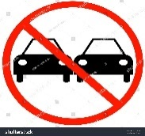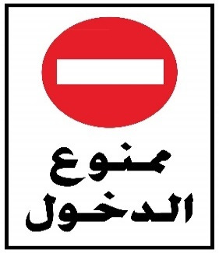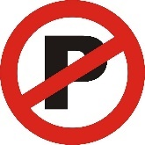

**No Entry**

**Speed limit**

**Dentist**

**No parking**

**No passing**



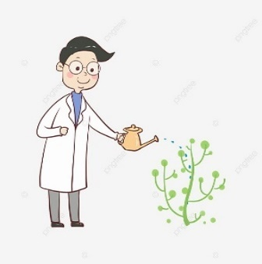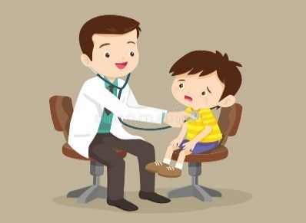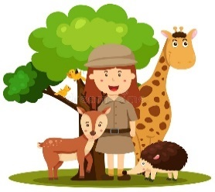

**firefighter**

**arborist**

**surgeon**

**Pediatrician**

**zoologist**