10

**(MG2.2 ) Midterm Exam 2nd Grade 2st Term unit 1 No.1**

Name:__________________________________________ Class: _________

2

**Read the text then answer:**

Mona is interesting in Geography books She has read many books on China, India and Korea. Mona

Visits the school library twice a week and the librarian is always ready to help her. Last week, **she** wrote

a very good note in the school Magazine. The headmistress gave her some books as a present for that note.

1. What does Mona like to read? ……………………………………………………………….
2. '' **She** '' refer to ………………………..

**( Q 1 ) Grammar:**

2

**A) Shade the correct answer for each sentence :**

|  |  |  |  |  |
| --- | --- | --- | --- | --- |
| **1-** | | | | |
| d) | c) | b) | a) |
| 2- | | | | |
| d) | c) | b) | a) |
| **3-** | | | | |
| d) | c) | b) | a) |
| **4-** | | | | |
| d) | c) | b) | a) |

 **B) Choose the correct sentence:**

2

a- He insisted that his mother teach him English.

b- He insisted that his mother teaches him English.

**C)** **correct the mistake: ( )**

………..……………….……………………………………………………………………………………….

**( Q 2 ) Vocabulary:**

2

**A) Circle the correct letter for each sentence:**

|  |  |  |  |  |  |  |
| --- | --- | --- | --- | --- | --- | --- |
| **1-** | | | | | | |
| d) | | c) | b) | | | a) |
| **2-** | | | | | | |
| d) | | c) | b) | | | a) |
| **3-** | | | | | | |
| d) | | c) | b) | | a) | |
| **4-** | | | | | | |
| d) | | c) | b) | a) | | |

2

**B) Classify**  ( / / / )

|  |
| --- |
|  |

|  |  |
| --- | --- |
| ذكر طبيب يوم الشجرة زرع الأمل, زراعة الأشجار, غرس الأشجار, يوم الشجرة PNG  وملف PSD للتحميل مجانا | ذكر طبيب يوم الشجرة زرع الأمل, زراعة الأشجار, غرس الأشجار, يوم الشجرة PNG  وملف PSD للتحميل مجانا |
| طباعة مجانية بدون علامات وقوف السيارات ، قم بتنزيل قصاصة فنية مجانية ،  قصاصة فنية مجانية - آخر | طباعة مجانية بدون علامات وقوف السيارات ، قم بتنزيل قصاصة فنية مجانية ،  قصاصة فنية مجانية - آخر |

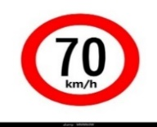**C) Match :**  ( / / / )

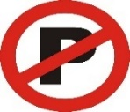

**………………………… …………………………….. ……………………………. …………………………….**

10

**(MG2.2 ) Midterm Exam 2nd Grade 2st Term unit 1 No.2**

Name:_____________________________________________ Class: _________

2

**Read the text then answer:**

Mona is interesting in Geography books She has read many books on China, India and Korea. Mona

Visits the school library twice a week and the librarian is always ready to help her. Last week, **she** wrote

a very good note in the school Magazine. The headmistress gave her some books as a present for that note.

1. Who gave Mona a present? ……………………………………………………………….
2. How many times does Mona visit the library? …………………………………………………………..

**( Q 1 ) Grammar:**

2

**A) Shade the correct letter for each sentence:**

|  |  |  |  |  |
| --- | --- | --- | --- | --- |
| **1-** | | | | |
| d) | c) | b) | a) |
| **2-** | | | | |
| d) | c) | b) | a) |
| **3-** | | | | |
| d) | c) | b) | a) |
| **4-** | | | | |
| d) | c) | b) | a) |

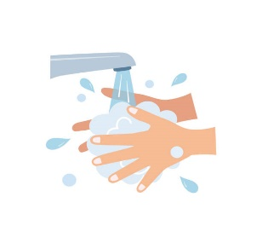**B) Choose the correct sentence:**

2

a- it is important that the doctor clean his hands before the surgery.

b- It is important that the doctor cleans his hands before the surgery.

**C) Correct the mistake: ( )**

…………………………..……………………………………………………………………………….

2

**( Q 2 ) Vocabulary:**

**A) Circle the correct letter for each sentence:**

|  |  |  |  |  |  |
| --- | --- | --- | --- | --- | --- |
| **1-** | | | | | |
| d) | c) | b) | | | a) |
| **2-** | | | | | |
| d) | c) | b) | | | a) |
| **3-** | | | | | |
| d) | c) | b) | | a) | |
| **4-** | | | | | |
| d) | c) | b) | a) | | |

**B) Classify ( / / / )**

2

|  |
| --- |
|  |

|  |  |
| --- | --- |
| 10 Mako Shark Clipart cartoon Free Clip Art stock illustrations ... | 10 Mako Shark Clipart cartoon Free Clip Art stock illustrations ... |
|  |  |

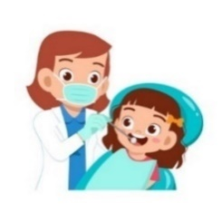**C) Match : ( / / / )**



   