Do the quiz and find out if you behave in a proper way to help save our planet
1.Do you sort out glass, paper, plastic bottles and cans ?
a  Yes , always.
b  Sometimes.
c  Never.

2. Do you buy fair trade products or organic or local food.
a  Yes , always..
b Sometimes.
c Never, it’s too expensive.

3. Do you use your own shopping bags?
a  Yes , always
b  Often
c  Once in a while

4. Do you recycle light bulbs and used batteries?
a  Yes , always.
b  Sometimes.
c  Never.

5. Do you always dispose of garbage in a proper way?
a  Yes , always of course.
b  Most of the times
c  Sometimes I don’t pay attention!

6. Do you bother picking up other people’s litter?
a  Yes , always.
b  Sometimes.
c  Never

7. Do you switch off the lights when you leave a room ?
a  Yes , always.
b  Sometimes.
c  Never

8. Do you switch off other electric appliances at night? (TV ,computer..)
a  Yes , always.
b  Sometimes.
c  Never

9. Do you put on warmer clothes when it’s cold instead of putting on the heating ?
a  Yes , always.
b  Sometimes.
c  Never, I prefer
putting the heating on more.

10. Do you have showers instead of baths?
a  Yes , always.
b  Often .
c  Never

11. Do you close the tap while you brush your teeth?
a  Yes , always.
b  Sometimes.
c  Never, I never think about it.

12. Do you leave the fridge door open when you do the cooking?
a  No, never., I always close it.
b  Sometimes.
c  Yes , it often happens

13. Do you use public transport or a bike or walk when possible?
a  Yes , always.
b  Sometimes.
c  Never

14. Do you have and use a composter at home?
a  Yes.( 2 pts)
b  No . (0 pt)

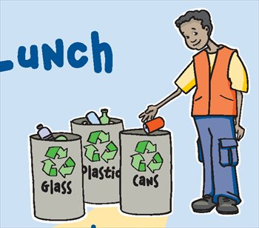
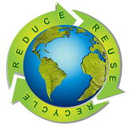

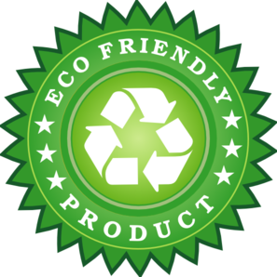









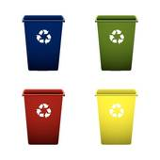

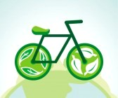


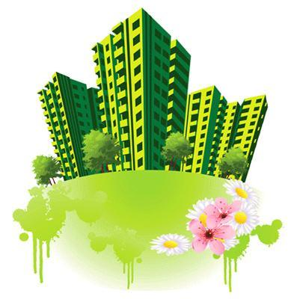
Check the number of points you have and see if you are GREEN !
a 2 points b 1 point c 0 point ( except question 14)
From 22 to 28
Congratulations, you are making real good efforts to help save our planet. Keep up the good work!
From 13 to 21 .
Well, you should do better , the environment is not really your priority but you can improve, can’t you !
Below 12
No , no, no !!That’s not possible , you should definitely do a lot more to leave an acceptable environment to your children and grandchildren!

Check the number of points you have and see if you are GREEN !
A 2 points b 1 point c o point (except question n°14)

From 22 to 28
Congratulations, you are making real good efforts to help save our planet. Keep up the good work!
From 13 to 21 .
Well, you should do better , the environment is not really your priority but you can improve, can’t you !
Below 12
No , no, no !!That’s not possible , you should definitely do a lot more to leave an acceptable environment to your children and grandchildren!

Check the number of points you have and see if you are GREEN !
A 2 points b 1 point c o point (except question n°14)

From 22 to 28
Congratulations, you are making real good efforts to help save our planet. Keep up the good work!
From 13 to 21 .
Well, you should do better , the environment is not really your priority but you can improve, can’t you !
Below 12
No , no, no !!That’s not possible , you should definitely do a lot more to leave an acceptable environment to your children and grandchildren!

