# MG 2.2 Unit (2) Going Green Revision

***( full infinitive → to + Vinf )***

***( gerund → Ving )***

{ verbs come after it gerund}

advise / enjoy / finish / go /

imagine / keep / quit /

recommend / stop / suggest

{ verbs come after it full infinitive}

agree / ask /attempt / decide /

expect / forget / learn /need/ offer /

plan/promise/remember/try/want

# Thinking About Quitting Smoking - A Cartoon Illustration Of A Man Thinking About Quitting Smoking. Royalty Free SVG, Cliparts, Vectors, And Stock Illustration. Image 140690683.

# Day Off Work Stock Illustrations – 920 Day Off Work Stock Illustrations, Vectors & Clipart - Dreamstime

My boss stopped smoking 3 months ago

Go shopping with your sister

I decided to take a day off

He wants to finish the project by himself

# Shopping and buying fresh food concept. Young smiling couple man and woman cartoon characters walking carrying fresh food after going to grocery store vector illustration Stock Vector Image & Art - Alamy

# 411,477 เรียนหนังสือการ์ตูน Images, Stock Photos & Vectors | Shutterstock

|  |  |
| --- | --- |
| **Subject**  **pronoun** | **Object**  **pronoun** |
| **I** | **me** |
| **he** | **him** |
| **she** | **her** |
| **it** | **it** |
| **we** | **us** |
| **they** | **them** |
| **you** | **you** |

{verbs followed by **object**

before the full infinitive}

ask / expect / need / want

{verbs with either gerund and full infinitive}

begin / can't stand / continue / intend /

hate / like / love / prefer / start

# Broken toaster damaged home appliance Royalty Free Vector

# 

I want to buy a new toaster

I want **him** to buy a new toaster

We love playing / to play with dad.

Start making / to make a list before shopping

# الأيدي مع قائمة التسوق فن البوب ​​الرجعية التوضيح النقطية. صورة معزولة على خلفية بيضاء. تقليد أسلوب الكتاب الهزلي.

|  |  |  |  |  |  |  |  |
| --- | --- | --- | --- | --- | --- | --- | --- |
| **1** | **Do you want …………..……a positive impact on the environment?** | | | | | | |
| **A** | **have** | **B** | **to have** | **C** | **having** | **D** | **had** |
| **2** | **You should consider ……………clothes that no longer fit you to others who can wear them** | | | | | | |
| **A** | **give** | **B** | **gave** | **C** | **giving** | **D** | **gives** |
| **3** | **I advise you to stop ……………things you don’t need** | | | | | | |
| **A** | **buy** | **B** | **bought** | **C** | **buying** | **D** | **buys** |
| **4** | **We asked ………………. to move the car away** | | | | | | |
| **A** | **she** | **B** | **they** | **C** | **them** | **D** | **I** |
| **5** | **Keep ……………your supermarket bags** | | | | | | |
| **A** | **use** | **B** | **reuse** | **C** | **reusing** | **D** | **reused** |
| **6** | **They offer…………….. together for the test** | | | | | | |
| **A** | **study** | **B** | **studies** | **C** | **studied** | **D** | **to study** |
| **7** | **Please don’t forget ………….. your food as a fertilizer for the soil** | | | | | | |
| **A** | **recycle** | **B** | **to recycle** | **C** | **recycling** | **D** | **recycled** |
| **8** | **My brother promised …………….his math exam.** | | | | | | |
| **A** | **pass** | **B** | **passing** | **C** | **to pass** | **D** | **passed** |
| **9** | **Can you imagine ……………… as a crime site cleaner?** | | | | | | |
| **A** | **work** | **B** | **works** | **C** | **worked** | **D** | **working** |
| **10** | **I like to ……………. chocolate ice cream.** | | | | | | |
| **A** | **eat** | **B** | **ate** | **C** | **eating** | **D** | **eats** |
| **11** | **Where did you learn …………….English?** | | | | | | |
| **A** | **speak** | **B** | **speaks** | **C** | **to speak** | **D** | **speaking** |

**Tr. Amal Al Sulami**

# 

# MG 2.2 Unit (2) Going Green Revision

**Present simple**

**S + Vs / Vinf**

**Present progressive (continuous)**

**S + be ( is /am /are ) + Ving**

# 

**(I'm)**

**I**

**you**

**They**

**we**

**I am**

**She**

**He**

**it**

**you**

**They**

**we**

**She**

**He**

**it**

**playing**

**are**

**is**

**play**

**plays**

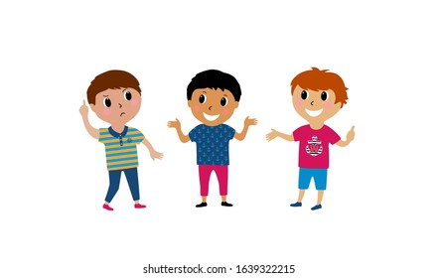

**studying**

**Verbs end with y before it consonant Study → studies**

**Verbs end with y before it vowel play → plays**

**Verbs end with ( o- sh - ch -ss-x ) ad es**

**go→ goes /watch → watches /mix →mixes /pass→ passes**

**Study → studying play→ playing**

**live → living singe → singeing Lie →lying**

**agree → agreeing stop→ stopping**

**Ali is playing tennis this week**

**She plays cards every week**

**He isn't playing cards**

**She doesn't play cards every day**

نجمة مهمة تنضّم إلى كوكب تويتر ...تعرّف عليها! - Al Arrab

**YesNo**

**Is he playing cards ?**

**Does she play cards every week ?**

**What is he playing ?**



**What does she play every week?**

**Whq**

**When is he playing tennis ?**

**When does she play cards ?**

**Who plays cards every week?**

**Who is playing tennis this week?**

**They are studying E these days**

**They play games once a week**

**They aren’t playing .**

**They don’t play cards every week**

**YesNo**

نجمة مهمة تنضّم إلى كوكب تويتر ...تعرّف عليها! - Al Arrab

**Are they studying Math ?**

**Do they play cards every week?**



**What are they studying ?**

**What do they play once a week?**

**When are they studying E ?**

**When do they play games ?**

**Whq**

|  |
| --- |
| Time expression ( key words ) |
| Usually, always, often , On Mondays  every day, week , month , Sunday …..  once a / twice a / 3 times a + week , day… |

**Who play games once a week ?**

**Who are studying E these days ?**

|  |
| --- |
| Time expression ( key words ) |
| now / right now / at this moment , today .currently  this + week/ weekend ( I am not working this week ) these + days / nights / At present Look ! / listen |

|  |  |  |  |  |  |  |  |
| --- | --- | --- | --- | --- | --- | --- | --- |
| **1** | **Ali ……………. to work every morning.** | | | | | | |
| **A** | **go** | **B** | **went** | **C** | **goes** | **D** | **gone** |
| **2** | **He ……………….. in new York** | | | | | | |
| **A** | **live** | **B** | **lives** | **C** | **living** | **D** | **lived** |
| **3** | **Omar is ……………….his father now** | | | | | | |
| **A** | **call** | **B** | **calls** | **C** | **calling** | **D** | **calling** |
| **4** | **A: ……………. are they doing? B: They are watching the game.** | | | | | | |
| **A** | **When** | **B** | **Why** | **C** | **What** | **D** | **Who** |
| **5** | **The poster ………… hanging on the wall** | | | | | | |
| **A** | **am** | **B** | **is** | **C** | **are** | **D** | **do** |
| **6** | **Look! Ahmad and Ali ……………..playing with their friend .** | | | | | | |
| **A** | **am** | **B** | **is** | **C** | **are** | **D** | **was** |
| **7** | **He ………………… football .** | | | | | | |
| **A** | **don’t play** | **B** | **doesn’t plays** | **C** | **doesn’t play** | **D** | **play** |
| **8** | **Do ………….. watch the game in the TV** | | | | | | |
| **A** | **they** | **B** | **she** | **C** | **he** | **D** | **It** |

**Tr. Amal Al Sulami**

# MG 2.2 Unit (2) Going Green Revision

**Present simple**

**( permanent )**

**Present progressive**

**( temporary )**

**Ali lives in Makkah but he is studying in France this year .**



I don’t understand the story.

**No stative verbs with the progressive**

**( like ,love , hate , want ,see , smell ,taste , hear , Know , understand )**



I am not understanding the story.

If clause

main clause

If conditional present / future

|  |  |
| --- | --- |
| Present facts  (zero conditional) | If + s + Vs / Vinf , s + Vs / V inf |
| If she heats water , It boils |
| Future facts  (first conditional) | If + s + Vs / Vinf , s + will / be going to + Vinf |
| If I have the money , I will / am going to buy the car |
| May/Might (possible) | If + s + Vs / Vinf , s + may /might + Vinf |
| If I have the money , I may buy the car  If she doesn’t have the skills , she may not get the job  If I don’t have the skills , I may not get the job |

You will pass the exam if you study hard

If you study hard , you will pass the exam



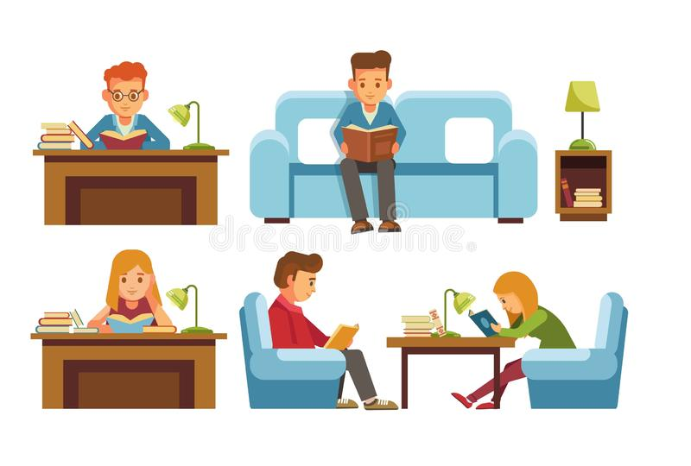

I'd rather + V inf ( to talk about preference)

**Would** **you rather study at home** **or** **in a library** ?

**I'd rather study at home**.

|  |  |  |  |  |  |  |  |
| --- | --- | --- | --- | --- | --- | --- | --- |
| **1** | **If you don’t water plants , they die** | | | | | | |
| **A** | **present fact** | **B** | **future fact** | **C** | **possible form** | **D** | **imaginary form** |
| **2** | **If she …………….junk food a lot , she will put on weight .** | | | | | | |
| **A** | **eat** | **B** | **ate** | **C** | **eats** | **D** | **eating** |
| **3** | **If you don’t study hard , you …………. not pass the exam ( future fact )** | | | | | | |
| **A** | **can** | **B** | **will** | **C** | **might** | **D** | **should** |
| **4** | **If we have time . we ……………..go shopping ( talk about possibility )** | | | | | | |
| **A** | **can** | **B** | **will** | **C** | **might** | **D** | **should** |
| **5** | **If we …………….a little longer , the bus might come .** | | | | | | |
| **A** | **Will wait** | **B** | **waiting** | **C** | **waited** | **D** | **wait** |
| **6** | **If I freeze water , it ………………..ice .** | | | | | | |
| **A** | **become** | **B** | **becomes** | **C** | **became** | **D** | **becoming** |
| **7** | **Our team ……………..if we don’t play well tomorrow** | | | | | | |
| **A** | **lose** | **B** | **will lose** | **C** | **lost** | **D** | **losing** |
| **8** | **If we hurry, we……………..the museum opening .** | | | | | | |
| **A** | **will miss** | **B** | **won't miss** | **C** | **doesn’t miss** | **D** | **didn’t miss** |
| **9** | **Would you rather ………………….. coffee or tea ?** | | | | | | |
| **A** | **drink** | **B** | **drinks** | **C** | **drank** | **D** | **drinking** |
| **10** | **I would rather …………..in a big city than a small one .** | | | | | | |
| **A** | **live** | **B** | **lives** | **C** | **lived** | **D** | **living** |

**Tr. Amal Al Sulami**

# MG 2.2 Unit (2) Going Green Revision Vocabulary

|  |  |  |  |  |  |  |  |
| --- | --- | --- | --- | --- | --- | --- | --- |
| **1** | **Pollution is the ……………..of many environment problems** | | | | | | |
| **A** | **air conditioner** | **B** | **source** | **C** | **organic** | **D** | **pesticides** |
| **2** | **………………..food is produced entirely without chemicals** | | | | | | |
| **A** | **pesticides** | **B** | **source** | **C** | **organic** | **D** | **recycle** |
| **3** | **It’s a ……………….and brave decision to live off the grid .** | | | | | | |
| **A** | **bold** | **B** | **weak** | **C** | **low** | **D** | **poor** |
| **4** | **Every parents should be …………………..and dedicated to their children** | | | | | | |
| **A** | **careless** | **B** | **uncommitted** | **C** | **committed** | **D** | **ignoring** |
| **5** | **Circle the odd advice** | | | | | | |
| **A** | **eat organic food** | **B** | **don’t recycle** | **C** | **conserve water** | **D** | **save energy** |
| **6** | **How about going out in a restaurant for dinner?** | | | | | | |
| **A** | **make a suggestion** | **B** | **ask for inf** | **C** | **answer what** | **D** | **a questionnaire** |
| **7** | **A: It's not working B: ………………you need a password to open it** | | | | | | |
| **A** | **a hassle** | **B** | **chuck** | **C** | **I guess** | **D** | **lame** |
| **8** | **Ss: Sorry I miss the bus cuz I was sleeping Tr: Really, this is a very …………excuse indeed** | | | | | | |
| **A** | **suitable** | **B** | **lame** | **C** | **right** | **D** | **appropriate** |
| **9** | **Ali : How did you solve it so easily . Bader : It's ……………..** | | | | | | |
| **A** | **a piece of cake** | **B** | **a hassle** | **C** | **difficult** | **D** | **hard** |
| **10** | **A: They offer me a full scholarship, what do you think? B: Really this is a ………, take it.** | | | | | | |
| **A** | **lame** | **B** | **no-brainer** | **C** | **hassle** | **D** | **chuck** |
| 11 | **A:I can't sort every material for recycling, this is a ……. B: But it's a good effort to your planet** | | | | | | |
| **A** | **simple** | **B** | **organic** | **C** | **hassle** | **D** | **easy** |
| **12** | **How dare you …………. away my old letters in the bin without asking me?** | | | | | | |
| **A** | **lame** |  | **no-brainer** |  | **hassle** |  | **chuck** |

**Classify the items into the correct category :**

**( enjoy – go – keep – stop – suggest - try – decide – forget – learn – plan – start - love- like – hate – can't stand )**

|  |  |  |
| --- | --- | --- |
| **Verb + gerund** | **Verb + full infinitive** | **either gerund or full infinitive** |
|  |  |  |

|  |  |  |  |
| --- | --- | --- | --- |
| 1 | relying | ( ) | dedicated |
| 2 | committed | ( ) | depending on |
| 3 | harsh | ( ) | basic service |
| 4 | utility | ( ) | severe, difficult |

**Match the words with their meaning**

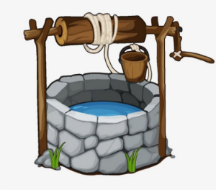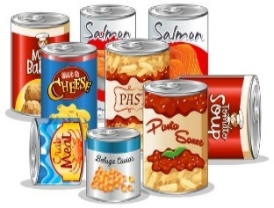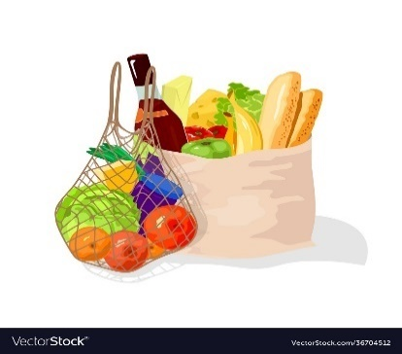

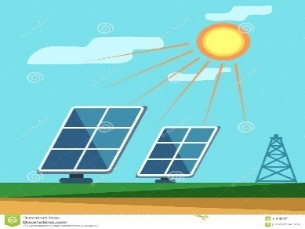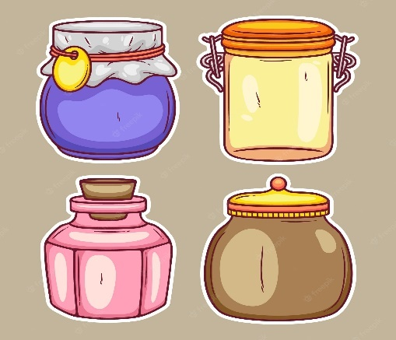

**Packaged food**

**Solar panels**

**jar**

**groceries**

**well**

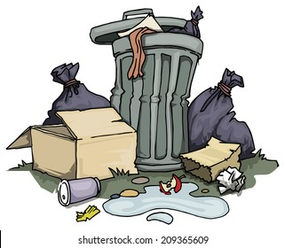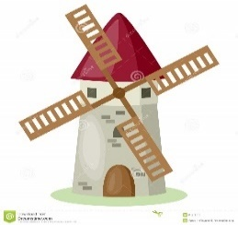

صورة تحتوي على خارجي, علامة, غرفة, مليء بالألوان

تم إنشاء الوصف تلقائياً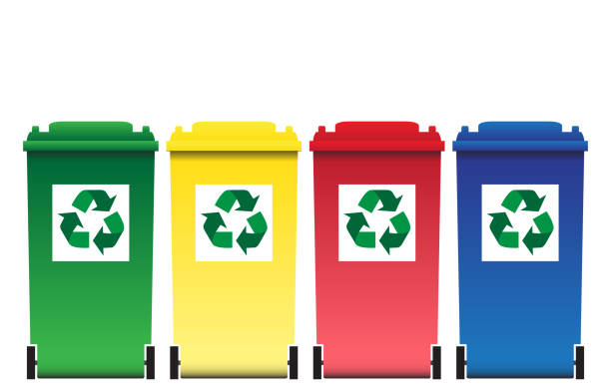

**garbage / waste /**

**landfill**

**utility**

**windmill**

**grid**

**recycling bin**

**Tr. Amal Al Sulami**