

**1- Do you think that laughter positively impacts both our mind and body?**

…………………………………..…………………………………………..………………………………………….……..

**3- Laughter can't help**

**to lose weight?**

……………………………………………………………………………………………………………………..………………

**2- Laughter increases oxygen levels in your body?**

…………………………………………………………………………..…………………………………………………..…

**MG2.3 U1 Reading**





**4- People with lower stress levels tend to get sick more often?**

………………………………………………………………………………………………………………………………

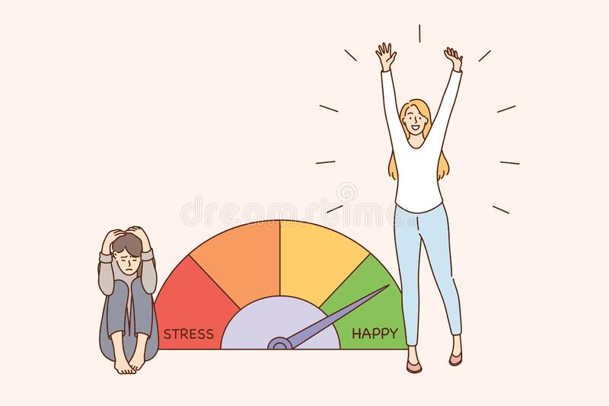

**5 -The first laughter club was started by an Indian doctor?**

…………………………………………..…………………………………………………………..…………………….……



**6- There are about 800 laughter clubs in the world today?**

………………………………………………………………………………………………………………………………

**Names:**

………….…………….…

…………….…………….

…………………………….

…………….…………….

……………………………

**6- Fake laughter does not produce the same health benefits as genuine laughter?**

………………………………………………………………………………………………………………………………………………

Tr. Amal Alsulami



