

اختبار فتري – الصف ..........
الاسم ثلاثي: |  | الفصل | / | الدرجة | / 20
Midterm Exam

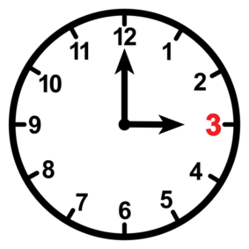
I. Choose the right answer :
2
- What is the time ?
- It is one o'clock. | - It is three o'clock.

- What does the firefighter do?
- He puts out fires . | - He flies plane .

222
II. Choose  OR 
3

It is seven o'clock. | He is a doctor. | I eat my lunch.
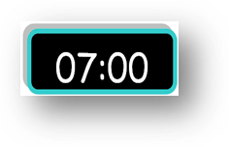 |  | 
  |   |  
2
III. Do as shown between brackets:

thirty | thousand | hundred |  1-one _______ . ( Choose )
ززززززززززززززززززززززززززززززززززززززززززززززززززززززززززززززززززززززززززززززززززززززززززززززززززززززززززززززززززززززززززززززززززززززززززززززززززززززززز |  |  | 2. is – a – she – teacher ( rearrange)
C. go | B. get | A. got | 1 – I usually ____ up at 5:00 .
C. Where | B. Who | A. What | 2. ____ does she do ? She is a nurse .
2

V. Choose the correct word:

6

 |  |  |  | 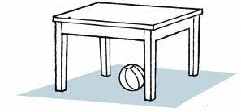 | 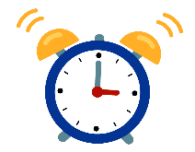
Eat | Take a bath | Engineer | Baker | Teacher | Clock
Brush | Get up | Firefighter | Nurse | Doctor | Ring
VI. Choose the correct letter:
  _ ilot |   dri_ _ |   ri_ _t | 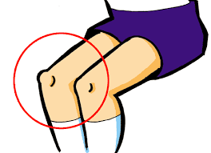  _ _ee |   ri_ _
b | nk | ph | gh | ng
p | kn | gh | kn | nk
5

TEACHER :

