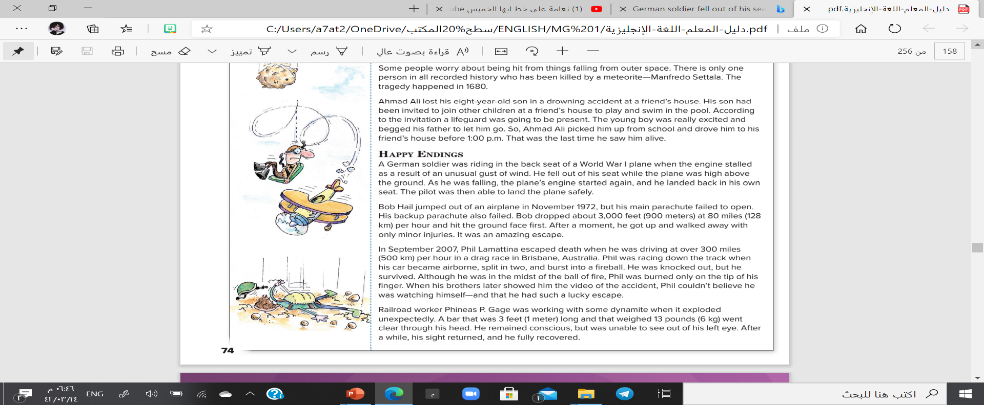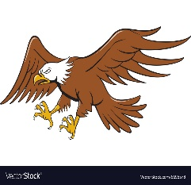

Unhappy Endings

Happy Endings

A German soldier?

…………………………………………………….…………………………………………………………….……………………………………………………….……………………………………………………………………….……………

Aeschylus death?

…………………………………………………….…………………………………………………………….……………………………………………………….……………………………………………………………………….……………

MG1.2 u5 reading ( Unusual Accidents and Deaths )

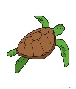

The Ostrich?

……………………………..……………………………………………………………..………..………………………………………..…………………………………………………………………..…….……….

Bob Hail?

…………………………………………………….…………………………………………………………….……………………………………………………….……………………………………………………………………….……………



Manfredo Settala?

……………………………………………………………………………………………………………………………..……………………………………………………………………………………………………………………………..…………

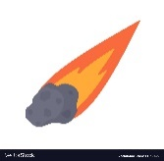

Phil Lamattina?

…………………………………………………….…………………………………………………………….……………………………………………………….……………………………………………………………………….……………

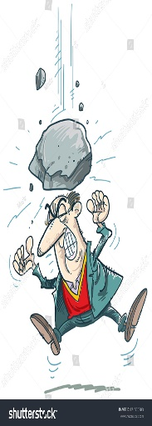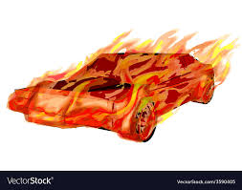

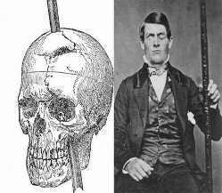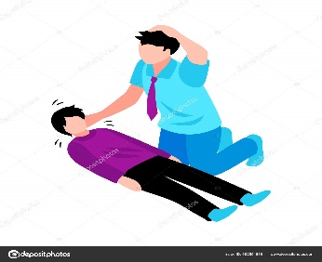

Phineas P. Gage?

…………………………………………………….…………………………………………………………….……………………………………………………….……………………………………………………………………….……………

Ahmad Ali's son?

……………………………………………………………………………………………………………………………..…………………………………………………………………………………………………………………………………………