**Revision Unit 6 Is there a view?**

**Name:……………………… Class: 1/..**

**☺vocabulary**

1. Match the words with the correct pictures:

( bathtub- lamp – chair – house – flowers - bed – laptop- stove)

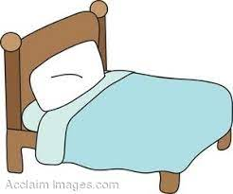

……………….. ……………….. ……………….. ……………….. ……………….. ……………….. ……………….. ………………..

1. Choose the correct answer: ( view – bedroom- large – garage – under- shelf)
2. I sleep in the ……………………………. with my sister.
3. The car is in the …………………………….
4. I put the books on the …………………………….
5. The opposite of (on) is …………………………….
6. The opposite of (small) is …………………………….
7. The balcony has a beautiful …………………………….
8. Choose the ***odd*** word:
9. Bathroom – bedroom – rug – kitchen
10. Mirror- shower- bathtub- sofa

**☺Grammar**

A) Choose the correct answer:

1. There ( are – is – be) a table in the kitchen.
2. There ( are – is – be) trees in the garden.
3. ( Are – Is – Be) there a sofa in the living room?
4. Shape

   Description automatically generated with medium confidence( Are – Is – Be) there pictures on the wall?
5. The ball is ( in – on – under) the box.
6. You can read a book ( or – but – out) a story.
7. She has a pencil ( bed – but – and) a bag.
8. My room is small ( or – but – out) comfortable.

**☺Orthography**

A)Choose the correct letter:

1. co….. d ( m- n- l) 4- hou…..e (s- v- m)
2. d….. yer (r- b- q) 5- d….. sk (e- i- a)
3. so….. a (n-f v) 6- di…..ing (m-n-d)

👍Good luck