**Revision Unit 9 Where do you do?**

**Name:……………………… Class: 1/..**

**☺ vocabulary**

1. Match the words with the correct pictures:

 ( player – cameraman – laptop - driver – smart phone - lawyer)

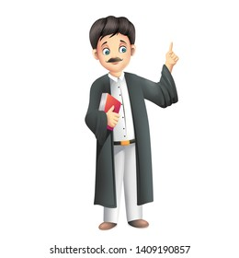

……………….. ……………….. ……………….. ……………….. ……………….. ………………..

( player – student – doctor – chef – flight attendant - grow up)

1. The ……………………………..works in a hospital.
2. When I ……………………………. I want to be a lawyer.
3. He is the best ……………………………. In the team.
4. Saleh likes to travel. He wants to be a …………………………….
5. She works at a restaurant. She is a …………………………….
6. Sandy is 13 years old. She is a …………………………….
7. Choose the ***odd*** word:
8. lawyer – sell - carpenter – waiter
9. cook – write - drive - film

**☺ Grammar**

A) Choose the correct answer:

1. I ( works – work – working ) in a store.
2. My father ( reading – reads – read) a story.
3. I sleep late ( so – or – because) I am tired.
4. I want a sandwich ( so – or – because) I am hungry.
5. Jack and I ( go – going – goes) to a pizza restaurant on Thursdays.
6. My cousin ( study –studies – studying) in her room in the afternoon.
7. My uncles ( play – plays – playing) football in the yard.

**☺ Orthography**

1. Choose the correct letter:
2. p….. ayer ( m- l- n) 4- t…..avel (n- r- m)
3. ga….. gets (f- b- d) 5- str….. ker (e- i- a)
4. web…..ite (s-k- c) 6- d…..eam (s - n-r)

👍Good luck