Name: …………………………………… Ms. Tahani
Class: 1st Intermediate
Revision Sheet _ Unit ( 8 ) : What Are You Doing?
- Vocabulary:
- Write the words under the pictures:
deliver – magazine – hang out – drink – wear


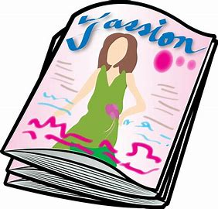


________________ __________________ __________________ __________________
- Classify the words:
science fiction – watch – comedy – study

Kinds of film | Verbs

- Circle the odd word:
- Kinds of film: action – comedy – sandwich – documentary

- Match:
- What’s up? a- looking for information
- checking out b- teenagers
. c- What’s happening?

- Fill in the blank with the correct words in the box:
food court – busy – generation – actor – speak

- I will be …………… cleaning the house.
- He can …………….. three languages.
- They ate dinner at the mall’s ……………………..
- Nasser AlQasabi is a famous ……………….

- Match the word with its opposite:
- advantage a- comfortable
- safe b- dangerous
c- disadvantage

- Grammar:
- Choose:
- We (am – is – are) studying now.
- He (am – is – are) playing volleyball now.
- I (am – is – are) eating now.
- Sara is (read – reads – reading) a story now.
- The children are (sleep – sleeps – sleeping).
- I would (like – to like – like to) a salad.
- I would (like – to like – like to) go to the mall.
- I would like (watch – to watch – watching) a comedy.

- Do as shown between brackets:
- He is chatting with a friend. (Change into negative)
…………………………………………………..
- They are surfing the internet. (Make a Yes/No question)
…………………………………………………..
- Is she drinking coffee? (Answer the question)
Yes, ……………………………
No, …………………………….
- I would like to a burger and fries. (Correct the mistake)
……………………………………………………
- I would like have lunch at the food court. (Correct the mistake)
……………………………………………………

