Unit 3 : Things We Do

* Choose the correct answer:

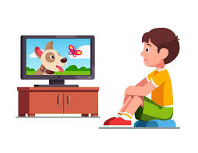

* I am ( watching – doing ) TV

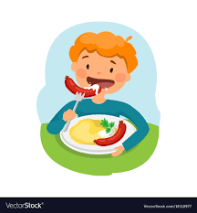

* I am ( drinking – eating ) snacks

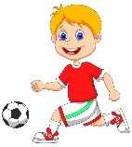

* I am ( doing – playing ) football

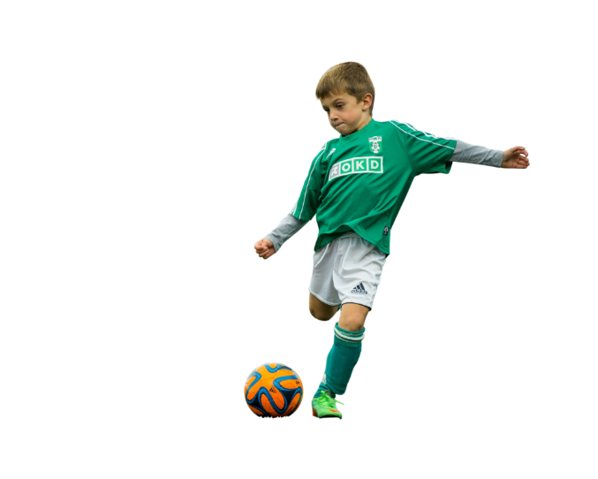ــــــــــــــــــــــــــــــــــــــــــــــــــــــــــــــــــــــــــــــــــــــــــــــــــ

* Put ( T ) or ( F ) :
* He is playing computer games ( )
* He is playing football ( )

ـــــــــــــــــــــــــــــــــــــــــــــــــــــــــــــــــــــــــــــــــــــــــــــــــــــ

* Fill in with ( t , d )

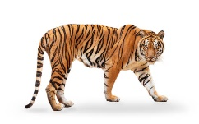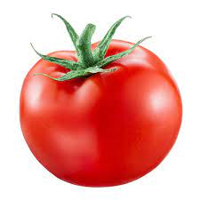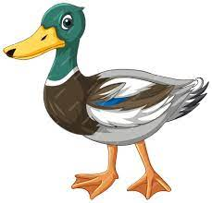

* ـــــ oor ـــــ iger ـــــ uck ــــــ omato

ــــــــــــــــــــــــــــــــــــــــــــــــــــــــــــــــــــــــــــــــــــــــــــــــــــــــــ

Unit 1 : Beautiful nature

**Quiz Unit 1**

**Beautiful Natures**

**ـــــــــــــــــــــــــــــــــــــــــــــــــــــــــــــــــــــــــــــــــــــــــــــــــــــ**

* **Match :**

|  |  |
| --- | --- |
| It’s beautiful | 1. Look it’s a plastic bag ! |
| It’s ugly | 1. Look at the flower |

* **Write the opposites :**  ( small , strong , short )

1. Long ــــــــــــــــــــــــــــــــــــــــــــــــــ
2. big ـــــــــــــــــــــــــــــــــــــــــــــــــــ

* **Match numbers with pictures** :

|  |  |  |  |  |  |
| --- | --- | --- | --- | --- | --- |
| 1- Snake | 2- summer | 3- winter | 4- noisy | 5- cake | 6- weak |

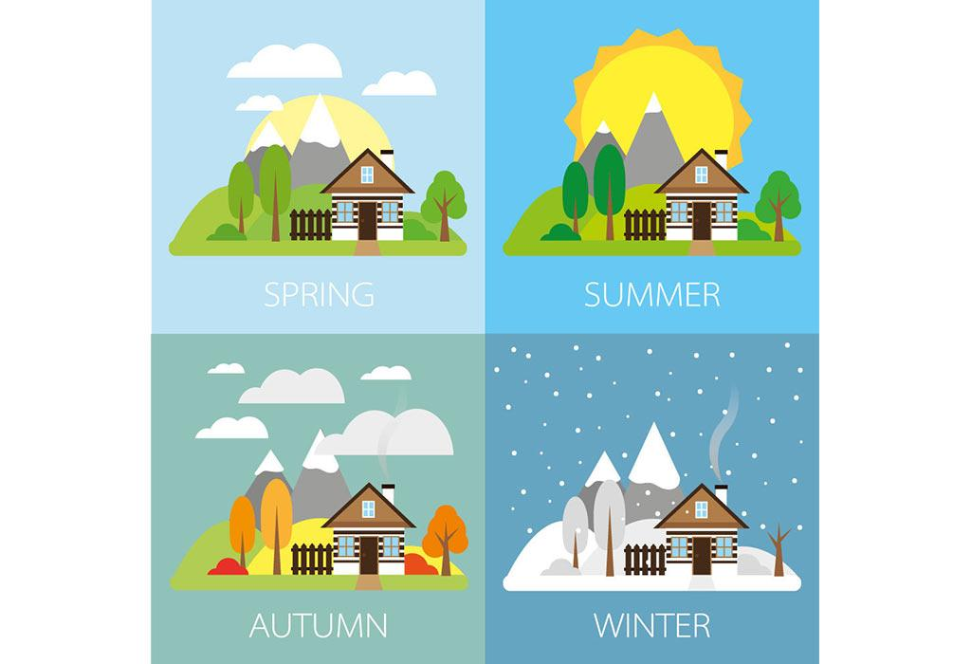

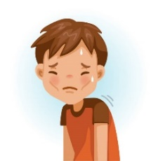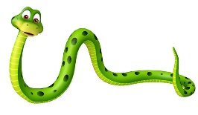

* **Fill in the missing letter ( cl , cr , gl , gr )**

|  |  |  |  |
| --- | --- | --- | --- |
|  |  |  |  |
| ـــ ـــ ass | ـــ ـــ ab | ـــ ـــ ass | ـــ ـــ ass |

**Teachers:** Samerah Alzahrani , Alia Alqahtani .