**Revision Unit 8 What are you doing ?**

**Name:……………………… Class: 1/..**

**☺ vocabulary**

1. Match the words with the correct pictures:

( pack - food court – newspaper – hang out - surf the net)



****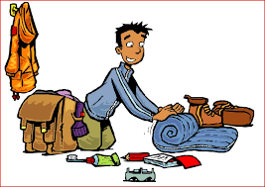

……………….. ……………….. ……………….. ……………….. ………………..

1. Choose the correct answer:

( customer – drinking – break - comedy – what's happening? - watching)

1. I'm ……………………………..TV.
2. My favorite kind of film is……………………………..
3. He's talking to a …………………………….
4. They need a ……………………………. after work.
5. She's ……………………………. coffee.
6. "What's up?" means ……………………………..

**☺ Grammar**

A) Choose the correct answer:

1. I ( am reading – read – reads) a story now.
2. My sister ( am – is – are ) watching a film.
3. The children ( am – is – are) playing video games.
4. Are you studying? Yes, ( I am – I am not – you are).
5. I would like to (go –going – goes) to the mall.
6. We (would like to - would like - would ) fries.

**☺ Orthography**

1. Choose the correct letter:
2. c….. fé ( o- e- a) 4- ci…..y (r- t- m)
3. wo….. k (r- b- t) 5- vi….. it (b- g- s)
4. he…..p (m-l- v) 6- custo…..er (m-n-v)

👍Good luck