

English Language

Intermediate Grade 1st

period Exam

………\20

Kingdom of Saudi Arabia

Ministry of Education

………..Education Directorate

………………… Intermediate School

Student's Name : class:

**Reading comprehension ✦**

[](https://t.me/Asmaworld)

……\ 5 marks

1-Read the following passage and answer the questions below:

My house is where my family lives. It is white. There are four bedrooms. We have a kitchen and three bathrooms. Our family room is where we like to watch television together. We have a playroom .There is a garden in the house and we have a swing there. Our house is near the elementary school.

|  |  |  |
| --- | --- | --- |
| 1-What color is the house? | | |
| c- red | b- white | a- blue |
| 2-Who lives in the house? | | |
| c- students | b- friends | a- family |
| 3-How many bedrooms are in the house? | | |
| c- four | b- five | a- one |
| 4-The house is …….. the elementary school. | | |
| c- next to | b- near | a- on |
| 5-What is in the garden? | | |
| c- bicycle | b- football | a- swing |

……\ 4 marks

**Grammar**  ✦

**A. Choose the correct answer.**

1- Ahmad is the ( tall – taller – tallest ) student in the class.

2- We live ( in – on – for )the twelfth floor.

3- We read ( or – and – but ) write in class.

4-( Is – Am - Are )there curtains in the kitchen?

5-There ( is - are – am ) a car in the garage ..

6-Sami is ( smart – smarter – smartest ).

7-. Ali lives ( in – on – from ) Jeddah.

8-Healthy food is( good – better – best ) than fast food.

**B. Do as shown between brackets.**

**1-Correct**

a-Summer is the **hotter** time of the year. …………………

b-There **are** a Tv in the living room. ……………………….

……\ 2 marks

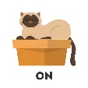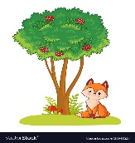**2-Choose the correct answer.**

……\ 2 marks

a-The cat is ( in – far from - on ) the box.

b-2-the fox is ((across from - between – next to )the tree.

✦  **Vocabulary**

……\ 5 marks

**A.Match the correct word for each picture.**

stove bridge bathtub lake

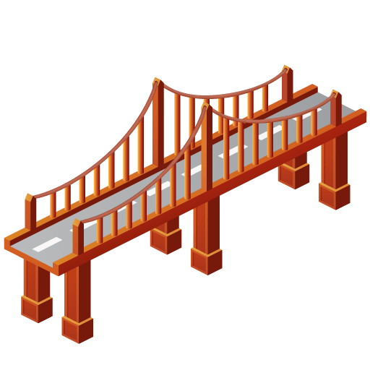

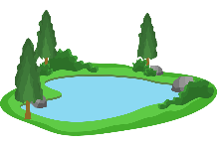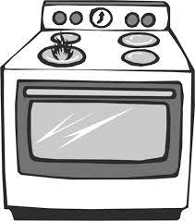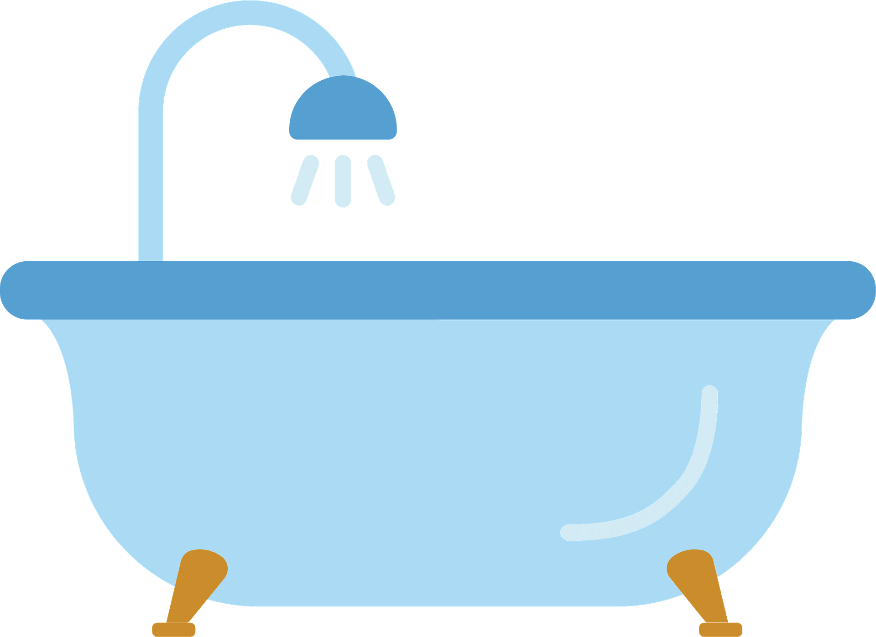

………………..

………………..

………………..

………………..

**B-choose the correct answer.**

1-a place to eat ( restaurant – bank - airport )

2-The opposite of small≠ ( big - tiny - happy)

3- The opposite of unusual ≠ ( cave – usual – bookstore)

4-a place to take a walk( (school- park – supermarket )

**C-Find the odd words.**

1- ( house parts ) : bedroom garage bank

2-(Laundry Room): washer laptop dryer

**✦ Orthography**

**Choose the corre**

……\ 2 marks

**A-Write the missing letters.**

1- Ar…..chair 2- Clo….et

**B.Choose the missing letters.**

1- a piz..eria is a restaurant that sells pizza.( z - o - k ).

2-He went to the museu… by taxi ( j – h – m ).

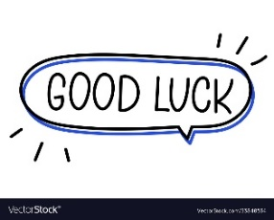

Your teacher …..:…………………………….