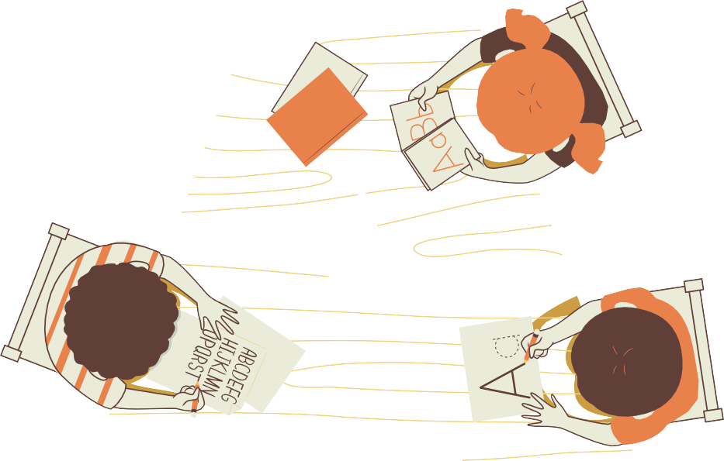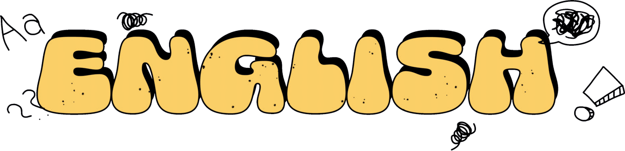

أوراق ﻋﻤﻞ

ﻟﺠﻤﻴﻊ وﺣﺪات اﻟﻔﺼﻞ اﻟﺪراﺳﻲ اﻟﺜﺎﻧﻲ ﻣﻦ اﻟﺼﻒ اﻟﺜﺎﻟﺚ ﻟﻠﺴﺎدس

)ﻟﻐﺔ اﻧﺠﻠﻴﺰﻳﺔ(

اﻋﺪاد اﻟﻤﻌﻠﻤﺔ: ﻋﺎﺗﻜﻪ ﻋﻄﻴﻒ

Nare:………………………………..

U:1

Yeeda¥ asd Tzda¥

¢zkhee

Dae: What time is it?

Da¢ he hz asd rise hasd zs each clzck z hz¢ he czec ire:

9:20

1:10

6:40

7:00

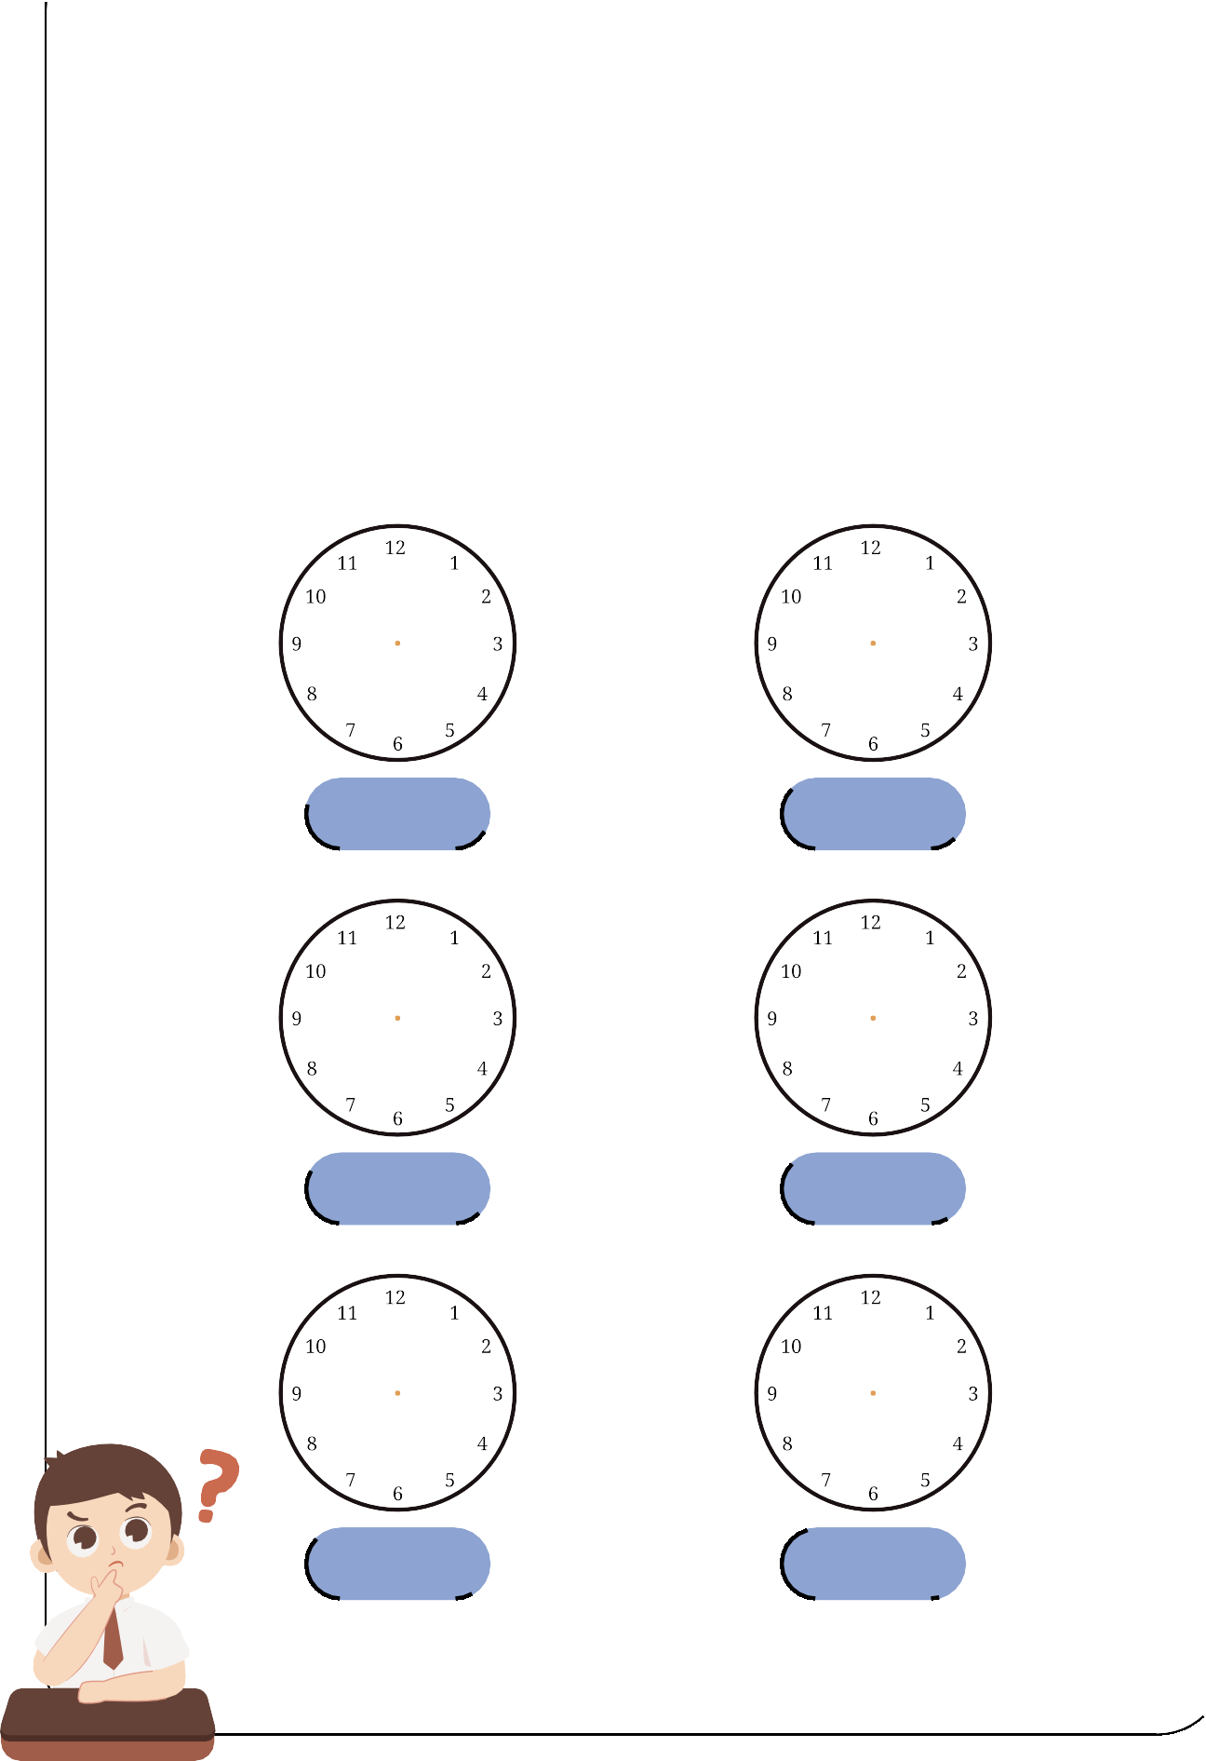

5:45 11:30

U:1

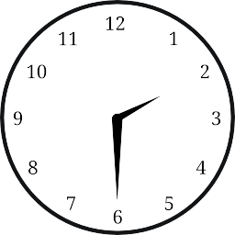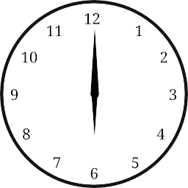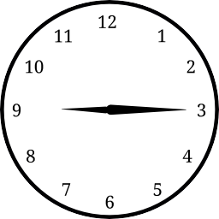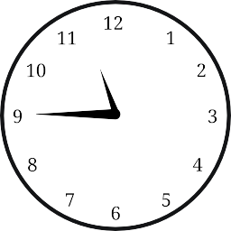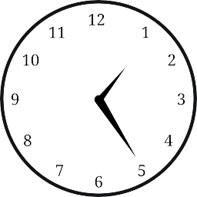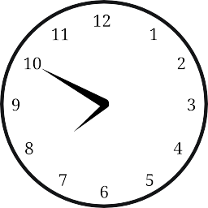

Yeeda¥ asd Tzda¥

¢zkhee

Nare:………………………………..

Dae: What time is it?

Wie he ire:

: : :

: : :

U:1

Yeeda¥ asd Tzda¥

¢zkhee

Nare:………………………………..

Dae:

What time is it?

## Choose the correct answer:

|  |  |  |  |
| --- | --- | --- | --- |
|  | 11:30 | 4:15 | 1:20 |
|  | 7:30 | 6:30 | 8:10 |
|  | 5:10 | 2:25 | 3:20 |
|  | 12:15 | 11:00 | 9:00 |
|  | 7:40 | 6:40 | 7:45 |



U:1

Yeeda¥ asd Tzda¥

¢zkhee



Nare:………………………………..

Dae:

What time is it?



Choose the correct answer:

|  |  |  |
| --- | --- | --- |
|  |  |  |
| a quarter past three  a quarter past seven half past two | half past one six O’clock  half past twelve | a quarter to nine  half past eghit  nine O’clock |
|  |  |  |
| seven O’clock twelve O’clock  a quarter past seven | a quarter past ten  ten O’clock  half past ten | four O’clock  half past five  a quarter to two |

Name:………………………………..

Date:

U:1/L:2

Yesterday and Today worksheet

Choose the correct answer:

|  |  |  |
| --- | --- | --- |
| **I usually at 6:00.** | get up | got up |

eat lunch ate lunch

**Yesterday I at 2:00.**

come home

**Yesterday I at 12:00.**

came home

do my homework

**I usually at 5:00.**

did my homework

|  |  |  |
| --- | --- | --- |
| **Yesterday I at 7:00.** | take a bath | took a bath |
|  |

|  |  |  |
| --- | --- | --- |
| **I usually at 10:00.** | go to bed | went to bed |



U:1/L:2

Yesterday and Today worksheet

Name:………………………………..

Date:

Write the past tense:

get up eat lunch come home



do my homework take a bath

go to bed

……………………………..

……………………………..

……………………………..

……………………………..

……………………………..

……………………………..

Name:………………………………..

Date:

U:1/L:2

Yesterday and Today worksheet

Match:



get up

did my homework

eat lunch

went to bed

come home

got up

do my homework

ate lunch

take a bath

took a bath

go to bed

came home

Name:………………………………..

Date:

U:1/L3

Yesterday and Today worksheet

**What Time Do You Do It?**

**Choose the correct time:**

10:00

6:00

1:00

2:00



**At o’clock,**

**I jump out of bed And brush my teeth.**

**At o’clock**

**I finish school￼￼￼ And ride the bus home**.

**At o’clock**

**I eat my lunch**

**And meet my friends**.

**At o’clock**

**I jump into bed And dream a lot**!

U:1/L:4

Yesterday and Today worksheet

Name:………………………………..

Date:

# Choose , or to complete the words:

nk

ng

ck



|  |  |  |  |  |  |  |  |  |  |  |  |
| --- | --- | --- | --- | --- | --- | --- | --- | --- | --- | --- | --- |
| swi…… | | | ro…… | | | ri…… | | | clo…… | | |
| nk | ng | ck | nk | ng | ck | nk | ng | ck | nk | ng | ck |

|  |  |  |  |  |  |  |  |  |  |  |  |
| --- | --- | --- | --- | --- | --- | --- | --- | --- | --- | --- | --- |
| i…… | | | dri…… | | | spri…… | | | ba…… | | |
| nk | ng | ck | nk | ng | ck | nk | ng | ck | nk | ng | ck |

Choose the correct sound:

Ph

Wh

Sh

Ch





…..ocolate …..ale



…..ip tele…..one

U:2/L:1

Jobs worksheet

Name:………………………………..

Date:

# Match:

1- doctor 2- housewife 3- astronaut 4- reporter

5- engineer 6- cook 7- pilot 8- firefighter

9- nurse 10- computer techni 11- lawyer 12- diver

13- businessman 14- teacher 15- architect



( ) ( ) ( ) ( ) ( )



( ) ( ) ( ) ( ) ( )



( ) ( ) ( ) ( ) ( )

U:2/L:1

Jobs worksheet

Name:………………………………..

Date:

# Choose the correct answer:

|  |  |
| --- | --- |
| He is….doctor. | |
| a | an |

|  |  |
| --- | --- |
| She is….nurse. | |
| a | an |

|  |  |
| --- | --- |
| He is….astronaut . | |
| a | an |

|  |  |
| --- | --- |
| He is….diver. | |
| a | an |

|  |  |
| --- | --- |
| He is….engineer. | |
| a | an |

|  |  |
| --- | --- |
| She is….teacher. | |
| a | an |

Name:………………………………..

Date:

U:2/L:3

Jobs worksheet

match:

1- teacher

2- baker

3- singer

4- designer

5- doctor

6- TV reporter

1. writer
2. presenter
3. scientist



( ) ( ) ( ) ( )



( ) ( ) ( ) ( )



( )

Name:………………………………..

Date:

U:2/L:4

Jobs worksheet

Choose the correct sound:

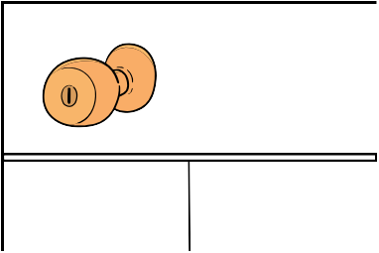

……ob

Kn

gh

|  |  |
| --- | --- |
| ni……t | |
| Kn | gh |

|  |  |
| --- | --- |
| li……t | |
| Kn | gh |

|  |  |
| --- | --- |
| ……ife | |
| Kn | gh |

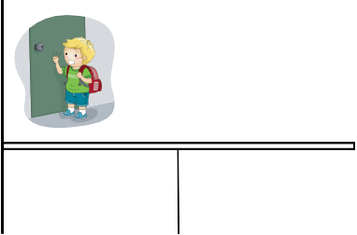

……ock

Kn

gh

|  |  |
| --- | --- |
| ri……t | |
| Kn | gh |

Choose the correct sound:



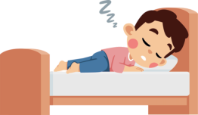

/Z/

/S/

/IZ/

sleeps……… watches……… goes………





teaches……… walks……… reads………

Name:………………………………..

Date:

U:2/L:4

Jobs worksheet



Write the missing numbers:

10 20 40

70 90

100 300 600

900

Name:………………………………..

Date:

U:3/L:1

Fun on the Weekend worksheet

Fill in the missing words in chart:

Verb Past tense -ed

………………………

|  |
| --- |
| clean |
| practice |
| watch |
| kick |
| play |
| study |
| cook |
| stay |

………………………

………………………

………………………

………………………

………………………

………………………

………………………



Name:………………………………..

Date:

match:

## Noura stayed home.

U:3/L:1

Fun on the Weekend worksheet

## ( )



1. They played computer games. ( )

## You practiced on the trampoline. ( ) 4-I cleaned my room.

( )

## Ali cooked breakfast. ( )

1. He kicked a ball for three hours. ( )

## He watched a DVD about sharks. ( )

1. Fahad studied for six hours. ( )

U:3/L:2

Fun on the Weekend worksheet

Name:………………………………..

Date:

## Categorize the following verbs as pronounced:

**practiced cleaned studied watched played cooked kicked stayed**

for **ed** say /**d**/

for **ed** say /**t**/



Name:………………………………..

Date:

U:3/L:3

Fun on the Weekend worksheet

## Fill in the blanks with How much or How many:

**1/ flour do we need to make a cake? 3 cups.**

**2/…………………tomatoes are there in the fridge? 6 tomatoes. ** **3/ apples do we need for the apple pie? I don‘t know.**



**4/…………………milk do you drink in the morning? About 2 cups. **

## Fill in the blanks with some or any:

**1/We have………………sugar, but we don‘t have milk.**

**2/There is orange juice in the kitchen.**

**3/There isn’t oil in the bottle.**

**4/There are chocolates in the box.**



Name:………………………………..

Date:

U:3/L:4

Fun on the Weekend worksheet

Choose the correct sound:

|  |  |
| --- | --- |
| sa……. | |
| nd | nt |

|  |  |
| --- | --- |
| pla……. | |
| nd | nt |

ha…….

nd

nt



pai…….

nd

nt



Name:………………………………..

Date:

U:4/L:1

Life’s Ups and Downs worksheet



Bad Things

Good Things

**Categorize the following sentences good things or bad things :**

**1-We were stuck in an elevator. 2-I saw a rainbow.**

**3-I got first place in a race. 4-I caught a cold.**

**5-I made a rocket. 6-I broke my leg.**

Name:………………………………..

Date:

match:

U:4/L:1

Life’s Ups and Downs worksheet

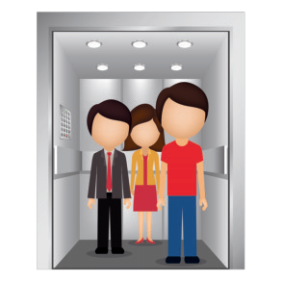

**( )**

**1-We were stuck in an elevator.**

**( )**

**2-I saw a rainbow.**

**( )**

**3-I got first place in a race.**

**( )**

**4-I caught a cold.**

**5-I made a rocket. ( )**

**6-I broke my leg.**

**( )**

**7-I won a table tennis**

**game 21 to 3. 8 0**

**( )**

1. **We lost a football game**

**8 to 0. ( )**

1. **My dad had an operation. ( ) 10-I was team captain.**

**( )**

Name:………………………………..

Date:

U:4/L:2

Life’s Ups and Downs worksheet

**Categorize the following verbs to present and past tense:**

get lost

won lose caught

made see

am,is was

win got

make

catch

had

broke

were

saw

break

are

have, has





|  |  |
| --- | --- |
| Present | Past |
|  |  |

Name:………………………………..

Date:

U:4/L:3

Life’s Ups and Downs worksheet

Write the past tense:

|  |  |
| --- | --- |
| Present | Past |
| gets |  |
| comes |  |
| has |  |
| is |  |
| goes |  |



Name:………………………………..

Date:

# match:

U:4/L:3

Life’s Ups and Downs worksheet

Present

Past

gets comes has

is

goes

went got was

had

came

Name:………………………………..

Date:

U:4/L:4

Life’s Ups and Downs worksheet

# Choose the correct sound:

f

ph

gh

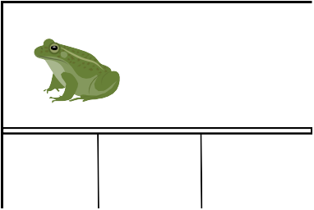

….rog

f

ph gh



…one

f

ph gh



ele…ant

f

ph gh

|  |  |  |
| --- | --- | --- |
| lau….. | | |
| f | ph | gh |

