Name: …………………………………… Ms. Tahani ☺

Class: 1st Intermediate

**Revision Sheet _ Unit ( 9 ) : What Do You Do?**

1. **Vocabulary:**
2. **Write the words under the pictures:**

**newspaper – lawyer – waiter – carpenter – reporter**



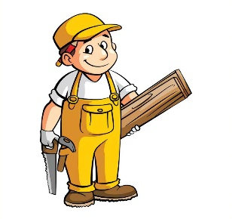

**________________ __________________ __________________ __________________**

1. **Classify the words:**

**clinic – mechanic – salesperson – school**

|  |  |
| --- | --- |
| **Jobs** | **Place of work** |
|  |  |
|  |  |

1. **Circle the odd word:**
2. **Jobs:** chef – designer – gadget – teacher
3. **Place of work:** hospital – restaurant – cameraman – store
4. **Match the opposites:**
5. agree a- bored
6. interested b- difficult

. c- disagree

1. **Fill in the blank with the correct words in the box:**

**cook – drive – meet – sell – travel**

1. These store ……………. clothes and shoes.
2. I will ………….. you at 10 o’clock.
3. Ali is not old enough to …………….. a car.
4. It is expensive to ……………… by plane.
5. **Grammar:**
6. **Choose:**
7. **A: (What – Where – Why)** do you do?

**B:** I am a flight attendant.

1. **A:** **(What – Where – Why)** do you want to be a doctor?

**B:** Because I want to help sick people.

1. I like Math **(and – but – or)** I like history.
2. I like coffee **(and – but – or)** I don’t like tea.
3. I am sick, **(because – so – or)** I will take a painkiller.
4. I want to be an architect **(because – so – or)** I like to design houses.
5. **A:** What **(do – does – are)** she do?

**B:** she **(do – does – is)** a nurse.

1. **A:** What **(do – does – is)** they do?

**B:** They are football players.

1. Yasser **(work – works – working)** in the bank.
2. My uncle **(drive – drives – driving)** a bus.
3. Ali and Omar **(play – plays – playing)** tennis.
4. Mothers **(cook – cooks – cooking)** the dinner for their children.
5. **Do as shown between brackets:**
6. Yara usually **(write)** a letter to her friend. **(Correct the mistake)**

……………………………………………………

1. Deema and Rand are teachers. They **(works)** at school. **(Correct the mistake)**

……………………………………………………

1. I like drawing, **(and)** I don’t like reading. **(Correct the mistake)**

……………………………………………………

1. I have to study **(so)** I have an exam tomorrow. **(Correct the mistake)**

……………………………………………………

1. for / writes / a magazine / Fahad  **(Rearrange)**

……………………………………………………

1. **A:** …………………………………………………? **(Complete)**

**B:** I am a bus driver.

1. **A:** ………………………………………………….? **(Complete)**

**B:** Sami is a reporter.