**Mega Goal 2.2 – Units 5-6 Quiz – Group A**

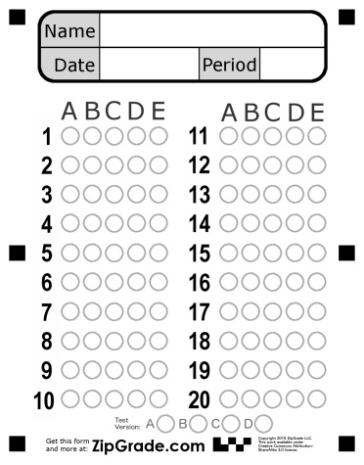**Name**: ……………………………………………………………………………….. **Class**: ……………………………..

|  |  |  |  |  |
| --- | --- | --- | --- | --- |
| **1** | **The……………………… performed surgery to fix the patient's broken leg.** | | | |
| 1. **engineer** | | 1. **habitat** | 1. **sewing** | 1. **surgeon** |
| **2** | **Don’t tell that guy what I said . ……………………** | | | |
| 1. **in a bind** | | 1. **keep it to yourself** | 1. **take off** | 1. **cover** |
| **3** | **………………….. = exactly the same** | | | |
| 1. **identical** | | 1. **flair** | 1. **captive** | 1. **analyze** |
| **4** | **……………… fruits and vegetables are grown without the use of harmful chemicals.** | | | |
| 1. **recycling** | | 1. **canvas** | 1. **organic** | 1. **energy** |
| **5** | **How do you do that ? “ It’s …………………………………… ! watch.** | | | |
| 1. **chucked** | | 1. **a piece of cake** | 1. **no-brainer** | 1. **lame** |
| **6** | **…………….. = depending on** | | | |
| 1. **bold** | | 1. **I guess** | 1. **perspective** | 1. **relying** |
| **7** | **……………….. = extremely large .** | | | |
| 1. **perspective** | | 1. **harsh** | 1. **enormous** | 1. **bold** |
| **8** | **It is important that she ………………………………… late.** | | | |
| 1. **not be** | | 1. **be not** | 1. **not being** | 1. **being not** |
| **9** | **I want you to …………………………… the dish** | | | |
| 1. **are cleaned** | | 1. **cleaned** | 1. **cleaning** | 1. **clean** |
| **10** | **You ……………………………… smoke here . It’s not allowed** | | | |
| 1. **must** | | 1. **mustn’t** | 1. **not must** | 1. **have to** |
| **11** | **He was watching TV, ……………………………………………. ?** | | | |
| 1. **Wasn't he** | | 1. **Was he** | 1. **He wasn't** | 1. **Doesn't He** |
| **12** | **I prefer …………………………… organic food** | | | |
| 1. **eats** | | 1. **to eats** | 1. **eating** | 1. **eat** |
| **13** | **I want to …………………………… TV** | | | |
| 1. **watches** | | 1. **watching** | 1. **watched** | 1. **watch** |
| **14** | **He …………………………… basketball every Sunday .** | | | |
| 1. **plays** | | 1. **is playing** | 1. **play** | 1. **are playing** |
| **15** | **If you freeze water , it …………………………… a solid .** | | | |
| 1. **became** | | 1. **becomes** | 1. **becoming** | 1. **become** |