|  |  |  |  |
| --- | --- | --- | --- |
| **متفوق** | **متقدم** | **متمكن** | **غير مجتاز** |
|  |  |  |  |

**رقم المهارة**

**التقييم**

**9**

|  |
| --- |
| **1 – How old are you ?**  **A** . **I am fine thank you .** **B** . **I am 7 years old .** |
| **I \_\_\_\_\_\_ \_\_\_\_\_ years old** . **2 –How old are you?** |

**رقم المهارة**

**التقييم**

25

|  |  |  |  |
| --- | --- | --- | --- |
| **متفوق** | **متقدم** | **متمكن** | **غير مجتاز** |
|  |  |  |  |

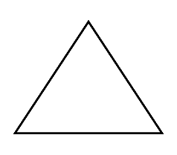

|  |  |  |
| --- | --- | --- |
| **1.It's a triangle .** | 🗸 | 🗴 |
| **2 – Three little camels .** | 🗸 | 🗴 |

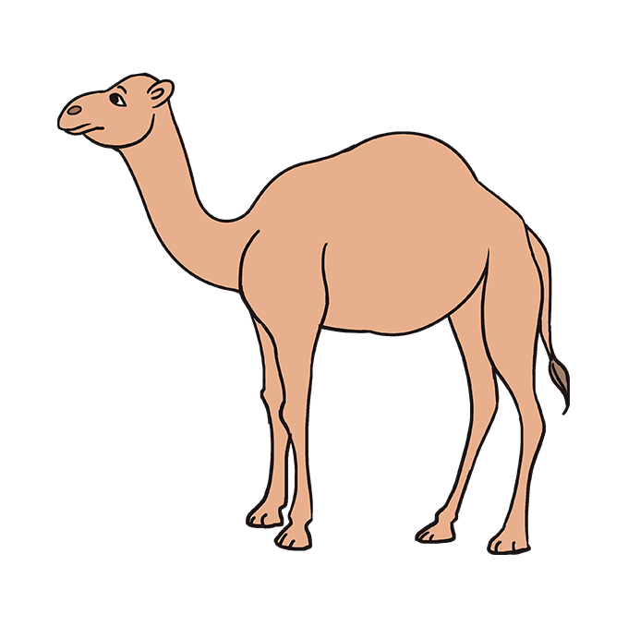

\_\_\_\_\_\_\_\_\_\_\_\_\_\_\_\_\_\_\_\_\_\_\_\_\_\_\_\_\_\_\_\_\_\_\_\_\_\_\_\_\_\_\_\_\_\_\_\_\_\_\_\_\_\_\_\_\_\_\_\_\_\_\_\_\_\_\_\_\_\_\_\_\_\_\_\_\_\_\_\_\_\_\_\_\_\_\_\_\_\_\_\_\_\_\_\_\_\_\_\_\_\_\_\_\_\_\_\_\_\_\_\_\_\_\_\_\_\_\_\_\_\_\_\_\_\_\_\_\_\_\_\_\_\_\_\_\_\_\_\_\_\_\_\_\_\_\_\_\_\_\_\_\_\_\_\_\_\_\_\_\_\_\_\_\_\_\_\_\_\_\_\_\_\_\_\_\_\_\_\_\_\_\_\_\_\_\_\_\_\_\_\_\_\_\_\_\_

**التقييم**

**رقم المهارة**

|  |  |  |  |
| --- | --- | --- | --- |
| **متفوق** | **متقدم** | **متمكن** | **غير مجتاز** |
|  |  |  |  |

23

**read aloud the following:**

|  |  |
| --- | --- |
| **camel** | **One** |
| **fish** | **star** |
| **Four little camels.** | **I am ten.** |

|  |  |  |  |
| --- | --- | --- | --- |
| **متفوق** | **متقدم** | **متمكن** | **غير مجتاز** |
|  |  |  |  |

31 **,** 1

**التقييم**

**رقم المهارة**

**read and complete the letters:**

|  |  |
| --- | --- |
|  | **F** |
|  | **H** |

|  |  |
| --- | --- |
| **b** |  |
| **d** |  |

|  |  |
| --- | --- |
|  | **Y** |
| **z** |  |

**Rewrite the letters**

-------------------------------------------------------------------------------------------------------------------------------------------------------------------------------------------------------------------------------------------------------------------------------------------------------------------------------------------------------------------------------------------------------------------------------------------------------------------------------------

**\_\_\_\_\_\_\_\_\_\_\_\_\_\_\_\_\_\_\_\_\_\_\_\_\_\_\_\_\_\_\_\_\_\_\_\_\_\_\_\_\_\_\_\_\_\_\_\_\_\_\_\_\_\_\_\_\_\_\_\_\_\_\_\_\_\_\_\_\_\_\_\_\_\_\_\_\_\_\_\_\_\_\_\_\_\_\_\_\_\_\_\_\_\_\_\_\_\_\_\_\_\_\_\_\_\_\_\_\_\_\_\_\_\_\_\_\_\_\_\_\_\_\_\_\_\_\_\_\_\_\_\_\_\_\_\_\_\_\_\_\_\_\_\_\_\_\_\_\_\_\_\_\_\_\_\_\_\_\_\_\_\_\_\_\_\_\_\_\_\_\_\_\_\_\_\_\_\_\_\_\_\_\_\_\_\_\_\_\_**

**رقم المهارة**

**28 ,29 , 30 , 32**

|  |  |  |  |
| --- | --- | --- | --- |
| **متفوق** | **متقدم** | **متمكن** | **غير مجتاز** |
|  |  |  |  |

**التقييم**

**I'm ten years old.**

------------------------------------------------------------------------------------------------------------------------------------------------------------------------------------------------------------------------------------------------------------

------------------------------------------------------------------------------------------------------------------------------------------------------------------------------------------------------------------------------------------------------------

\_\_\_\_\_\_\_\_\_\_\_\_\_\_\_\_\_\_\_\_\_\_\_\_\_\_\_\_\_\_\_\_\_\_\_\_\_\_\_\_\_\_\_\_\_\_\_\_\_\_\_\_\_\_\_\_\_\_\_\_\_\_\_\_\_\_\_\_\_\_\_\_\_\_\_\_\_\_\_\_\_\_\_\_\_\_\_\_\_\_\_\_\_\_\_\_\_\_\_\_\_\_\_\_\_\_\_\_\_\_\_\_\_\_\_\_\_\_\_\_\_\_\_\_\_\_\_\_\_\_\_\_\_\_\_\_\_\_\_\_\_\_\_\_\_\_\_\_\_\_\_\_\_\_\_\_\_\_\_\_\_\_\_\_\_\_\_\_\_\_\_\_\_\_\_\_\_\_\_\_\_\_\_\_\_\_\_\_\_\_\_\_\_\_\_\_\_\_\_

**التقييم**

|  |  |  |  |
| --- | --- | --- | --- |
| **متفوق** | **متقدم** | **متمكن** | **غير مجتاز** |
|  |  |  |  |

**رقم المهارة**

**5**

**Listen to the word and match with letters :**

|  |  |  |  |
| --- | --- | --- | --- |
| **h** | **j** | **g** | Straw Hat Madeline Hat Cospaly Monkey D Luffy Performance Props Costume  Party Yellow Summer Strawhats with String Sun Beach Hats Japanese Pirate  Anime Fans Men Women Youth Kids Gifts Decorations : Buy  **1 –** |
| **k** | **c** | **f** | figure of camel for Sale OFF 65%  **2-** |
| **b** | **g** | **d** | 53+ Thousand Cartoon Goat Royalty-Free Images, Stock Photos & Pictures |  Shutterstock  **2-** |

\_\_\_\_\_\_\_\_\_\_\_\_\_\_\_\_\_\_\_\_\_\_\_\_\_\_\_\_\_\_\_\_\_\_\_\_\_\_\_\_\_\_\_\_\_\_\_\_\_\_\_\_\_\_\_\_\_\_\_\_\_\_\_\_\_\_\_\_\_\_\_\_\_\_\_\_\_\_\_\_\_\_\_\_\_\_\_\_\_\_\_\_\_\_\_\_\_\_\_\_\_\_\_\_\_\_\_\_\_\_\_\_\_\_\_\_\_\_\_\_\_\_\_\_\_\_\_\_\_\_\_\_\_\_\_\_\_\_\_\_\_\_\_\_\_\_\_\_\_\_\_\_\_\_\_\_\_\_\_\_\_\_\_\_\_\_\_\_\_\_\_\_\_\_\_\_\_\_\_\_\_\_\_\_\_\_\_\_\_\_\_\_\_\_\_\_\_

|  |  |  |  |  |
| --- | --- | --- | --- | --- |
| 53+ Thousand Cartoon Goat Royalty-Free Images, Stock Photos & Pictures |  Shutterstock | GMAT Circles: An Introduction - Magoosh Blog — GMAT® Exam | A blue fish cartoon Royalty Free Vector Image - VectorStock | Cartoon jet fighter military machine Stock Illustration by ©illustrator_hft  #147056643 | Stars Cartoon png download - 2555*2430 - Free Transparent Star png  Download. - CleanPNG / KissPNG |
| Camel | circle | fish | ink | star |
| goat | triangle | hat | jet | car |

|  |  |  |  |
| --- | --- | --- | --- |
| **متفوق** | **متقدم** | **متمكن** | **غير مجتاز** |
|  |  |  |  |

**التقييم**

**24**

**رقم المهارة**

\_\_\_\_\_\_\_\_\_\_\_\_\_\_\_\_\_\_\_\_\_\_\_\_\_\_\_\_\_\_\_\_\_\_\_\_\_\_\_\_\_\_\_\_\_\_\_\_\_\_\_\_\_\_

**التقييم**

**رقم المهارة**

|  |  |  |  |
| --- | --- | --- | --- |
| **متفوق** | **متقدم** | **متمكن** | **غير مجتاز** |
|  |  |  |  |

**26**

**Listen then write the missing letter:**

|  |
| --- |
| Number 7-images - Number 7 Images Cartoon Transparent PNG - 4325x6704 -  Free Download on NicePNG  **1 – \_\_even** |
| figure of camel for Sale OFF 65%  **2- \_\_amel** |
| Ice Cream Cartoon Stock Illustrations – 84,016 Ice Cream Cartoon Stock  Illustrations, Vectors & Clipart - Dreamstime  **2- \_\_ce cream** |

\_\_\_\_\_\_\_\_\_\_\_\_\_\_\_\_\_\_\_\_\_\_\_\_\_\_\_\_\_\_\_\_\_\_\_\_\_\_\_\_\_\_\_\_\_\_\_\_\_\_\_\_\_\_\_\_\_\_\_

Good luck T.

Controlled writing

|  |  |
| --- | --- |
| المهارة / رقمها | ترجمتها |
| Ask and respond to basic questions about personal information Using verb to be (am, is, are), and wh. questions (what, where, who), how)  9 | **يسأل ويجيب باستخدام ( (IS , AM , ARE**  **وباستخدام انواع الاسئلة**  **( من – ماذا – اين – كيف )** |
| Read and comprehend simple short sentences  25 | **قراءة الجمل القصيرة واستيعابها** |
| Read aloud simple words and sentences.  23 | **كتابة الحروف الكبيرة والصغيرة** |
| Write upper / lower case letters correctly  31 | **كتابة الحروف الكبيرة / الصغيرة بشكل صحيح** |
| Recognize and produce the sounds of the English alphabet  1 | **التعرف على أصوات الحروف وقرائتها** |
| Recognize and apply directionality in writing English  28 | **معرفة وتطبيق الاتجاه المناسب عند الكتابة باللغة الانجليزية \_ (من اليسار لليمين , أعلى , أسفل )** |
| Use lined paper correctly with headline, midline, and baseline  29 | **استخدام الورق المسطر والكتابة علية بشكل صحيح** |
| Copy words , numbers and simple short sentences .  30 | **نسخ الكلمات والأرقام والجمل القصيرة البسيطة** |
| Use appropriate spacing between words  And sentences.  31 | **استخدام المسافات المناسبة بين الكلمات والجمل عند الكتابة .** |
| Recognize and match sounds to letters  5 | **التعرف على الأصوات ومطابقتها مع الحروف** |
| Read and match words to photos.  24 | **قراءة ومطابقة الكلمات مع الصور.** |
| Spell some simple sight words correctly.  26 | **تهجئة بعض الكلمات بشكل صحيح وكتابة الحرف الناقص .** |

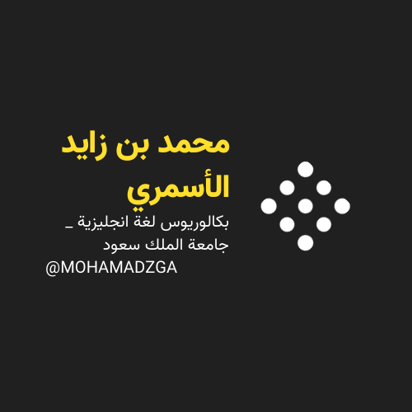

**لا تنسوني من صالح دعائكم**

****



M\_zaid0