Revision of units 6 – 7- 8
الاسم : .................................................................... الصف : اول متوسط

I) Vocabulary:
A)- Match words with their meanings :
1- different ( ) | ( A ) look for information
2- comfortable ( ) | ( B ) the opposite of same # ………
3- bookstore ( ) | ( C ) talk
4- here ( ) | ( D ) a place where you buy books
5- historic ( ) | ( E ) you feel good & relaxed
6- break ( ) | ( F ) the opposite of there # ………
7- check out ( ) | ( G ) old
8- chat ( ) | ( H ) the opposite of work # ………

B) – Write the correct word under each picture:


dining room - living room - laundry room - cave - armchair


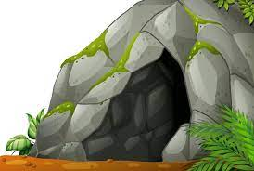
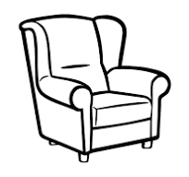

……………… ………………… …………….. …………… ………………...
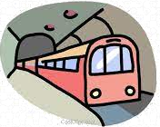
pharmacy - schedule - subway - building – train station
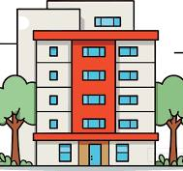


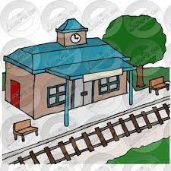

……………… ………………… …………….. …………… ………………...

C) - Choose the correct answer:
1- There is a ………… in the bathroom.
(D) car | (C) TV | (B) shower | (A) microwave

2- The ………… is a place with many stores.
(D) health club | (C) mall | (B) park | (A) restaurant

3- ………… are the people between 12 – 18 years old.
(D) Friends | (C) Customers | (B) Generation | (A) Teenagers

Ii) Grammar:
A) Choose the correct answer:

1- There …….. a nice table here.
(D) am | (C) is | (B) are | (A) no

2- The sink is …….the mirror.
(D) behind | (C) in | (B) on | (A) under

3- My room is small ……. comfortable.
(D) no | (C) but | (B) or | (A) and

4- The park is ……. The mall and the bank
(D) across from | (C) on | (B) next to | (A) between

5- Taraf lives ……. Jeddah.
(D) in | (C) on | (B) at | (A) to

6- Riyadh is ……. than Taif.
(D) more big | (C) biggest | (B) bigger | (A) big

7- She is …….. now.
(D) studying | (C) studied | (B) studies | (A) study

8- Are you writing now? - Yes, ………
(D) I not | (C) I am | (B) I am not | (A) am I

9- I would …….. a burger.
(D) liking | (C) like to | (B) liked | (A) like

B) Change into negative:

1- There are trees in the yard.

………………………………………………………………………

2- I am reading now.

………………………………………………………………………

iii) spelling:
Choose the correct letter:

1- Mohammed has sound sy… tem in his room.
(D) d | (C) k | (B) f | (A) s


2- There is a ….ase with flowers on the table.
(D) m | (C) r | (B) v | (A) t


3- I like this neighbo…hood , it's big.
(D) m | (C) r | (B) b | (A) p

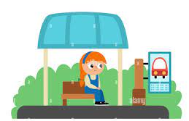
4- Diala is waiting for the bus at the bus s…op.
(D) n | (C) r | (B) k | (A) t


5- She is talking to a custo…er on the phone.
(D) d | (C) m | (B) h | (A) p

6- The teenagers' favorite place to han… out is the mall.
(D) L | (C) r | (B) s | (A) g

Good luck (= I really love you all, Dalal Al-Juaid <3

