*Student`s name : Mid Term Test 1st grade*

*Unit 5-6*

***Q1. Match the words with the picture :***

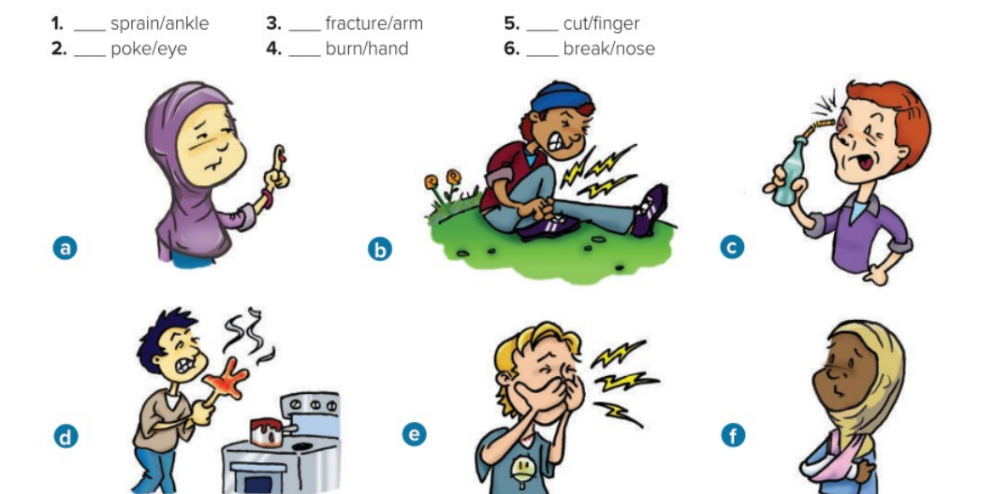

***Q2. Choose the correct answer :***

*1. Did you hurt ( himself / yourself ) ? .*

*2. Most accidents happen ( so / because ) people don`t pay attention. .*

*3. You ( must / should ) stop at the traffic light.*

*4. He drove ( quick / quickly ) .*

*5. They had better ( study / studying / studied ) well for the exam.*

*6. ( How many / How much ) books do read per month ?*

*7. I eat ( a little / a few ) salt .*

*8. I went to the gym this morning . ( so did I / Neither do I ) .*

***Q3. Change the adjectives to be adverbs in each sentence :***

*1. I listened ( careful ) to my father.*

*_________________________________________________________________*

*2. They played ( good ) in the last match.*

*__________________________________________________________________*

*3. He study ( hard ) for the test.*

*__________________________________________________________________*

*Q4. Match the word with its meaning :*

