1- Choose the correct answer:
1- You were in Jeddah, ( wasn't- weren't- aren't ) you?
2-They aren't from Abha, ( are they - are not they – do they) ?
3- Majed is able to ( drive – drives – driving ) a car.
4- Sara should ( see – saw – seen ) the doctor.
5- She is cute, (isn’t she – is she – is it)?
6- Let's (help – helping – helped) Mona.
7-You could (using – use – used) my laptop.
8-He is able to (fixing – fixes – fix) his bike.

2- Match the words with their meanings :
1- heredity |  | what you get from your parent
2- coincidence |  | three children born at the same time
3- triplets |  | child who has lost his parents
4- orphan |  | two children born at the same time
 |  | two things happen by chance
3- Identify the following objects
1-broom 2-hammer 3-screw driver
4-rocking chair 5- teddy bear 6- hose

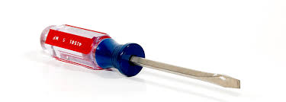 | 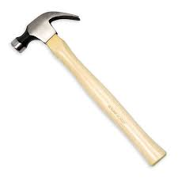 |  | 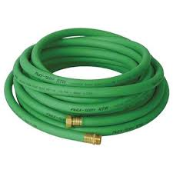 | 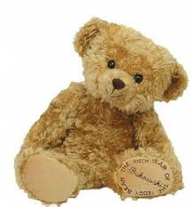 | 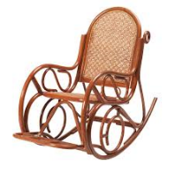

D-Do as shown between brackets:
1- go \ Let's \ shopping. (reorder).

