Name: …………………………………… Ms. Tahani ☺

Class: 1st Intermediate

**Revision Sheet _ Unit ( 10 ) : What’s School Like?**

1. **Vocabulary:**
2. **Write the words under the pictures:**

**experiment – archaeology – math – athletic – confused**

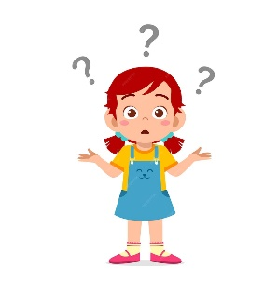

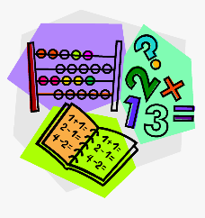****

**________________ __________________ __________________ __________________**

1. **Classify the words:**

**math – tall – thin – history**

|  |  |
| --- | --- |
| **School subjects** | **Adjectives to describe people’s look** |
|  |  |
|  |  |

1. **Circle the odd word:**
2. **School subjects:** geography – PE – team – science
3. **Adjectives:** smart – fun – strict – basketball
4. **Match the opposites:**
5. easy a- intelligent
6. boring b- interesting
7. long c- difficult

d- short

1. **Fill in the blank with the correct words in the box:**

**glasses – active – excavate – fascinating – blond**

1. She has ……………………. hair and blue eyes.
2. He is an ……………………. student.
3. I see so much better with my new …………………...!
4. History is not boring. It’s quite a ……………………... subject.
5. **Match:**
6. active a- difficult
7. interesting b- athletic
8. smart c- annoyed
9. hard d- intelligent

e- not boring

1. **Grammar:**
2. **Choose:**
3. He **(speak – speaks – speaking)** English.
4. They **(speak – speaks – speaking)** English.
5. He doesn’t **(speak – speaks – speaking)** English.
6. They don’t **(speak – speaks – speaking)** English.
7. Leen **(doesn’t watches – doesn’t watch – don’t watch)** TV every night.
8. Leen and Reem **(doesn’t watches – doesn’t watch – don’t watch)** TV every night.
9. **(Do – Does – Is)** Ali teach geography?
10. **(Do – Does – Are)** they teach math?
11. Do they **(play – plays – playing)** volleyball?
12. Does she **(play – plays – playing)** volleyball?
13. I am never **(bored – boring – boreds)** in science class.
14. This book is **(bored – boring – boreds).**
15. **Do as shown between brackets:**
16. has / black / Sara / hair  **(Rearrange)**

…………………………………………………..

1. is / Tala / short  **(Rearrange)**

…………………………………………………..

1. Ghina **(read)** a story every Sunday. **(Correct the mistake)**

…………………………………………………...

1. Fahad gets up early.  **(Change into negative)**

……………………………………………………

1. They brush their teeth. **(Change into negative)**

…………………………………………………….

1. Dana drinks coffee every morning. **(Make a Yes/No question)**

……………………………………………………

1. They pray in the mosque. **(Make a Yes/No question)**

…………………………………………………….

1. Science is a difficult subject.  **(Use ‘really’)**

……………………………………………………

1. Rana is tall. **(Use ‘very’)**

……………………………………………………