Revision of units 9 – 10- 11
الاسم : .................................................................... الصف : اول متوسط

I) Vocabulary:
A)- Match words with their meanings :
1- doctor ( ) | ( A ) absolutely not
2- striker ( ) | ( B ) the opposite of easy # ………
3- career ( ) | ( C ) who makes goals
4- difficult ( ) | ( D ) who works in a hospital
5- modern ( ) | ( E ) great
6- cool ( ) | ( F ) the opposite of early # ………
7- late ( ) | ( G ) job
8- No way ( ) | ( H ) the opposite of old # ………

B) – Write the correct word under each picture:


acting - flight attendant - mechanic - tennis player - striker



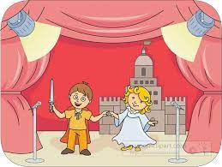

……………… ………………… …………….. …………… ………………...


Art - time - science - clubs – midnight


12 a.m

……………… ………………… …………….. …………… ………………...

C) - Choose the correct answer:
1- He's a ………… designer. He works with technology.
(D) house | (C) interior | (B) high-tech | (A) fashion

2- Math, PE, Art and English are ………….
(D) food | (C) subjects | (B) verbs | (A) adjectives

3- I sleep late at 12:00 a.m around the …………..
(D) midnight | (C) afternoon | (B) evening | (A) morning

Ii) Grammar:
A) Choose the correct answer:

1- She …….. English very well.
(D) spoke | (C) speaking | (B) speaks | (A) speak

2- What ……. they do ?
(D) is do | (C) doing | (B) does | (A) do

3- Hala sleeps ……. she's tired.
(D) because | (C) but | (B) or | (A) so

4- ……. Raghad speak English?
(D) Are | (C) Doing | (B) Do | (A) Does

5- Sara has a ……. .
(D) tall | (C) long hair | (B) hair long | (A) long

6- I'm never ……. in science class.
(D) pretty | (C) very | (B) boring | (A) bored

7- We …….. pray 5 times a day.
(D) never | (C) usually | (B)sometimes | (A) always

8- I get up …… 7 o'clock.
(D) of | (C) on | (B) at | (A) in

9- Fajr …….. her homework now.
(D) is doing | (C) doing | (B) do | (A) does

B) Make a question:

1- Leen is a nurse.

………………………………………………………………………

2- He works in a school.

………………………………………………………………………

iii) spelling:
Choose the correct letter:

1- He carries a brei… case and put all his stuff in it.
(D) d | (C) m | (B) f | (A) s


2- I want to be a we ….site designer. I'm good with computer.
(D) m | (C) k | (B) b | (A) t


3- I like to study geo…raphy , it's fun.
(D) m | (C) g | (B) b | (A) p


4- Hi…tory is fascinating and has a lot of stories.
(D) n | (C) v | (B) k | (A) s

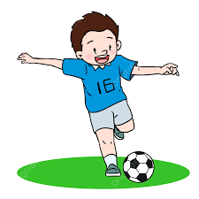
5- He usually plays foo…ball during PE.
(D) z | (C) m | (B) h | (A) t


6- Dana is ha…ing breakfast in the morning .
(D) L | (C) v | (B) s | (A) g

Good luck (= I really love you all, Dalal Al-Juaid <3

