|  |  |  |  |  |  |  |  |  |  |
| --- | --- | --- | --- | --- | --- | --- | --- | --- | --- |
| **المملكة العربية السعودية** | |  | | | | **المادة** | | **اللغة الانجليزية (شفوي)** | |
| **وزارة التعليم** | | **الصف** | | **الثاني متوسط** | |
| **الادارة العامة للتعليم ب_______** | | **المقرر** | | **Super Goal 2** | |
| **مدرسة __________ المتوسطة** | | **الزمن** | | **نصـف ساعة** | |
| **اختبار نهاية الفصل الدراسي الثاني – الدور الأول للعام الدراسي 1445 هــــــــ** | | | | | | | | | |
| **الاستماع 5** |  | **التحدث 5** |  | **المجموع 10** |  | | | | |
| **الاسم ثلاثي** |  | | | **الفصل** | **ثاني /** | | **رقم الكشف** | |  |

**Listen and circle the right answer:**

|  |
| --- |
| 1. What’s wrong? I have a earache - stomachache - headache .   You should take some medicine. |

|  |
| --- |
| 1. When were you last worried?   About a month ago. I lost my lap top - wallet – cell phone . |

|  |
| --- |
| 1. What do you want to do tonight?   Why don’t we stay up - late – home and watch a film on TV? |

|  |
| --- |
| 1. What did you do last Saturday?   I went to the pen – sport – history museum. |

|  |
| --- |
| 1. Excuse me? Where is the women’s department?   Take the elevator - escalator – exit . It’s on the second floor. |

|  |
| --- |
| 1. Which is the world’s most beautiful – interesting – dangerous fish?   It’s the great white shark. |

** Write or :**

|  |
| --- |
| 1. Majid refuse Saeed suggestion. ( ) 2. The daughter broke the microwave. ( ) 3. The speaker has toothache problem. ( ) 4. The store opens at 11 P.M. ( ) |

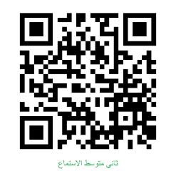

Audio : <https://youtube.com/watch?v=OBitdP0xDmw&si=EnSIkaIECMiOmarE>

Form : <https://forms.office.com/Pages/ShareFormPage.aspx?id=b4OQU5QpqkK9sELnf3f9C84PUFGeBGBFuY4-jPdGsvZUMEkxUlpZSVdWUFM1QUJPN1A5WVNNRUdYNyQlQCNjPTEu&sharetoken=NCnevY2X1MCZD75CYS3d>

**Audio Script:**

|  |  |
| --- | --- |
| Super Goal 2 Listening | Resources |
| 1. What’s wrong?   I have a stomachache.  You should take some medicine. | Unit 8 - Page 67  Pair Work  Audio CD2 trick 15 |
| 1. When were you last worried?   About a month ago, I lost my cell phone. | Unit 7- Page 59  Pair Work  Audio CD2 trick 9 |
| 1. What do you want to do tonight?   Why don’t we stay home and watch a film on TV? | Unit 9 – Page 75  Pair Work  Audio CD2 trick 21 |
| 1. What did you do last Saturday?   I went to the Sports Museum. How was it?  It’s was interesting. I really like the football exbibit. | Unit 6 – Page 51  Pair work  Audio CD2 trick 3 |
| 1. Excuse me? Where is the women’s department?   Take the escalator. It’s on second floor. | Unit 10 – Page 83  Pair Work  Audio CD2 trick 27 |
| 1. Which is the world’s most dangerous fish?   It’s the great white shark. | Unit 11 – Page 91  Pair Work  Audio CD2 trick 33 |
| 1. Is this Majid? Saeed, here. Hi Saeed. What’s up?   Do you want to go to the mall tonight?  I can’t go out today. My room is a mess. I can’t find anything in here. I have to clean it. | Unit 9 – Page 77  Listening  Audio CD2 trick 22 |
| 1. Mom, can I talk to you? Ok what’s up?   Now don’t be angry, mom. Don’t lose your cool, please  I broke the washing machine. There’s soap and water everywhere. YOU DID WHAT?  Don’t worry I’ll clean up the mess. | Unit 7 – Page 62  Conversation  Audio CD2 trick 12 |
| 1. I can’t resist candy, chocolate and other sweets. I love soda, too I don’t brush my teeth very often. Now I have problems with my teeth. | Unit 8 – Page 69  Listening  Audio CD2 trick 16 |
| 1. Don’t miss Milford’s annual sale this Saturday at Greentree Mall. The store opens at 10:00 a.m. and closes at 9:00 p.m. don’t miss this sale. All major credit cards are acceptable. | Unit 10 – Page 85  Listening  Audio CD2 trick 28 |

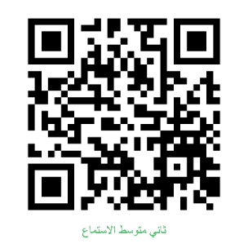

Audio : <https://youtube.com/watch?v=OBitdP0xDmw&si=EnSIkaIECMiOmarE>

Forms: <https://forms.office.com/Pages/ShareFormPage.aspx?id=b4OQU5QpqkK9sELnf3f9C84PUFGeBGBFuY4-jPdGsvZUMEkxUlpZSVdWUFM1QUJPN1A5WVNNRUdYNyQlQCNjPTEu&sharetoken=NCnevY2X1MCZD75CYS3d>

**اللغة الانجليزية )شفوي (الثا ن متوس ط**

**Super Goal 2 نصـف ساعة**

**المملكة العربية السعودي ة المادة :**

**وزارة التعلي م الصف**

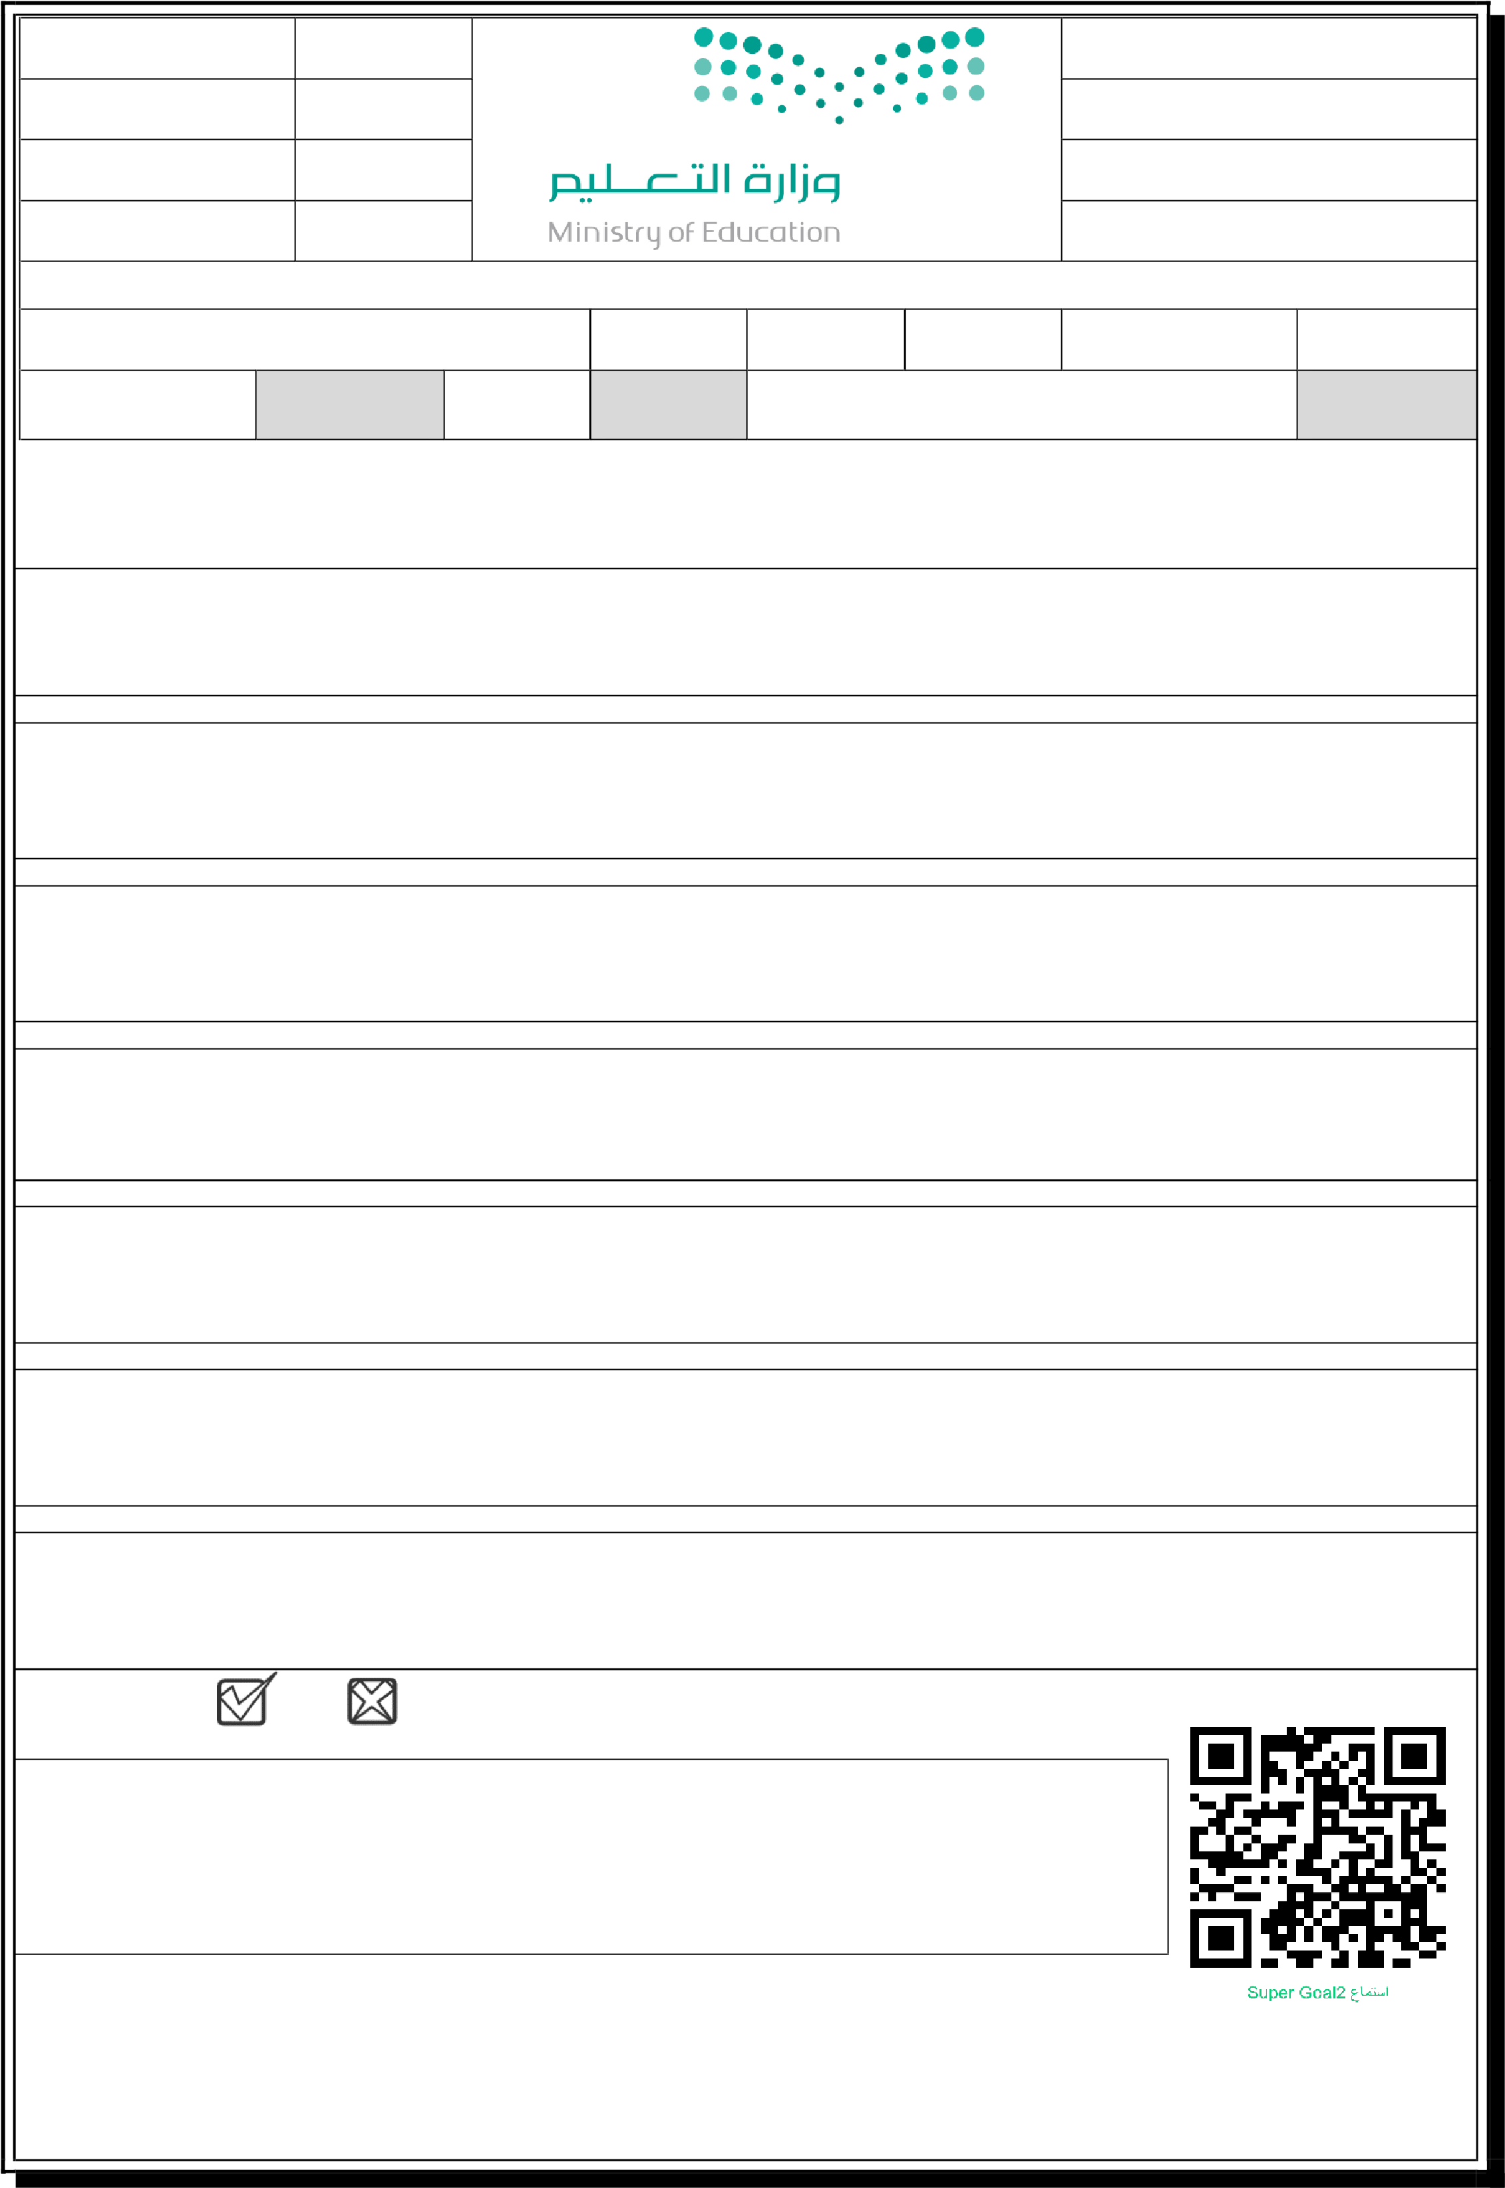**الادارة العامة للتعليم ب_______ مقر ر مدرسة __________ المتوسط ة الزم ن اختبار نهاية الفصل الدراسي الثان – الدور الأول للعام الدراسي _______ ه ـ**

**الاستماع 5 التحدث 5 المجموع 10**

**الاسم ثلاثي الفصل ثان / رقم الكشف**

**Listen and circle the right answer:**

1. What do you have to do today?
   1. have to do the dishes – the laundry – my homework .

1. What kind of museum do you prefer?
   1. like sport - history – Islamic museums best.

1. The Home Department is on the third - fourth – fifth floor.

1. What happened?

An MPV – An SUV – A van hit a car .

1. The speaker has a earache – backache - toothache .

1. Imad is busy now, but he will be free on Thursday morning – evening – night .

1. The laptop doesn’t have mouse – Bluetooth – Internet .

**Write or :**

1. Tokoy is the noisiest city in the world. ( )
2. The patient is at the doctor’s office. ( )
3. The speaker doesn’t like the football game. ( )

Audio : <https://youtu.be/HD53iwhFhsA>

Forms: [https://forms.office.com/Pages/ShareFormPage.aspx?id=b4OQU5QpqkK9sELnf3f9C84PUFGeBGBFuY4jPdGsvZURTdRS0lMMjVONFdHWEk3NjA2U0lWM1gwUyQlQCNjPTEu&sharetoken=9tSjhwY9npRu4i27u96e](https://forms.office.com/Pages/ShareFormPage.aspx?id=b4OQU5QpqkK9sELnf3f9C84PUFGeBGBFuY4-jPdGsvZURTdRS0lMMjVONFdHWEk3NjA2U0lWM1gwUyQlQCNjPTEu&sharetoken=9tSjhwY9npRu4i27u96e)

|  |  |  |
| --- | --- | --- |
| **اسم الطالبة بالعربي:** | **الدرجة** |  |
| **الفصل:** | **5** |

**A.** Listen to the recording and check **☑** the correct answer for each question:

|  |  |  |  |  |  |
| --- | --- | --- | --- | --- | --- |
| What did the man order? | | | | | **1** |
| Grilled chicken | **C** | Calamari | **B** | Roasted chicken | **A** |
| He took the order with baked potato. ( ) | | | | | **2** |
|  |  | **🗴** | **B** | **🗸** | **A** |
| The man ordered fresh juice. ( ) | | | | | **3** |
|  |  | **🗴** | **B** | **🗸** | **A** |
| What kind of dessert did he order? | | | | | **4** |
| Cheesecake | **C** | Ice-cream | **B** | Apple pie | **A** |
| What did the woman order? | | | | | **5** |
| shrimp | **C** | pasta | **B** | pizza | **A** |
| What kind did she order? | | | | | **6** |
| Margherita | **C** | Cheese and mushrooms | **B** | Grilled | **A** |
| What size is it? | | | | | **7** |
| large | **C** | Medium | **B** | Small | **A** |
| She took a house sald. ( ) | | | | | **8** |
|  |  | **🗴** | **B** | **🗸** | **A** |
| What kind of drink did she order? | | | | | **9** |
| Fresh juice | **C** | Iced tea | **B** | Cola | **A** |
| Where are they ? | | | | | **10** |
| In the supermarket | **C** | In the house | **B** | In the restaurant | **A** |

|  |  |  |
| --- | --- | --- |
| **اسم الطالبة بالعربي: نــــــمــــوذج إجــــابـــــة** | **الدرجة** | **5** |
| **الفصل: 🞎أ 🞎 ب** | **5** |

**A.** Listen to the recording and check **☑** the correct answer for each question: **½ for each**

|  |  |  |  |  |  |
| --- | --- | --- | --- | --- | --- |
| What did the man order? | | | | | **1** |
| **Grilled chicken** | **C** | Calamari | **B** | Roasted chicken | **A** |
| He took the order with baked potato. ( ) | | | | | **2** |
|  |  | **🗴** | **B** | **🗸** | **A** |
| The man ordered fresh juice. ( ) | | | | | **3** |
|  |  | **🗴** | **B** | **🗸** | **A** |
| What kind of dessert did he order? | | | | | **4** |
| Cheesecake | **C** | **Ice-cream** | **B** | Apple pie | **A** |
| What did the woman order? | | | | | **5** |
| shrimp | **C** | pasta | **B** | **pizza** | **A** |
| What kind did she order? | | | | | **6** |
| Margherita | **C** | **Cheese and mushrooms** | **B** | Grilled | **A** |
| What size is it? | | | | | **7** |
| large | **C** | **Medium** | **B** | Small | **A** |
| She took a house sald. ( ) | | | | | **8** |
|  |  | **🗴** | **B** | **🗸** | **A** |
| What kind of drink did she order? | | | | | **9** |
| Fresh juice | **C** | **Iced tea** | **B** | Cola | **A** |
| Where are they ? | | | | | **10** |
| In the supermarket | **C** | In the house | **B** | **In the restaurant** | **A** |

**Listening Transcription**

|  |  |
| --- | --- |
| **Server:  Hameed:  Server:  Hameed:**  **Server:**  **Hameed:**  **Server:  Aisha:  Server:  Aisha:  Server:  Aisha:  Server:  Aisha:** | Can I help you? I’d like the grilled chicken. With baked potato or fries? The baked potato, please. And can I have a large soda?  OK. Do you want any dessert?  Let me see. Yes, I’d like some vanilla ice cream.  Would you like to order now? Yes, please. I want a pizza. What kind? Cheese and mushrooms. What size? Medium, please. Sure. Would you like a house salad? Yes. And an iced tea. |



|  |  |  |
| --- | --- | --- |
| **المملكة العربية السعودية** | | **مادة اللغة الانجليزية / اختبار استماع نهائي** |
| **مكتب التعليم شمال جدة** | | **الزمن : .........** |
| **المتوسطة…….** | | **الصف / .........** |
| **الفصل الدراسي الثاني للعام الدراسي 14____هـ / 14____هـ** | | |

(Listening Comprehension / اختبار الاستماع النهــــائي)

ال

|  |  |  |  |
| --- | --- | --- | --- |
|  | الدرجة المستحقة |  | اسم الطالبة |
| 2nd grade /…. الثاني متوسط /ثاني ..... | الفصل |

Listen to the audio carefully then:

5

**A) Choose the correct answer:**

1) Smallpox leave you with ………………….. itchy dots on your skin.

A. red B. blue C. brown D. white

2) Many smokers get ………………….. cancer.

A. ear B. arm C. lung D. leg

3) A …………… makes you sneeze.

A. cold B. earache C. toothache D. sore throat

4) Sam is a …………………………….

A. lawyer B. policeman C. teacher D. doctor

5) Some diseases are treated with pills or …………………...

A. stone B. medicine C sweet D. plant

6) Sam lives in ………………..

A. Riyadh B. Dammam C. Abha D. Jeddah

**B) Circle (T) or (F)**

1) Sam is a doctor since 1975. True False

2) Older people sometimes get back and neck pain. True False

3) The flu cannot kill its victims. True False

4) A fever is a low temperature. True False

T. Noureyah Alghamdi



|  |  |  |
| --- | --- | --- |
| **المملكة العربية السعودية** | | **مادة اللغة الانجليزية / اختبار استماع نهائي** |
| **مكتب التعليم شمال جدة** | | **الزمن : .........** |
| **المتوسطة…….** | | **الصف / .........** |
| **الفصل الدراسي الثاني للعام الدراسي 14____هـ / 14____هـ** | | |

(Listening Comprehension / اختبار الاستماع النهــــائي)

ال

|  |  |  |  |
| --- | --- | --- | --- |
|  | الدرجة المستحقة | نموذج الاجابة | اسم الطالبة |
| 2nd grade /…. الثاني متوسط /ثاني ..... | الفصل |

Listen to the audio carefully then:

5

**A) Choose the correct answer:**

1) Smallpox leave you with ………………….. itchy dots on your skin.

A. red B. blue C. brown D. white

2) Many smokers get ………………….. cancer.

A. ear B. arm C. lung D. leg

3) A …………… makes you sneeze.

A. cold B. earache C. toothache D. sore throat

4) Sam is a …………………………….

A. lawyer B. policeman C. teacher D. doctor

5) Some diseases are treated with pills or …………………...

A. stone B. medicine C sweet D. plant

6) Sam lives in ………………..

A. Riyadh B. Dammam C. Abha D. Jeddah

**B) Circle (T) or (F)**

1) Sam is a doctor since 1975. True False

2) Older people sometimes get back and neck pain. True False

3) The flu cannot kill its victims. True False

4) A fever is a low temperature. True False

T. Noureyah Alghamdi



الثاني متوسط

وزارة التعليم مادة اللغة الإنجليزية

المتوسطة .... الفصل الدراسي الثاني عام 1444هـ

(Listening Comprehension / اختبار الاستماع النهــــائي)

نموذج النص السمـــــــاعي

5

5

Listening Script

Listen to the audio carefully then choose the correct answer:

Listen carefully

Health and diseases

I am Sam. I am a doctor. I live in Abha. I work in a hospital. I have been a doctor since 1975. There are many diseases. Some diseases are very deadly, and some are not so serious. Most people catch a cold sometimes. A cold makes you cough and sneeze. Colds can be passed on from person to person. Some people get the flu. With the flu, you get a fever. A fever is a high temperature. If you have the flu, you will feel very bad. You have to stay home in bed. The flu can kill its victims. There are diseases that children get. Smallpox and measles leave you with red itchy dots on your skin. Older people sometimes get back and neck pain. There are people who get heart disease. In many cases, a healthy lifestyle can prevent heart disease. Cancer can attack different parts of the body. Many smokers get lung cancer. Some diseases are treated with pills or medicine. Other diseases need to be treated in the hospital. Sometimes doctors need to give you tests to find out what kind of disease you have. The doctor might have to do a blood test or an x-ray to find out what is wrong with you. Most diseases can be cured by a doctor.

Answer the questions