30 | 2nd intermediate stage  Final exam, 2nd semester  Time / 1.5 hours |   1446  ثاني متوسط  الدور الأول | THE MINISTRY OF EDUCATION  ________ DIRECTORATE EDUCATIONAL  ________INTERMEDIATE SCHOOL
إسم الطالب :................................................................................ |  |  | رقم الجلوس: .......................
Student’s Mark Written /

Comprehension

Q1: Read the passage then answer the questions:

There was another accident at the corner of Lake and Willow. The accident happened around 3:15 p.m. An SUV crashed into a car. Fortunately, there were no injuries. It was the car driver’s fault because he didn’t stop at the stop sign. He was talking on his cell phone.

6

- Put ( √ ) or ( X ):

• There wasn’t accident at the corner of Lake and Willow. ( )
• The accident happening around 3:15 p.m. ( )

- Choose the right answer:

• An SUV crashed ( out - into - on ) a car.
• Fortunately, there ( were – was – did ) no injuries.

- Complete:
• It was the car ……………..….. fault because he didn’t stop at the …………………….. sign.

Grammar

Q1: Choose the right answer:

7
- How was the museum tour? It ( Did - was - is ) good.
- They saw Ahmed in his office 10 minutes ( ago - for - since ).
- Ahmed has a toothache. He ( must - shouldn’t - should ) go to the dentist.

Q2: Complete sentences with correct words:

are - Can - must - so - very

- I ……………………….…. clean my room.
- ……………………….…. I have another cookie? No, you can’t.
- He is .………………………………… fast that he won the race.

Q3: Write Irregular Past Forms:
Do ……………………… Have ……………………. Come …………………….
1

Vocabulary

7
Q1: Write word under the right picture:
Police officer - Robot - Go bowlling - Hand - Accident
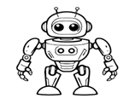 | 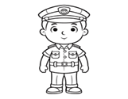 | 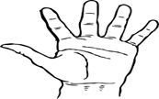 | 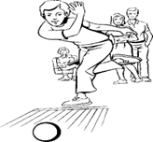
……………………..……..…….. | ……………………..……..…….. | ……………………..……..…….. | ……………………..……..……..

Q2: Write word’s number in left in front of suitable word in right :

1. old ( ) a blender and a microwave.
2. Home Department ( ) older – oldest.

Q3 : Reorder :
He - at - was - home. ……………………..………………………………………………………………………..……..
Spelling

Q1: write the missing letters :

4

o - r - m - w - a

 | 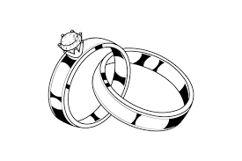 | • Arabic callig ___ aphy has beautiful lines and shapes.  • Take care of your appearance and your cl ___ thes.
• Ho____ e. | • Je____ elry.

Composition

Q1: Write a paragraph about events in your town no less than 50 words, use the following words and phrases:

6

What? – Where? – When? - Who? - Why? - How? - Witness

................................................................................................................................................................................................................................................
................................................................................................................................................................................................................................................
................................................................................................................................................................................................................................................
................................................................................................................................................................................................................................................
................................................................................................................................................................................................................................................
2

