Mega Goal Book 1.2

Unit 2: Take My Advice

**Vocabulary**

**Choose the correct word:-**

**1. I am always glad to see Hameed. We .............. each other so well.**

|  |  |  |  |
| --- | --- | --- | --- |
| **a-turn down** | **b-get along with** | **c-give up** | **d-put off** |

**2. Our teacher does not ..................talking during class.**

|  |  |  |  |
| --- | --- | --- | --- |
| **a-put up with** | **b-take up** | **c-throw away** | **d-turn down** |

**3. After the interview Alex decided to ............ the job offer. He didn’t like the idea of working long hours and being on the road seven days a week.**

|  |  |  |  |
| --- | --- | --- | --- |
| **a-turn down** | **b-get along with** | **c-give up** | **d-put off** |

**4. If you really want to get in shape, you should ................ tennis.**

|  |  |  |  |
| --- | --- | --- | --- |
| **a-put up with** | **b- take up** | **c-throw away** | **d- turn down** |

**5. I hate to ................ art class, but I just don’t have time to go anymore.**

|  |  |  |  |
| --- | --- | --- | --- |
| **a-turn down** | **b-get along with** | **c-give up** | **d-put off** |

**6. Don’t .......................... cleaning your car. It will just get messier!**

|  |  |  |  |
| --- | --- | --- | --- |
| **a-turn down** | **b-get along with** | **c-give up** | **d-put off** |

**7. Some people never ................ anything. They keep things they don’t use anymore.**

|  |  |  |  |
| --- | --- | --- | --- |
| **a- put up with** | **b- take up** | **c-throw away** | **d- turn down** |

**Grammar**

**Choose the best answer to fill in the blank in each question.**

**8. It is freezing outside! You ................ wear a warmer coat.**

**A. had better**

**B. better had**

**C. might**

**D. could**

**9. Sara is waiting for you. You .................... go meet her.**

**A. might**

**B. should**

**C. could**

**D. may**

**10. It doesn’t matter which car you buy. You _______________ buy the blue one *or* the red one.**

**A. had better**

**B. ought to**

**C. could**

**D. should**

**11. If that company offers me a job, I had better not _______________.**

**A. turn down**

**B. them turn down**

**C. turn down them**

**D. turn them down**

**12. He feels much more relaxed since he _______________ yoga.**

**A. took up it**

**B. took it up**

**C. took up**

**D. take up**

**13. If you can’t _______________ each other, you shouldn’t work together.**

**A. get along with**

**B. get them along with**

**C. get along**

**D. get along to**

**14. I didn’t wear those shoes anymore so I _______________.**

**A. threw away it**

**B. threw it away**

**C. threw away them**

**D. threw them away**

**15. _________sugar do you eat?**

**A. How many**

**B. How**

**C. Much**

**D. How much**

**16. ______________ when you have a toothache?**

**A. What do you do**

**B. How do you do**

**C. What do you feel**

**D. How do you**

**Reading**

**Read the text and answer the questions. Write T or F at the end of each question/ statement.** 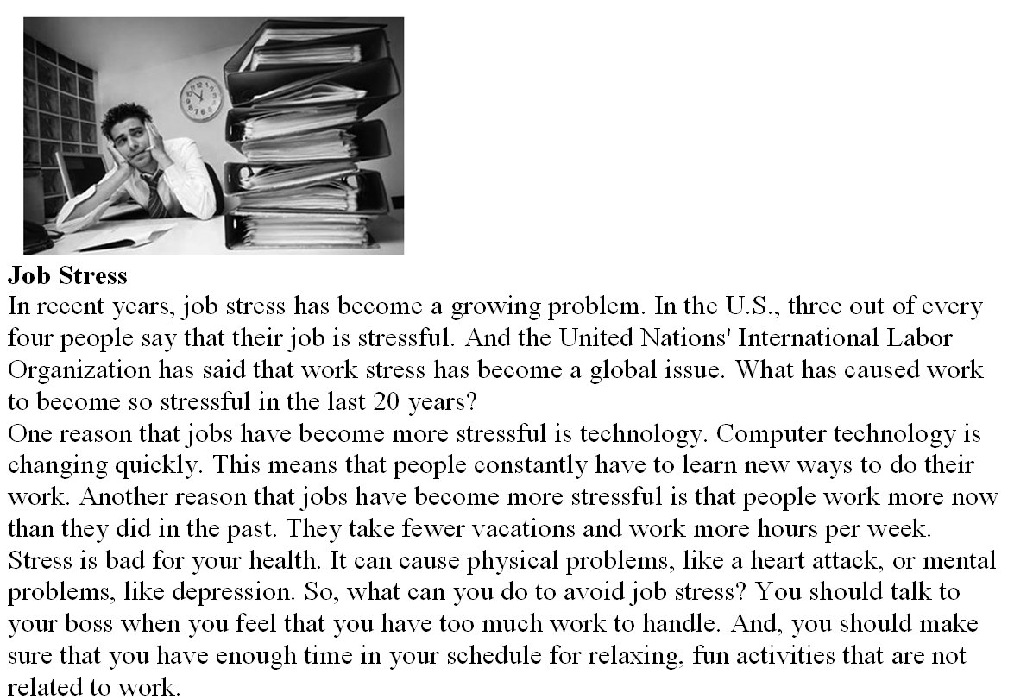

**1. Job stress is only a problem in the United States**

**2. Changing technology is a cause of job stress.**

**3. Depression is a cause of job stress**

**4. Jobs are more stressful now than they were in the past.**

**5. The writer thinks that you should quit your job if you feel stressed.**